
Date: 07/12/16

Group Number:
CE1
Programme of Study:
Chemical Engineering
Project Supervisor:
Dr. S. J. Anthony
Project Members:
Joseph Smith 200737446
Carl Jackson 200876132
Ghulam Qureshi 200712745
Ashleigh Buck 200838360
Adi Ab Fatah 200876783
DETERGENT POWDER MANUFACTURE
CAPE3000
DESIGN PROJECT: PART 1 REPORT
SCHOOL OF CHEMICAL AND PROCESS ENGINEERING
DECLARATION OF INDIVIDUAL CONTRIBUTIONS TO PART I – REPORT

Chapter | Main Author(s) [% contribution] | Signature(s) | Other members involved in this chapter [% contribution] | Signature(s)
Raw Materials and Products | Adi Hani Ab Fatah [65%] |  | Ghulam Qureshi [35%]
Process Route Evaluation and Selection | Equal contribution from all group members |  | Equal contribution from all group members
Safety, Health and Environmental | Joseph Smith [65%] |  | Ashleigh Buck [35%]
Project Management | Ghulam Qureshi [65%] |  | Joseph Smith  [35%]
Mass and Energy Balances | Equal contribution from all group members |  | Equal contribution from all group members
Report Presentation | Ashleigh Buck [65%] |  | Carl Jackson [35%]

EXECUTIVE SUMMARY
The Thomas Hedley Company have commissioned a compact detergent powder plant to manufacture a new product under the ‘Dazzle’ brand. The specifications include a formulation specification and production rate of 60,000 tonnesyr⁻¹ of a ‘white, free flowing powder that is dust free and quick to dissolve’, with a nominal density of 850kgm⁻³. The sale of the new brand is for target markets in Austria, Switzerland and Germany. The site selected for the plant is in Zdemyslice, Czech Republic. A non-tower agglomeration process has been selected to achieve the required density using an adiabatic, high shear neutralization mixer with a LABSA feed rate of 856.16kg h⁻¹ sprayed at 7000kPa and a medium shear conditioning stage (operating at 328K and 323K, respectively) with a cooling requirement of 487kW. The Alkyl Ethoxylate and LABSA are stored at a temperature of 313K, requiring a heater with maximum duties of 100kW and 300kW respectively, while providing trace heating of 10.5kW and 20.2kW to overcome energy losses.
The subsequent agglomerates will have a particle distribution in the range of 400µm - 1000µm and are dried in a fluidised bed drier and cooler requiring a wet air flow rate of 0.11kg s⁻¹ and 5.99 kg s⁻¹, respectively. The air heater of the dryer requires a duty of 13kW while the air stream requires cooling by 122.4kW. Fines are managed by a cyclone and bag filter unit that recycles them to the medium shear stage. Pump duties are also calculated where necessary to ensure conditions are achieved by estimating pressure losses from storage across the pipe network. Particle classification is achieved by use of a sieve and grinder with an internal recycle. Post addition powders are weighed in a drum mixer, with liquid additions sprayed via nozzle at a pressure of 7000kPa. The end product has a moisture content of 4.5% consisting of free and bound water to prevent dusting or stickiness. The Miscellaneous material derived from raw material feeds is 195.5kghr⁻¹ assuming these are not separated by any operation in the process.

Table of Contents

Nomenclature vi
Terminology vii
1 INTRODUCTION 1
2 RAW MATERIALS AND PRODUCTS 3
2.1 LABSA and Alkyl Sulphate 3
2.3 Zeolite A Properties and Market Demand 4
2.4 Sodium Sulphate and Sodium Carbonate Properties and Market Demand 4
2.5 Percarbonate Bleach Properties and Market Demand 5
2.6 Summary and Purchasing 6
2.7 Additives Properties and Purchasing 6
2.8 Compact Detergent Powders 7
2.9 Target Market: Germany, Austria and Switzerland 7
3 PROCESS ROUTE EVALUATION AND SELECTION 9
3.1 Site Selection 9
3.2 Conventional Spray Drying Techniques 9
3.3 Alternative Processes 11
3.3.1 Extrusion 11
3.3.2 Dry Mixing 12
3.4 New Technologies 12
3.5 Process Route 13
3.5.4 Post-Addition Mixer 18
3.5.5 Particle Classification 18
3.5.6 Powder Handling 18
4 SAFETY, HEALTH AND THE ENVIRONMENT 19
4.1 Background 19
4.2 Material Transport and Handling 19
4.2.1 Anionic and Non-ionic Surfactants 19
4.2.2 Other Detergent Ingredients 20
4.2.3 Additives, Enzymes and Hygienic Design 20
4.3 Process Safety 22
4.3.1 Dust Control and Explosion Protection 22
4.3.2. Health and Safety Legislation and Training 22
4.4 Process Emissions 23
4.4.1 Ecotoxicology and Biodegradability of Surfactants 23
4.4.2 Detergent and Dust Emissions Regulation 24
4.4.3 Carbon Dioxide Emissions Regulations 25
4.4.4 Plant Automation and Operator Training 25
5 PROJECT MANAGEMENT 26
5.1 Background 26
5.2 Delegation and Scheduling 26
5.3 Key Milestones, Project Timeline 28
5.4 Associated Risks and Mitigation 29
6 MASS AND ENERGY BALANCES 31
6.1 Mass Balances 31
6.1.1 Production Rate 31
6.1.2 Process Flow Diagram and Raw Materials Specification 32
6.1.3 Assumptions 33
6.1.4 Post Addition Mixer 34
6.1.5 Sieving and Milling 35
6.1.6 Fluidised Bed Cooling 36
6.1.7 Fluidised Bed Drying 37
6.1.8 Fine Separation and Recycling 38
6.1.9 Medium Shear Mixer (Agglomerator) 40
6.1.10 High Shear Mixer/Neutralization 41
6.2 Energy Balance 43
6.2.1 Preliminaries 43
6.2.2 Alkyl Ethoxylate Heating 46
6.2.3 Heating of LABSA 48
6.2.4 High Shear Mixer (Neutralization) 48
6.2.5 Agglomerator 50
6.2.6 Fluidised Bed Dryer 50
6.2.7 Fluidised Bed Cooler 52
Conclusion 59
References 60
Appendix 1
A1 Ancillary information 1
A1.I Summary of Thermodynamic Properties 1
A1.II Dryer and Cooler Inlet Air Pressure Estimations 2
A2 Process Flow Diagram 2
A2.I Equipment Designations 2
A2.II Stream Data 2
A3 Minutes of Group Meetings 3
A3.I Minutes of the Group Meeting held at 12:00 on 30/09/16 3
A3.II Minutes of the Group Meeting held at 11:00 on 04/10/16 4
A3.III Minutes of the Group Meeting held at 12:00 on 10/10/16 6
A3.IV Minutes of the Group Meeting held at 13:00 on 11/10/16 8
A3.V Minutes of the Group Meeting held at 13:30 on 17/10/16 10
A3.VI Minutes of the Group Meeting held at 12:00 on 19/10/16 13
A3.VII Minutes of the Group Meeting held at 12:00 on 24/10/16 16
A3.VIII Minutes of the Group Meeting held at 10:00 on 02/11/16 18
A3.IX Minutes of the Group Meeting held at 2PM on 17/11/2016 21
A3.X Minutes of the Group Meeting held at 3PM on 21/11/2016 24
A3.XI Minutes of the Group Meeting held at 12:00PM on 28/11/2016 27
A3.XII Minutes of the Group Meeting held at 11:00AM on 29/11/2016 29
A3.XIII Minutes of the Group Meeting held at 12:00 on 05/12/2016 31
A3.XIV Minutes of the Group Meeting held at 14:00 on 05/12/2016 33

Nomenclature
Symbol | Description | Units
ΔHº_{f} | Specific enthalpy of formation at standard conditions | kJmol⁻¹
ΔHº_{r} | Specific enthalpy of reaction at standard conditions | kJmol⁻¹
ΔHº_{v} | Specific enthalpy of vaporization at standard conditions | kJmol⁻¹
C_{p} | Specific heat capacity at constant pressure | kJmol⁻¹K⁻¹
$$\dot{m}$$ | Mass flow rate | kghr⁻¹
Q̇ | Heat Flow | kJs⁻¹
T | Temperature | K
P | Pressure | kPa
ṅ | Molar Flow Rate | kmolhr⁻¹
M_{w} | Molecular Weight | kgkmol⁻¹ or gmol⁻¹
H_{r} | Hausner Ratio | Dimensionless
W | Work Done | kJ
Δ | Change in | Dimensionless
µ | Micron | 10⁻⁶m

Terminology
CMC Sodium Carboxymethyl Cellulose
FMCG Fast Moving Consumer Good
HMI Human Machine Interface
HSE Health and Safety Executive
LABSA Linear Alkyl Benzene Sulphonic Acid
LAS Linear Alkyl Benzene Sulfonate
LC₅₀ Median Lethal Concentration
Na₂CO₃ Sodium Carbonate
NaLAS Sodium salt of Linear Alkyl Sulphonic Acid
OSHA Occupational Health and Safety Administration
PPE Personal Protective Equipment
SCADA Supervisory Control and Data Acquisition
TAED Tetraacetylethylene diami

1 INTRODUCTION

Commercially, the laundry detergent market represents a global retail value of $60.9 Billion (2012). Of this, the sale of laundry detergent in Western Europe accounts for $11.7 Billion. The primary mode of sale for laundry detergents is as a FMCG for domestic use, with minority industrial sales (€658 million in the EU, 2013) (Bianchetti et al, 2015). It is a mature industry with significant regional variation in consumer trends and preferences, such as intrinsic cleaning power, sustainability, environmental implications, toxin content and general appearance (smell and colour). These performance and life cycle characteristics are becoming increasingly important due to the worldwide growth in middle class consumers (1.8 billion in 2009 to 4.9 billion in 2030) (Nielsen, 2016), who have a more disposable income while being more discerning about product choices. Compact detergent powders represent company innovation to meet consumer’s needs – they can be packed more easily and for greater quantities, have greater cleaning efficacy for smaller doses and have lower environmental costs than conventional wash powders (Cahn, 1998).
The mechanism to which the detergent removes soiling is through initial wetting and adsorption due to the surfactant presence. Further adsorption typically leads to removal of the substrate through alteration in interfacial chemical properties between fabric and soil. Once removed, the colloid is stabilised by emulsification and thus dispersed. This prevents redeposition upon the fabric and is typically classified as secondary washing. Further protection of the treated fabric is then often applied by the product (Smulders et al, 2002) (Zoller, U. 2004a). Such mechanism therefore requires a variety of components to achieve such a broad range of tasks.
The Thomas Hedley Company have identified a potential market for compact detergent powders for Tier 1 consumers. As part of the design, it is required that the plant produce 60,000 tonnes/year of product with a formulation specification outlined in Table 1 and with particular emphasis on the end product quality and plant flexibility, citing a ‘white, free flowing powder that is quick to dissolve’ with a bulk density of 850kgm⁻³. The remit of the following work is a comprehensive analysis of viable manufacturing routes, selection and development of a preferred production route with regard to all design choices and environmental factors. For the chosen process, a technical proposal is to be outlined consisting of unit operations, material flows and raw material sourcing, and ideal conditions to operate a continuous plant.

Table 1. ‘Dazzle’ Compact Powder Formulation Specification
Key Ingredients | formulation level  % active ingredient
Alkyl Sulphate | 5
Linear Alkyl Benzene Sulphonate | 10
Non-ionic Surfactant | 4
Zeolite | 25
Percarbonate Bleach | 12
Sodium Carbonate | 18
Sodium Sulphate | Balance
Additives Minors | 8.5

The target region for retail of this new compact is in Austria, Switzerland and Germany. In view of this, the plant site must be situated in a region to benefit from strong trade relationships, cheaper distribution and low labour costs. The initial portion of this work details the material feedstocks required in the process, with regard to their physical and detergency properties, in addition to a purchasing overview that covers price forecasting and available suppliers. Conventional manufacturing techniques (e.g. spray drying) and other non-tower routes (e.g. extrusion) are reviewed in the context of achieving the desired product qualities, particularly the density requirement, and then compared with the selected processing route. A selection of resources will be used to develop a composite manufacturing process, citing ideal operating parameters in terms of temperatures, unit operations and materials handling found in industry. The technical choices ensure a flexible plant design which will accommodate formulation changes and safe operation. This is summarised in a detailed process flow diagram that concisely describes all material streams, energy requirements and process parameters cited in the route selection.
Subsequent mass and energy balances were performed on the selected process route, considering all reactions, waste streams, separations and energy requirements of the system. Pump power requirements were determined for material transport in addition to heating requirements for storage of a 2 day supply. In cases where more detailed design is required, pressures and temperatures have been assumed or determined from literature. In summary, the report provides a comprehensive design for the manufacture of high bulk density detergent powder for a selected process route considering the product requirements, flexibility of the process, environmental impact and cost effectiveness.

2 RAW MATERIALS AND PRODUCTS

2.1 LABSA and Alkyl Sulphate
Linear alkyl benzene sulphuric acid is the main anionic for producing detergent. This acid is among the most important of the organic-sulphur compounds because salts and other derivatives form the basis of the manufacture of detergents, water-soluble dyes and catalysts. In detergent production, the acid is neutralized with alkaline ingredient to produce detergent salts (Block, 2016). Typically, cleaning products incorporate more than one surfactant to achieve the desired cleaning action, therefore alkyl sulphate is another anionic surfactant to be added in the production of detergent (SDA, 1994). Alkyl sulphate is normally provided in salt form which is sodium dodecyl sulphate, as the acid form is unstable and not suitable for long term storage and handling. The purchased material does not require neutralization and will be directly agglomerated with the NaLAS and other ingredients (De Groot et al, 1995). A full description of chemical and physical properties is shown in Table 2.1 and 2.2.
These materials are easily sourced within Europe and can be sustainably sourced from the supplier ‘Henkel’ due to their long term energy reduction plan. The company target is an improvement of efficiency threefold by 2030 (Henkel, 2016). Sodium dodecyl sulphate can be purchased from Sigma-Aldrich Chemie. The company has operated since 1975 and have established a commitment to increase the sustainability of their products and packaging through new technologies and knowledge partnerships with academic researchers. Figure 2.1 shows the global average price of LABSA per unit was steady around $1.5 then decreased to $1. Albeit a slight increase in recent time, the global price of LABSA per unit is still in the range of proposed price.
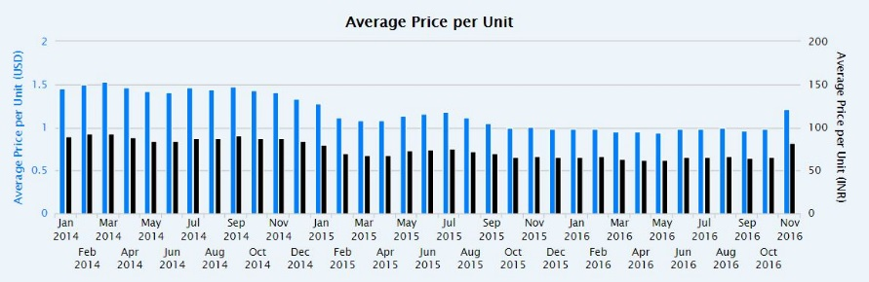
Figure 2.1: Bar chart showing the global price of LABSA from 2014 to 2016 (Zauba, 2016)
2.2 Alkyl Ethoxylate Properties and Market Demand
Alternatively called ethoxylated fatty alcohol, it is widely used in detergency due to its superior performance and soil dispersion characteristics. Due to the varying lengths of the ethylene oxide, the chains are averaged to give a consistent value, this variation is also responsible for the differing properties. A primary alcohol with a carbon number of 14-15 with 7 moles ethylene oxide per mole alcohol is utilized in high performance detergent powder (De Groot et al, 1995)
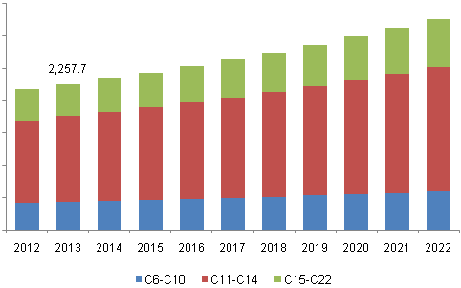
Figure 2.2: Global fatty alcohols market volume by product, 2012 – 2022 (Grandview Research, 2016a)
Fatty alcohol ethoxylate can be purchased from Nantong Earth Chemical Co. Ltd., this company has been established over 40 years and has passed ISO9001 quality verification in order to guarantee the product's quality and demand sustainability (Nantong Earth Chemical, 2009a). In Figure 2.2, global market demand shows a growing trend which forecasts the market volume in future. Increasing demand for biodegradable and sustainable products to reduce petrochemical reliance is likely to remain a crucial driving aspect for the global fatty alcohols industry. Due to more sustainable product being demanded, the prices are expected not to change significantly during the period.

2.3 Zeolite A Properties and Market Demand

Zeolite A is typically the form used in detergents, with the role to soften the wash water by decreasing the calcium and magnesium concentration. This material has a well-defined crystal structure resulting in a highly accessible porous structure. Due to this feature, sodium ions contained in this structure are highly mobile and can be easily exchanged by ions responsible for water hardness (De Groot et al, 1995). Zeochem, a manufacturer of high quality zeolites was chosen for purchasing zeolite A as they have extensive manufacturing experience in the production of high-performance products and they give an assurance of supply in long-term demand (Zeochem, 2016). A report, Global Zeolite Market 2016-2020, has analysed and estimated the market to grow at a compound annual growth rate of 7.86 % over the period 2016 to 2020. The report has also been observing the increase in production volumes (Research & Markets, 2016).

2.4 Sodium Sulphate and Sodium Carbonate Properties and Market Demand

Sodium carbonate, also known as soda ash, is used as an alkaline builder by precipitation of calcium and magnesium ions, forming their individual carbonates in detergent powders and as a neutralization agent for LABSA (HA Campbell, 2011). Sodium sulphate is another filler used in detergent powder as a processing aid. It provides important physical characteristics to the detergents such as proper flow, viscosity, solubility, stability and uniform density. It principally acts as a diluent which assists in manufacturing but can affect the ionic strength of colloidal systems and is also source of sodium ions for salting out active phases in detergent slurries (SDA, 1994). Both fillers are supplied by Unichimica. They ensure the supply distribution despite the location and the demand owing to having their own transport to deliver the products. Moreover, the company has two warehouses with large capacity to ensure continuity of suppling and a wide choice of products that can be used in various areas (Unichimica, 2016).
Soda ash is likely to witness increasing competition from substitutes such as caustic soda over the next eight years. Synthetic soda ash production is a highly energy intensive process, hence product pricing has been distorted despite its lower demand. However, restricting production of synthetic soda ash in several countries has further increased the demand for natural soda ash leading to price stability and has increased the market growth (Unichimica, 2016). Figure 2.3 shows the average price of sodium sulphate per unit over recent years. Its price has remained stable with minor fluctuations and is expected to do so for the foreseeable future (Zauba, 2016).
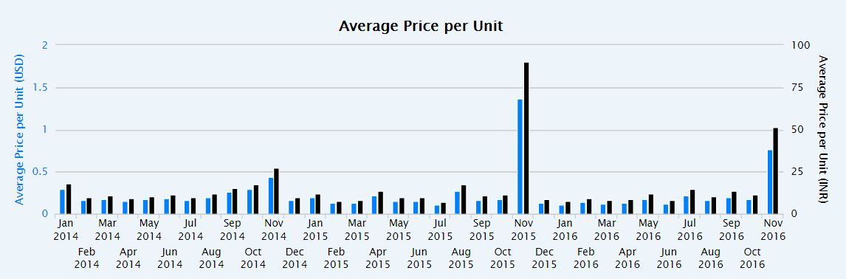
Figure 2.3: Bar chart showing the global price of sodium sulphate from 2014 to 2016 (Zauba, 2016).

2.5 Percarbonate Bleach Properties and Market Demand

Chemical bleaches in detergent laundry powder increase performance of cleaning by the removal of organic colours from fabrics. Bleaching is typically carried out with oxidizing agents like sodium percarbonate. It is the chemical product of a direct addition of sodium carbonate and hydrogen peroxide, with formula 2Na₂CO₃·3H₂O₂ (PubChem, 2016). When dissolved in water, it yields a mixture of hydrogen peroxide which eventually decomposes to water, oxygen and sodium carbonate. Many products in the market mix a percentage of sodium percarbonate with sodium carbonate. Sodium percarbonate is less expensive in its pure form and can be adjusted to any percentage the user desires (Jones, 1999). It can be purchased from the same manufacturer as the fillers which is Unichimica. Petroleum based fatty alcohols are subjected to volatile crude oil prices and demand for oleo chemicals is high from bio-diesel application. Hence, availability of raw materials can be major concern for the players in laundry detergents material market.

2.6 Summary and Purchasing
Table 2.1: List of chemicals, properties and prices.
Chemical | LABSA | Alkyl Sulphate | Alkyl Ethoxylate | Zeolite | Sodium Sulphate | Sodium Carbonate | Percarbonate Bleach
Melting point (K) | Melt 283  Boil 588 | 477 | 275 | 1973 | 1161 | 1132 | -
Decomposition point (K) | - | - | 523 | - | - | - | 323
Appearance at 298K | Brown liquid | White solid | White to light yellow liquid | White powder | White hygroscopic liquid | Greyish-white powder | Colourless crystalline solid
Molecular weight (gmol⁻¹) | 326.49 | 288.38 | 538 | 202.14 | 142.04 | 105.98 | 314.02
Density at 298K (Kgm⁻³) | 1060 | 1010 | 1100.5 | 170-450 | 2660 | 2540 | 2100
Solubility | - | - | Soluble in water | poor | Insoluble in alcohol | Insoluble in ethanol | High in water
Reference (properties) | World of Chemicals, 2016 | PubChem, 2016 | Sonia, 2012.  Cameo Chemicals, 1998 | HERA, 2004 | PubChem, 2006 | PubChem, 2006 | PubChem, 2016
Source location | Wein, Austria | Munich, Germany | Shanghai, China | Zurich | Italy | Italy | Italy
Supplier | Henkel | Sigma-Aldrich Chemie Gmbh | Nantong Earth Chemical Co. | ZeoChem | Unichimica | Unichimica | Unichimica
Price (USD Kg⁻¹) | 1.00-2.00 | 68.45 | 1.00-2.00 | 68.45 | 1.00 | 2.00 | 22.53
Reference (Supplier) | Henkel, 2016 | Sigma Aldrich, 2016 | Nantong Earth Chemical, 2009 (b) | Malewski, 2016 | Unichimica, 2016 | Unichimica, 2016 | Unichimica, 2016

2.7 Additives Properties and Purchasing
Table 2.2: List of additives and minors with details (SDA, 1994)
Additives | Functions | Supplier and Cost | Forecasting Demand in Future
Enzymes (Protease) | Proteins classified by the type of the soil they break down to simpler forms for removal by detergent. | Sichuan Habio Bioengineering Co., Ltd. (2002) in China  USD $5 - 20 / kilogram | Set up two large-scale production factories for microbial fermentation products
Perfume oil (Fragrance blends) | Mask base odour of ingredients and package, provide pleasant odour to clothes and rooms | Dongguan Boton Flavors & Fragrances Co., Ltd. (2014b) In China  USD $1 - 12 / kilogram | Named as one of the top ten Fragrance Enterprises in China.  Annual production capacity exceeds 2000 tonnes
Perfume encapsulates | Perfume is encapsulated in a coating of polymer material | Dongguan Boton Flavors & Fragrances Co., Ltd. (2014a)  USD $1 - 12 / kilogram
Brighteners | Attach to fabrics to create a whitening or brightening effect when exposed to daylight | Hangzhou Yuanhui Technology Co., Ltd. (2010) in China  USD $3.8 - 4.3 / kilogram | Established long-term and strong business relationships with most customers in Europe
Polycarboxylate (Sodium Polyacrylate) | Prevent soil from resettling after removal during washing.  Co-builder of zeolite | Jiangmen City Xinhui District Zhongsheng Bio-Tech Co (2007)  USD $2.9 / kilogram | Biggest supplier in additives in China with top quality.
CMC (Sodium Carboxymethyl Cellulose) | Oil suspension polymer designed to create a barrier to soils in the wash solution | Linyi Viho Chem Co., Ltd (2000) in China  USD $0.4 - 1 / kilogram | Total CMC produced per year goes beyond 7000 tonnes to supply market
TAED Bleach Activator  (Hirschen ,2005) | React with hydrogen peroxide to form peroxyacids.  a more active bleach than hydrogen peroxide at lower temperatures (<60 °C) | Shanghai Worldyang Chemical Co., Limited  USD $1 - 15 / kilogram | Trading from Western Europe contribute 12% of their total annual revenue. Products widely trusted
Sud-suppressor (Polydimethylsiloxane) | Control sudsing where suds would interfere with cleaning action | Shandong Wanda Organosilicon New Material Co., Ltd (2012)  USD $1 -10 / kilogram | Own innovative facilities. Annual production capacity 80,000 ton to meet demands

2.8 Compact Detergent Powders

The formulation is strongly affected by the temperature of the cleaning water and varies from country to country. Compact detergents are typically never used in bulk material for other processes and as a precursor for other production, though there are other applications besides household washing. It can be used as fuel additives. Both carburettors and fuel injector components of Otto engines benefit from detergents in the fuels to avoid fouling (Smulders, 2002). It can also be applied as biological reagent. Reagent grade detergents are used for the isolation and purification of integral membrane proteins found in biological cells (Koley and Bard, 2010).

2.9 Target Market: Germany, Austria and Switzerland

The detergents market in Europe is dominated by P&G and Unilever. To understand the target market analysis, those big companies’ market plan can be compared. The main comparative difference between these two companies is their key sector. Unilever mainly focus in foods and personal care which contribute about 80% of total revenue. Despite the fact, P&G is leading with fabric and home care with 60% of total revenue. One of the advantages for P&G in comparison to Unilever is their market research activities and consumer understanding. Instead of focusing their product on a low-growth market, they analysed key trends and market needs and decided to establish themselves in high-growth markets. Such decisions were supported by in-depth market research planning and identifying areas for improvement. Unilever, on the other hand, is more likely to attract customers from developing countries because of their brand merger and acquisition plan (Nielsen, 2016).
Germany is the largest consumer market in the European Union with a population of 80.6 million. The capacity of trade and Germany’s location at the centre of other’s European Union countries make it a country around which many companies centre their growth strategies (Export.gov, 2016). Germany’s major trends in the market show an increase in the use of time saving and convenient products. As part of a long-term shift in consumer lifestyles, including an increasing number of working women, products that offer convenience and ease of use have performed well in recent years (US Commercial Service, 2014). Austria is an active European Union member country offering export opportunities for many manufacturing organizations. General laundry care in Austria is constantly driven by innovation. Most manufacturers focused on either improving their existing packaging or offering more effective products that provide greater washing results with minimal effort required from the consumer. In 2015, the tendency towards switching from standard to concentrated detergents, as well as from powder to liquid detergents, continued to evolve (Euromonitor, 2016). Given the size of the country, Austria signifies a desirable and wealthy model market in Europe (Export.gov, 2016). They open to new products due to Austria’s strategic spot between western and eastern European markets, which can help to boost the sale of new products (Department of International Trade, 2016).
However, Switzerland is not affiliated to the European Union and is not likely to join in the probable future. The competitive landscape in laundry care was rather concentrated in Switzerland over a long period. The top four players, namely Migros Genossenschaftsbund, Henkel & Cie, Procter & Gamble Switzerland and Unilever Schweiz, made up a 78% value share in 2015. In the same year, there were three main trends in laundry care in Switzerland. First, Swiss households were more accustomed to concentrated and liquid laundry detergents, which pushed aside powder detergents. Second, ecologically-friendly products were more cherished by a wider group of consumers. Finally, the consumer favourite for all-in-one detergents continued to rise, coupled with the ongoing decline of laundry aids and other detergents, which was also along with the trend of efficient housekeeping (Euromonitor, 2016).

3 PROCESS ROUTE EVALUATION AND SELECTION

3.1 Site Selection

The site location is Zdemyslice, Czech Republic. This selection was due to the reduced labour costs in comparison to the alternative neighbouring European countries. Although Austria would provide reduction in distribution costs, it has a labour cost of €32.40 – 3.5 times that of Czech Republic’s typical labour cost (€9.90) (Eurostat, 2015).
The country is stable both politically and economically, with a Social and Christian coalition as of 2014 and strong international relations. The GDP of the Czech Republic has seen rapid growth, with a 3% increase in 2015. Primary trading is with Europe which accounts for 80% and with Germany comprising 33% (Eurostat, 2015). As a result, the country is a desirable location for a company such as The Thomas Hedley Company that distributes to Germany, Austria and Switzerland.
The rural village presents a population of approximately 500 inhabitant and presents a variety of possible plots for a large plant while also being situated 84km southwest of Prague. This provides strong infrastructure through roadwork and the developed railway network of Czech Republic (Eurostat, 2015). The infrastructure network and central Europe positioning of Czech Republic provides opportunities for market expansion to that of the remaining Western and Eastern Europe. As a result, importation costs from The Thomas Hedley’s Company’s primary material suppliers, such as Unichimica, are minimised while also optimising the deportation route of the end product.
The land of interest is 120 Acres and 400m from the village. It is situated on the opposing side of the school. This shall minimise sound pollution while also maintaining access to the major roadwork and small train station for commuting employees from Prague and neighbouring villages. There are also no current industrial sites within the village, allowing Dazzle to independently manage any disruption the site may cause.

3.2 Conventional Spray Drying Techniques

Spray Drying is used in detergent manufacturing to produce a dry powder from a slurry. This is achieved by spraying the slurry through a current of hot air, the rapid heat exchange causes the droplets to quickly dry, forming granules of product (Zoller, 2004b).
A process flow diagram shows the unit operations for the spray drying process (see Figure 3.1). The liquid ingredients are first combined into a slurry in a crutcher, the slurry is then heated and pumped through nozzles under high pressure, 50 – 30000 kPa (Mujumdar, 2014). The acid precursor LABSA is added to the crutcher and neutralised prior to the addition of the other ingredients. The mixture is then preheated to 353K. The nozzles used in the process atomise and disperse the slurry under high pressure to achieve consistent particle size distribution. The droplets produced from these nozzles fall through a current of hot air, forming small hollow granules as they dry (Zoller, 2004b).
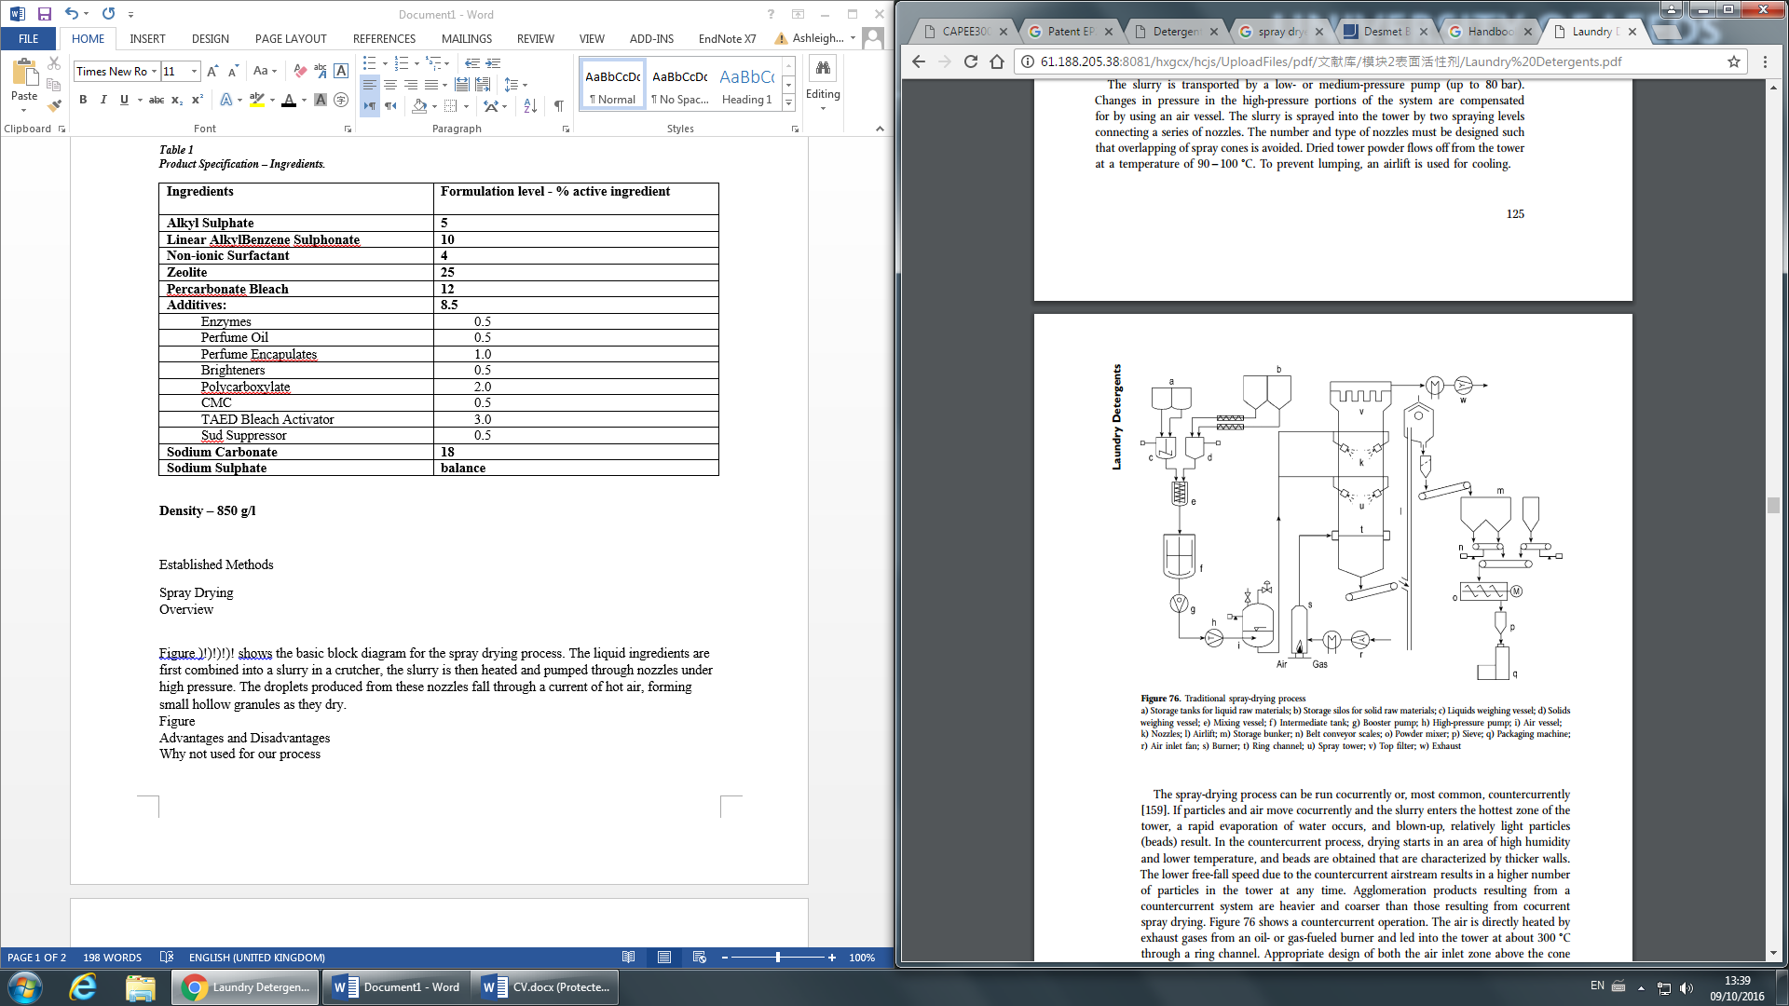
Figure 3.1: Traditional Spray Drying Process (Smulders, 2002).
a) Storage tanks for liquid raw materials; b) Storage silos for solid raw materials; c) Liquids weighing vessel; d) Solids weighing vessel; e) Mixing vessel; f ) Intermediate tank; g) Booster pump; h) High-pressure pump; i) Air vessel; k) Nozzles; l) Airlift; m) Storage bunker; n) Belt conveyor scales; o) Powder mixer; p) Sieve; q) Packaging machine; r) Air inlet fan; s) Burner; t) Ring channel; u) Spray tower; v) Top filter; w) Exhaust (Smulders, 2002).
The flow regime for spray drying is normally run counter currently with a flow of air due to the higher yield of granules. The granules also tend to have thicker walls and higher density (Smulders, 2002). In the spray drying unit the air is heated to 573K by burner exhaust gases. Water vapour expelled in rapid evaporation of the slurry, combustion gases and excess air are withdrawn from the tower by a ventilating fan (Smulders, 2002). The resulting particles are collected in a filter and taken out of the tower. Ingredients sensitive to the thermal conditions of the spray drying such as enzymes are added afterwards (Finnan, 1992). The advantages to spray drying are energy recover with heat exchangers using the exhaust gas energy. The exhaust air can also be up to 50% recycled and mixed with fresh air to achieve 10-20% energy savings (Smulders, 2002). The slurry composition used in spray drying is compatible with the design specifications shown in Table 1.
The process route, in isolation, generates a high porosity product of insufficient density and consequently large packing volumes that is not compatible with the process specification of 850 kgm⁻³ (see Figure 3.2) (Cahn, 1998). The process also has a high equipment cost due to the water removal, and the granules produced are typically of poor appearance (Goovaerts et al, 1996).
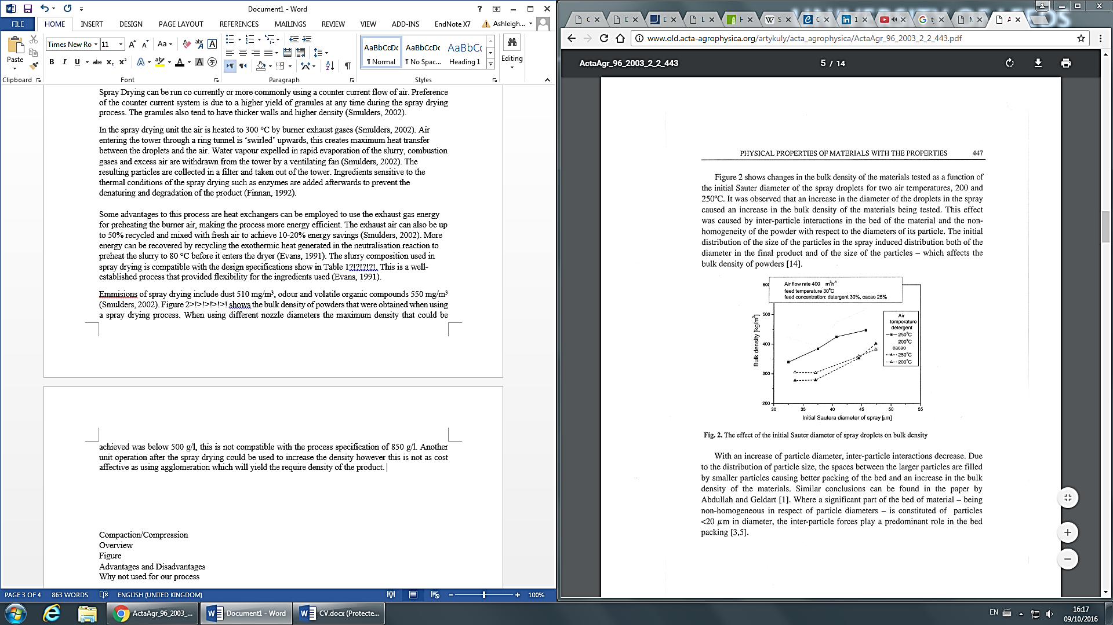
Figure 3.2: The effect of diameter of spray droplets on bulk density (Smulders, 2002)
Additionally, use of non-spray tower routes can result in energy (85%) and water (80%) savings. Producing powders with low water content increases the stability of ingredients and the high drying temperatures prohibit heat sensitive ingredients such as ethoxylated surfactants due to volatization of alcohols leading to high plume opacities (Cahn, 1998). The final reason that spray drying is avoided is due to the higher operating costs and VOC’s generated, which in the latter case are virtually eliminatedin non-tower routes (Cahn, 1998).

3.3 Alternative Processes

3.3.1 Extrusion
The extrusion process is a modern process to generate compact detergent powders. The technique involves extruding a plasticised mixture at 333K – 353K and 70 – 110000 kPa of the raw materials through small holes of 1.4mm diameter (Smulders, 2002). The unit operations are presented on the flow diagram in Figure 3. Lubricants are admixed to prevent abrasion of the metal surface and hence particles joining the product stream. The resulting uniform cylinders being extruded from the bore holes are then rounded in a spheroniser. Specialised knives are then rotated to cut the cylinders into fine particles (Smulders, 2002). A cooling step is the used to harden the particles, this leaves a finished product of almost completely uniform spheres.
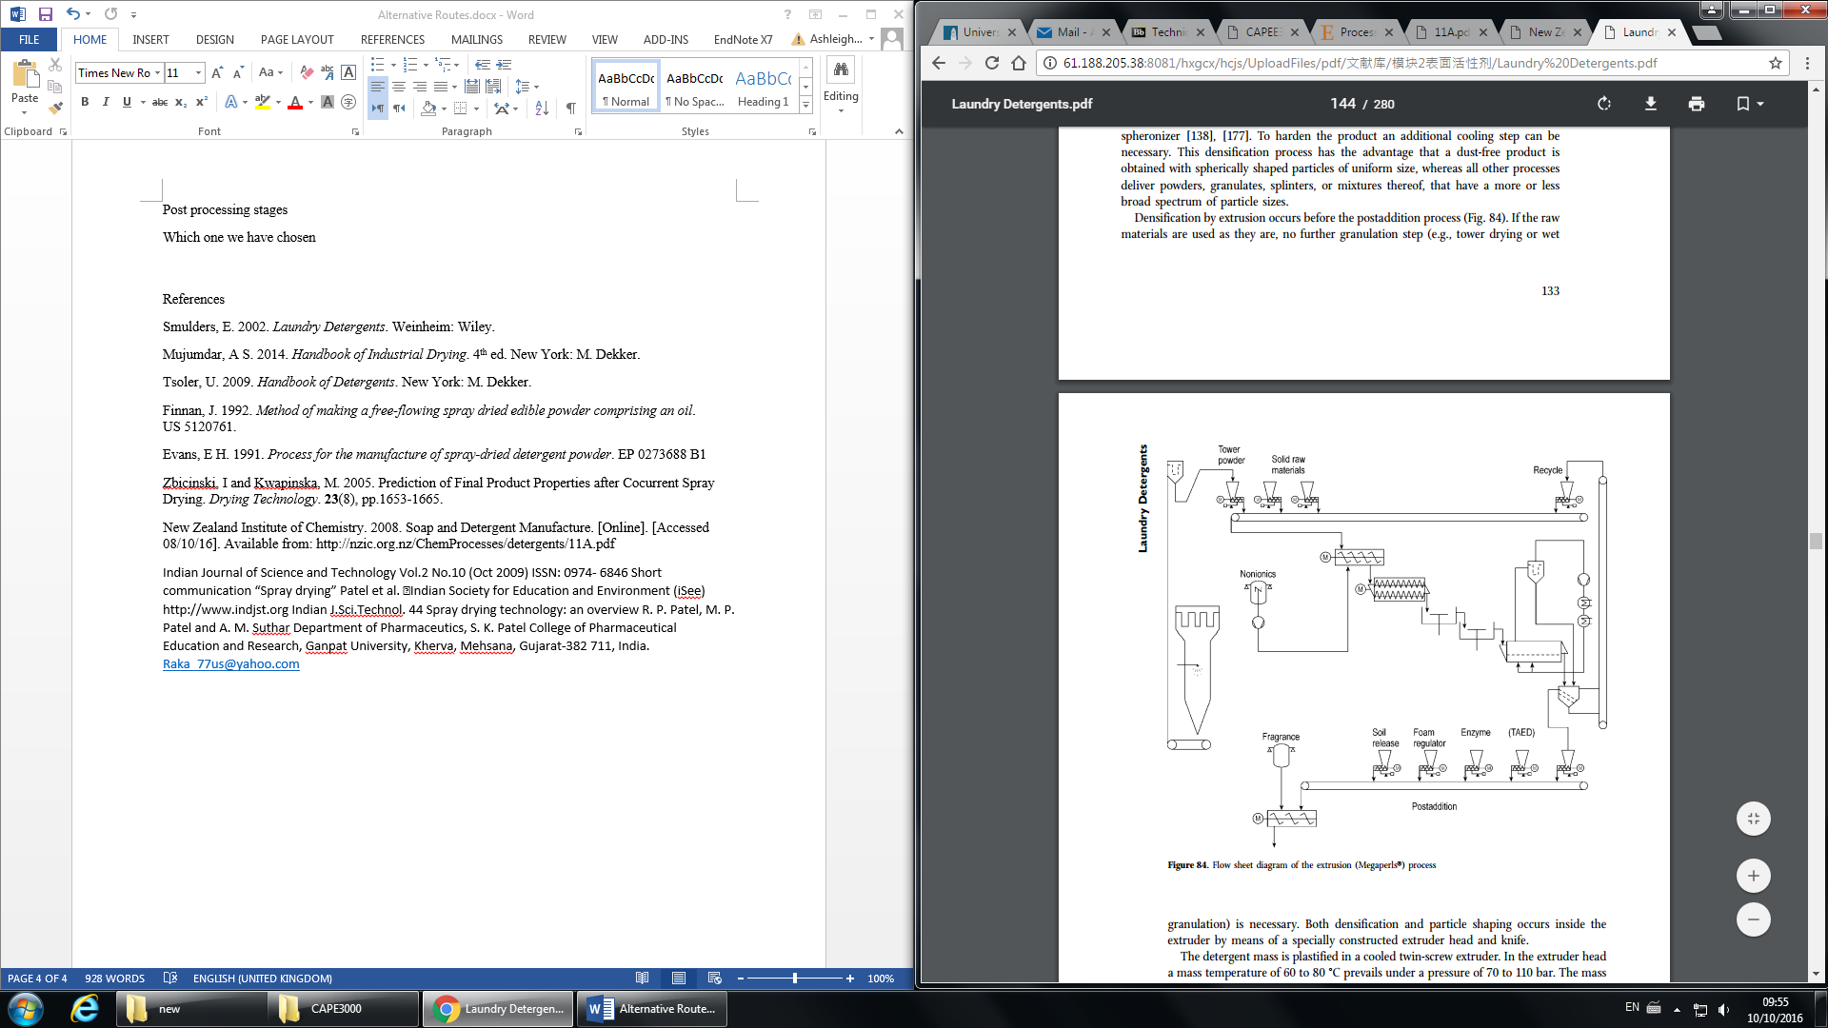
Figure 3.3: PFD Extrusion Process (Smulders, 2002).
The advantages offered by extrusion include no dust formation and good free-flowing characteristics. Typically, spaghetti extrusion is used to generate compact detergent powder of bulk density 1400 kgm⁻³, which exceeds the density requirement for the process specification (Smulders, 2002). The granules from the process have a particle size >.5mm diameter, due to the difficulty in manufacture of narrower size holes. Additionally, there is lack of reliable information on parameters necessary to achieve median particle sizes, shapes, densities etc. for extrusion processes (Salman, 2006).

3.3.2 Dry Mixing

Dry mixing is a process used where all the ingredients of the detergent powder enter a mill all in the solid state as a powder. This technique is incompatible for this process primarily because the raw materials do not all come in powder form. The primary anionic surfactant, LABSA, is delivered in acid form and powdered forms of the materials typically cost premium prices. The bulk density of powders produced from dry mixing are typically in the range of 650kgm⁻³ to 720kgm⁻³, which is insufficient for the product specification (Smulders, 2002).

3.4 New Technologies

The following describes a selection of innovations and process technologies that have not been implemented in industrial use, though are promising for future integration. The primary feeding mechanism for powders in the selected process is belt conveyors, and the rate of addition can significantly influence the agglomerate properties, particularly for low residence, high shear mixers. Hence accurate feed rate control is crucial for product quality. This can be affected when belt mis-tracking occurs and the conveyor goes out of alignment; Riccardi and Landry (2011) have invented a method that automatically adjusts mis-tracking. The innovations involves a sensor to detect the error and a motor to correct the alignment of the pulley using an automated controller. This can be used on a variety of conveyors that utilise belts and improve reliability of feed rates into the mixers.
Foam granulation is a relatively new technology used in agglomeration, this production method involves transforming the binder solution into a foam by mixing it with air. This foam is then dispersed via a pipe into the agglomerator while the powder is being mixed, this method of delivery means that selecting the right nozzle to disperse the binder is no longer a concern. With this process, less binder is required than in standard liquid dispersion which reduces raw material costs, furthermore less binder translates to less time drying and an increased production rate. Although Foam granulation yields a similar granule pore size and surface area to the traditional spray granulation method, it was found that other properties may differ such as a higher plasticity. Along with the common problems with new technology, such as a lack of studies and raw data which can affect the reliability of such a process. There is a further issue that main use of this process is within the pharmaceutical industry, therefore it is unclear how well this would carry over to produce detergent powder as most of the few studies that have been done would be geared towards the production of pharmaceutical tablets (Tan and Hapgood, 2011).

3.5 Process Route
NB: A process flow diagram for the selected process is provided in Appendix A for online submission, and is enclosed for the print copy.

3.5.1.1 Neutralization of LABSA with Na₂CO₃

The initial stage of the process is neutralization of the acid precursor (LABSA) in a high shear mixer. The LABSA is delivered to the site in a stable acid form (96% active), and stored in a heated storage vessel at 328K. The mode of heating is a warm water circulation jacket on the tank (De Groot et al. 1995). The acid is transported via stainless steel piping (which is trace heated at 313K) and through a positive displacement pump to the mixer, where spray nozzles atomize droplets into the mixer at 7000-10000 kPa (De Groot et al. 1995). In this design, all spray nozzles atomize at 7000kPa due to a reduction in liquid viscosity via trace heating. Typical mixers used for this neutralization include Lodige CB series mixers, Schugi Granulator and a Drais K-TTP 80 (Appel, 1994). The Na₂CO₃ powder addition acts as the neutralizer, and first micronized using a jet mill or micronizer with air to a mean particle size 5-10µm (ideally 1µm) to enhance the specific surface area and hence contact area for the reaction (Mort III and Sullivan, 2004). This also ensures that the agglomerate formed during the reaction has good flowability and is not too sticky (Mort III and Sullivan, 2004). The Na₂CO₃ is then transported via belt conveyor to the high shear mixer. Additionally, water is added via spray nozzle at 2-3 wt% of the LASBA to catalyse the reaction and enhance the rate of neutralization. This added water content must not exceed 10% as this can lead to gelling of the LABSA (Zoller, 2009b). The stoichiometry of the reaction is as seen in Equation 1(De Groot, 1991).
(3.1)

The Na₂CO₃ is fed in stoichiometric excess of at least 1:3.5, LABSA: Na₂CO₃ to ensure complete neutralization of the LAS acid. The reaction proceeds at a temperature of 328K, and due to the exothermic nature of the neutralization the mixer is operated adiabatically at this constant temperature (Mort III and Sullivan, 2004). The temperature selected ensures that the reaction is immediate, though it may be limited by diffusional effects such as reduction of contacting area of the acid droplet (Stepanek et al, 2011). The bulk of neutralization occurs in <1min (Zoller, 2009b) and typical residence times are in the range of 0.2-50s (Mort III and Sullivan, 2004). The residence time selected is 50s to ensure high conversion of the acid. The side product CO₂ is removed from the mixing tank via a vent, and has a negative pressure relative to the atmosphere to entrain the dusts by using a fan. This negative pressure is small, typically around 0.2kPa. The rate constant at 333K is given by Equation 2 (Stepanek et al, 2011).
(3.2)
The product from this stage is a primary agglomerate (dry, free flowing) with a typical bulk density of 500-800kgm⁻³ that is transported via belt conveyor into the medium shear mixer (Nitta, H et al, 2006). The extent of neutralization for the reaction may be determined offline by taking a sample of the powder, immersing it in nitrogen and using a methylating reagent (e.g. methyl tolyl trizaene (MTT)) with H-NMR techniques to determine the acid content (Appel, 1994). It is assumed that neutralization to have been at least 80% complete in the high shear mixer, and the remainder in the medium shear mixer (Mort III and Sullivan, 2004). Conversion estimates may be more conservative (~70%), but it is important that the acid is neutralized prior to post addition.
There a selection of design and control measures to ensure complete neutralization: stoichiometric excess of micronized Na₂CO₃, which is metered by a weigh belt feeder and a surge hopper to ensure consistent loading, high shear mixing to ensure the acid surface is exposed, water addition to catalyse the reaction and spray nozzles to ensure a fine LAS droplet size. Additionally, the operating temperature promotes mixing within the vessel by lowering the viscosity of the acid precursor (Stepanek et al, 2011).

3.5.1.2 Justification

The dry neutralization variant of the non-tower process is preferred due to its cost effectiveness and simple equipment use (Zoller, 2009b). Alternatively, the LABSA may be added in situ with the agglomeration/granulation stage as a single operation (e.g. Kettemix) (Goovaerts et al, 1996). This generates a high density granule for lower shear conditions and lower temperatures. However, there are process control challenges associated with this route. In particular, the exothermic nature of the reaction limits the rate of addition of LABSA, as well as possible clumping of powder due to the formation of hot spots within the mixer. The specification highlights the need for a “white, free flowing, dust free and quick to dissolve”, and un-neutralized acid can lead to discolouration of the final product, excessive agglomeration, degradation of the perfume odour (in post addition) and poor granule strength (Salman et al. 2006). The use of spray nozzles allows for a uniform droplet size that promotes growth of a spherical agglomerate (Goovaerts et al, 1996).

3.5.2.1 Medium Shear Mixing and Agglomeration
The neutralized LAS (NaLAS) intermediate with sodium carbonate is transported via belt conveyor into a medium shear mixer (typically a Lodige KM ‘Ploughshare’) (Appel et al, 1994). The liquid addition, alkyl ethoxylate, is stored at 313K to prevent solidification and transported in a trace heated pipeline to the medium shear mixer, where it is sprayed via nozzle (De Groot et al, 1995). The material is hygroscopic and hence a desiccant is added in the tank vent to prevent moisture ingress. The alkyl sulfate is unstable in acid form and is supplied as the neutralized powder (sodium lauryl sulfate) and fed via screw conveyor (to enhance mixing) into the mixer with other powder ingredients (De Groot et al, 1995). Other components included in the powder addition include sodium sulphate and zeolite. Additionally, a powder recycle stream consisting of fines and coarse granules are used for process control and waste reduction; water is added as an additional binder. These can be varied without altering the formulation specification and water is easily removed via the dryer (Zoller, 2009b).
The mean residence time for the mixture in this stage is 10 minutes (Mort III and Sullivan, 2004). It operates in a temperature range of 20-70ºC to promote agglomerate coalescence. The selected temperature is to operate at 323K. The desired median particle size for the agglomerate for this stage are in the range of 400µm - 500 µm (Zoller, 2009b), alternatively 400µm - 1000µm (Mort III and Sullivan, 2004). The proportion of particles should not exceed 5% (due to dustiness) and in the former case should not exceed 2% above 800µm (Zoller, 2009b).

3.5.2.2 Agglomeration and Product Quality

The product specification requires a bulk density of 850kgm⁻³ of a white, free flowing powder that is dust free. The bulk density is a function of the following in Equation 3.3 (Zoller, 2009b):
(3.3)
The density and porosity are inversely proportional, and may be characterised via an Instron compression test (for the bulk modulus) prior to the drying stage (Appel et al, 1994). As shown in Figure 3.4, a bulk density of >850kgm⁻³ is achievable for a particle porosity ε_{p} ≤ 10%. For a 500 µm particle, the bulk porosity of the powder ε_{b} is ideally in the range of 0.38 – 0.45, dependent on particle sphericity (De Groot et al, 1995). The shape of the particle influences the packing effectiveness and is optimally a perfect sphere (sphericity = 1). To achieve this, the spray nozzles ensure a uniform LABSA shape and size at the start of agglomeration. Additionally, high energy input per kg of powder using high shear mixing also promotes spherical particles and ‘squeezes out’ porosity (Zoller, 2009b). The following figure shows the bulk density as a function of particle porosity, with a value of 960kgm⁻³ achieved at a sphericity of 1.2 (De Groot et al, 1995).
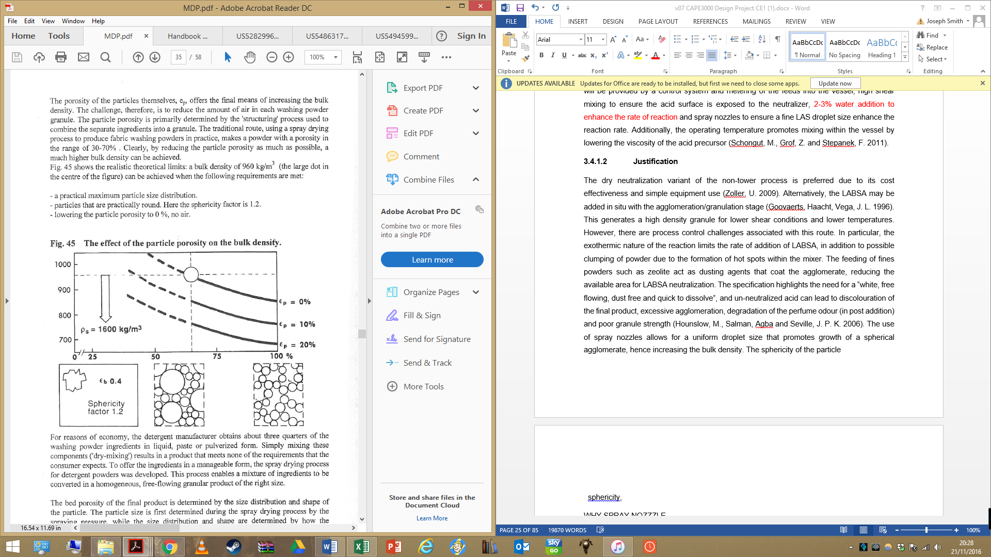

Figure 3.4: Bulk density of powder as a function of particle porosity, ε_{p} (De Groot et al. 1995)
The stickiness of the agglomerate influences the packing of the powder, and a high stickiness is associated with low bulk densities and poorly neutralized LABSA. The stickiness can be managed by addition of zeolite or other dusting agents (e.g. fines) which coat the agglomerate surface and limit coalescence. This also leads to a reduction in the median particle size. In the medium shear mixer, the coarse granules are separated by a sieve and ground with a rod mill before adding into a recycle stream. The coarse grains act as cores to promote growth of the agglomerate, and fines are also recycled to manage the particle size distribution (Zoller, 2009b). To monitor this process, optical granulometry or laser diffraction may be used to determine the particle size distribution (York, 2003) (Nitta, H et al, 2006). The flow ability of the powder may be determined by an empirical measures such as the Hausner ratio, given as the following function shown in Equation 4.3 (York et al, 2003).
(3.4)
Where: ρ_{tapped} = tapped density, ρ_{bulk} = bulk density
A ratio value of ≤ 1.11 indicates excellent flow ability, with increased values corresponding to poorer flowability. The equipment to characterise this property is simple and can be taught to operators within the plant (York et al, 2003). The regime for agglomeration is given by Figure 3.5, and is a function of the deformability of the powder stream and the pore saturation. The pore saturation is given by Equation 3.5 (Zoller, 2009b).
(3.5)
Where w = mass ratio of liquid to solid, ρ_{s} and ρ_{l} = density of solid and liquid, respectively, ε_{min} = minimum porosity of granule
The growth of the granule can be managed by increasing the pore saturation with binder, in this case water or coarse granules. Steady growth is linearly related to time, hence increasing the residence time in the medium shear mixer can also be used to alter agglomerate properties. Induction growth occurs with poor deformable or strong granules, and may lead to rapid growth as binder is moved to the surface (Nieuwmeyer, 2009). The deformation number if given by Equation 3.6 (Zoller, 2009b).
(3.6)
Where: ρ_{g} = density of granules, U_{c}² = collision velocity in mixer, Y_{g} = dynamic yield stress
A free flowing powder is achieved by minimising the pore saturation and maximising the deformability of the mixture, though effective binding of the granule requires nucleation and growth before ending as a dry powder (Nieuwmeyer, 2009). Overwetting can be remediated through the use of recycled fines to reduce pore saturation (Zoller, 2009b). Temperature may also be varied to enhance agglomerate coalescence (see Figure 3.5).
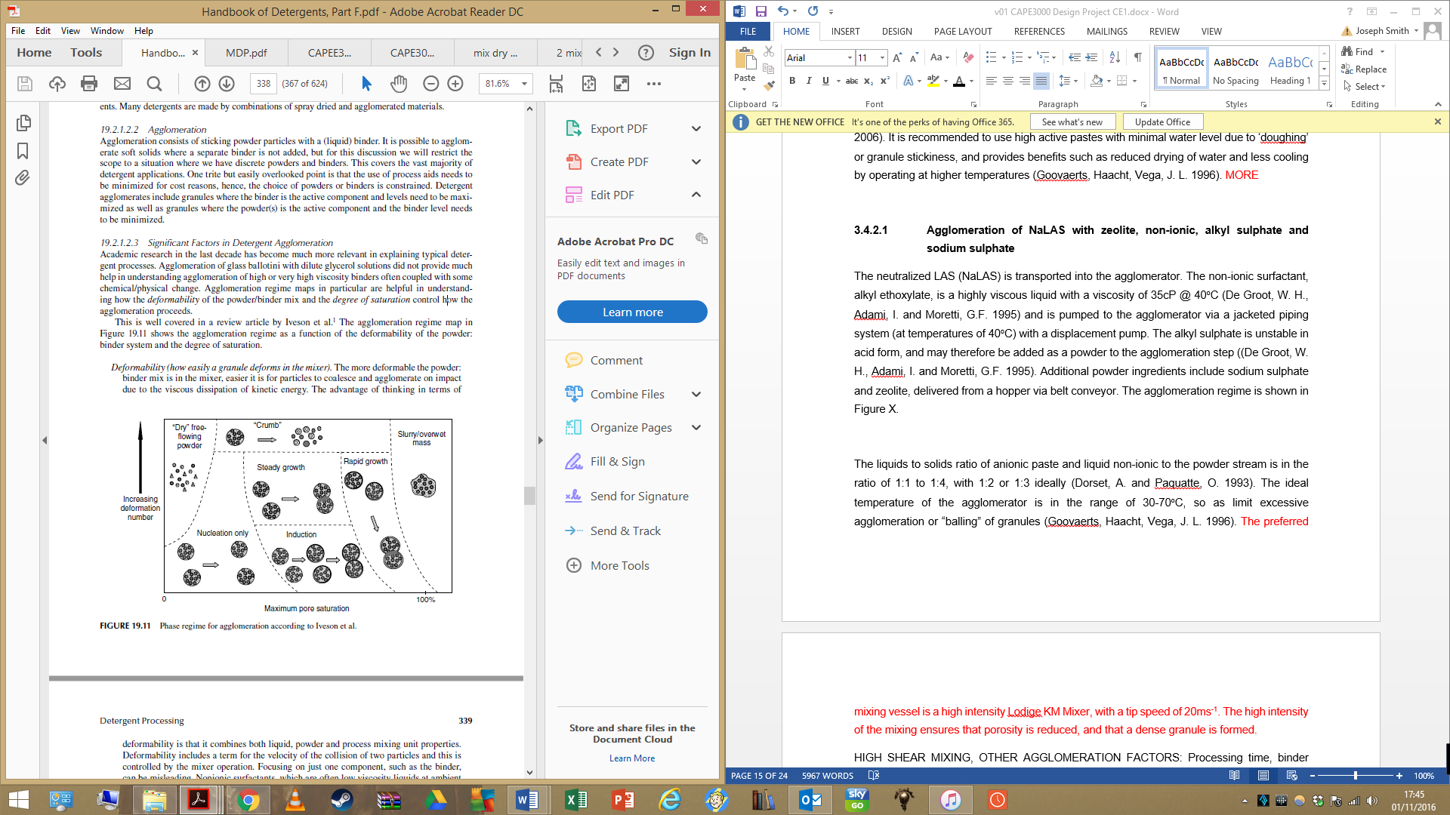

Figure 3.5: Regime for agglomeration as a function of pore saturation. The ordinate may also be considered as decreasing binder viscosity and the abscissa as binder amount (Zoller, U. 2009).

3.5.3.1 Drying and Cooling of the Product

The agglomerates are then fed via a belt conveyor into a fluidised bed dryer. Air is heated to 408K at the entrance and blown onto the powder to remove excess moisture, and the agglomerates are cooled via a cold air stream in a separate unit at 278K (Goovaerts et al, 1996). The smaller fines are extracted by a fan into a hydro cyclone, where 95% of water and fines are removed and added into the recycle stream. The remainder is fed into a bag filter where air is removed, and these fines are added into the agglomerator. The underflow from the cyclone is also deposited into a hopper with coarse agglomerates that are reduced in size via a rod mill post-cooler. The cooled agglomerated powder is classified in a vibratory sieve; a parallel wire sieve may also be used.

3.5.3.2 Justification

The fluidized bed dryer is ideal for particle sizes in the range of 50-2000µm, and provides high rates of moisture removal, low maintenance cost and high thermal efficiency (Mujumdar, A. S. et al. 2006). In this design, the dryer is necessary if additional water binder is added and cooling reduces the temperature of agglomerates prior to the post addition mixer. This is due to the moisture and temperature sensitivity of the additives and percarbonate bleach (Smulders, 2002). The use of fluidized bed for drying increases the flexibility of process, as water can be used as an additional agglomeration parameter (Mujumdar, 2006).

3.5.4 Post-Addition Mixer
The dry agglomerates are transported via belt conveyor into the post addition mixer. The post addition ingredients are either pumped in liquid phase or transported in powder form via belt conveyor into the post addition mixer. The large number of dry additives supports the use of a single feeder, which simplifies the plant design and allows layering before addition into the mixer (Zoller, 2009b). The mixer is a drum mixer sized appropriately to allow the liquid ingredients, which are sprayed via nozzle, to age and absorb into the powders. This prevents caking of the finished powder. The spray angle of the nozzle will be sized to prevent spraying the drum wall and hence product build up (Zoller, 2009b). Baffles are included on the drum wall to enhance mixing (Showell, 1998). Finally, extraction fans are situated at the inlet/outlet of the powder addition to minimise flammable atmospheres (De Groot et al. 1995).

3.5.5 Particle Classification
Particle sizing is to be achieved through the use of a mechanically vibrating sieve tower with the use of elliptical movement to improve separation and reduce blockages. The unit will consist of 3 decks to screen for particle sizes between 0.2-1mm, hence coarse particles shall be removed on deck 1 whereas fine removal will be achieved at the base of unit. The stated decks are to be sloped to increase the screening capacity per unit area (Morgenson, 2016). A rod mill is included to reduce the particle size, some coarse are recycled to the process and the correct size are fed into the post addition mixer. The cyclone for fines removal < 100 μm may be designed and influences the size and gas velocity. Efficiency can be increased at the cost of pressure drop within the gas stream. Typically, the specific capacity of the separator is determined, therefore restricting the chamber diameter. A phenomenon is also observed in industry in which the relative pressure drop declines for a higher loading and efficiency, up until 3 kgm⁻³. After, pressure drop increases with loading (Perry and Green, 2008).

3.5.6 Powder Handling
The primary mode of transportation for the powder materials is via belt conveyor. These are selected over alternatives such as screw and pneumatic conveyors as these exert a great deal of force on the granules which can reduce the size by up to 25% and produce a great deal of fines (Salman et al, 2006). Additionally, belt conveyors are highly versatile and are commonly used (Shamlou, 1988) which ensures adequate data, designs and consultancy for conveying materials are available. They are suitable for a wide variety of materials as long as the temperature is under 393K, and belt speeds of up to 2.7 m/s are possible which can transport 4400 t/hr (Shamlou, 1988). A single screw conveyor is used for powder premixing prior to the medium shear mixer, as this includes a high quantity of different powder ingredients (e.g. zeolite, sodium sulfate etc) and ensures good mixing.

4 SAFETY, HEALTH AND THE ENVIRONMENT

4.1 Background
This section details the main health, ecological and safety issues associated with detergent manufacture via agglomeration. A selection of operational controls are provided to manage the process safety of the plant, which includes handling and transportation of raw materials and recommended extrinsic safety controls in the event of equipment failure. The primary environmental concern from detergent manufacture is associated with surfactant releases, due to their surface active properties and eco toxicological effects (Smulders, 2002). The legislative standards for surfactant concentration limits are detailed based on the lethal concentration to kill 50% of an exposed sample size (LC₅₀) and biodegradability of the species. The toxicological data for all detergent ingredients used in the process are presented in Table 4.1. Other pollutants generated from the process include volatile organic emissions, though these are typically low for agglomeration techniques (Cahn, 1998), and dust releases. The particulate emissions are minimised via internal recycle streams using solids separation equipment such as hydro cyclones and filters, and appropriate dust control measures are detailed (Zoller, 2004b).

4.2 Material Transport and Handling

4.2.1 Anionic and Non-ionic Surfactants
The process uses Linear Alkyl Benzene as a major active ingredient in the detergent powder. The acid precursor may be stored for long periods due to the stability of the sulphur-carbon bond, and presents a high degree of biodegradability (>99% primary biodegradation based on OECD test methods) (Zoller, 2004a) (Farn, 2006). The corrosivity of LAS is similar to that of concentrated sulphuric acid (~2 – 3 pH, depending on composition) (BASF, 2012) and hence must be stored in stainless steel AISI 304 or 316 storage tanks or mild steel tanks with an epoxy phenolic internal lacquer to prevent corrosion and discolouration of the end product (De Groot et al, 1995). Moisture ingress into the tank must also be minimised to limit degradation of the acid. For transportation from the storage tank to the neutralization vessel, it is recommended to use stainless steel piping. All shaft seals, gaskets and flanges should be acid resistant and prevent leakage when transferring from pumps (De Groot et al, 1995).
In the event of leakage or spillage, bunding may be installed around the storage area sized to 110% of the largest tank and composed of an acid resistant material (e.g. brick) (Health and Safety Executive, 2003). Additionally, overfill protection via a high level alarm may also be fitted to alert operators or shut down filling pumps (Health and Safety Executive, 2003). Operator contact with the acid should be minimised as it is a persistent eye and skin irritant, and in cases where splashing or contact may be possible (tanker unloading or equipment cleaning), protective eyewear, apron and gloves should be provided. A washing station should also be situated close to the unloading area (De Groot et al, 1995). LAS acid has been determined to have no carcinogenic or mutagenic effects over long term exposure (Zoller, U. 2004a).
The supplementary anionic, alkyl sulphate, is delivered as a neutralized salt powder. It presents a skin and eye irritation hazard and therefore PPE must be worn by operators in close contact. The non-ionic, alkyl ethoxylate, is also a mild irritant in its pure form; the same PPE procedures apply. The storage temperature for alkyl ethoxylate with C₁₄₋₁₅, 7 EO is less than 50ºC and due to the hygroscopic nature of the material, a desiccant may be used in ventilation to prevent moisture pickup (De Groot et al, 1995).

4.2.2 Other Detergent Ingredients
The powder ingredients are all stored in mild steel tanks prior to addition in the agglomeration stage. The neutralization agent, sodium carbonate, is delivered in a ‘light’ form to enhance the contact area of reaction and does not pose significant explosion or fire risk. However, nuisance dusts may occur and can be a mild eye and inhalation irritant (Fisher Scientific, 2009). The powder is also mildly hygroscopic, so moisture ingress must be minimised as this can lead to caking and lumping that limits the effectiveness of neutralization (De Groot et al, 1995).
The primary builder, Zeolite A, replaced conventional phosphate builders due to eutrophic effects during wastewater discharge. Comprehensive analyses of Zeolite A toxicology have determined that it has no sensitization or irritancy properties from inhalation or skin contact (Zeodet, 2000). It can, however, be a nuisance dust and thus it is recommended that operators wear inhalation protection in areas where occasional contact is expected (De Groot et al, 1995). Additionally, it was found to have no acute toxicological effect if ingested. Long term contact does not lead any carcinogenic, mutagenic or fibrogenic properties (except in the case of erionite, a natural zeolite) (Zeodet, 2000). For effluent discharge, Zeolite A does not detrimentally affect aquatic life or the performance of sewage treatment of waste water (Zoller, 2004a). The filler, sodium sulphate, has similar irritant properties to sodium carbonate, and will form hydrates and cake if exposed to moisture below 305K. Storage in mild steel tanks with desiccants situated near ventilation or points in contact with the atmosphere is recommended (De Groot et al, 1995).

4.2.3 Additives, Enzymes and Hygienic Design
The moisture and temperature additives are post mixed into the agglomerated powder. The foam regulator (Polydimethylsiloxane) is not biodegradable, however it strongly absorbs onto sludge’s during waste water treatment and hence it not present in any appreciable quantity in the environment. In the event that waste water sludge’s containing the silicone fluid are used for soil treatment, the material is decomposed by photocatalytic degradation. They also do not bio accumulate and have a low aquatic toxicity (Smulders, 2002). Perfume fragrances are a complex mixture of different compounds with varying properties. The formulations tend to be highly absorptive and volatile, and present in low quantities that mitigates any toxic effects (Smulders, 2002). However, particular chemicals are avoided, including; nitromusks such as benzoid chemicals due to their neurotoxicity and polycyclic musk’s (galaxolide) due to bio accumulation issues. A full list of banned or restricted materials is provided in the International Fragrance Association Code of Practice for the Fragrance Industry (IFRA), in Annexes II & III of the Cosmetics Directive (International Fragrance Association (IFRA), 2006).
The remaining additives; TAED, Optical Brighteners, Polycarboxylate and CMC are all mild irritants for the eyes, skin and lungs if persistent contact is maintained. These effects can be minimised via good ventilation of the plant area, and during operator handling it is advised to include an enclosure to minimize potential dust releases (Zoller, 2004b). The aquatic toxicity of these additives is provided in Table 4.1. Sodium percarbonate bleach provides a slight toxicity from contact, due to the alkalinity of the powder. They will decompose at temperatures >298K with free moisture, hence storage temperatures should be below this limit and the relative humidity below 60%. It is recommended to store the bleach in a chemically inert and water tight material such as PVC, resin coated surfaces, glass or stainless steel. Extensive decomposition of the powder in storage can lead to high volumes of heat evolved, in addition to oxygen and steam. It is therefore advisable to minimise flammable materials in the vicinity of the storage vessel, and avoid dust formation due to potential explosions (De Groot et al, 1995). Contact with organic material can cause spontaneous ignition and should be avoided.
Enzymes are proteins used for the breakdown of soils in the detergent powder formulation. They are potential sensitizers for operators if the polymer coating is broken, generating an allergic response similar to hay fever if inhaled (Smulders, 2002). Respiratory equipment is recommended to minimise inhalation, and dust formation can be minimised through effective ventilation (AISE, 2013). To minimise potential bacterial growth of enzymes, stainless steel vessels should be used with protective seals. A regular cleaning regime must be established for storage vessels of no greater than 30 days. The geometry and surfaces for enzyme storage should have no metal-to metal contact other than welding, and potential growth sites such as crevices must be avoided (AISE, 2013).

4.3 Process Safety

4.3.1 Dust Control and Explosion Protection
The feed systems to the mixers should be fully enclosed to prevent the release of any dusts. The materials used throughout the process are irritants due to both inhalation and skin irritation, therefore contact should be minimised where possible. In the post addition mixer, a rotary drum is used which sprays liquid ingredients on the agglomerated powder (Zoller, 2004b). The powder inlet and outlet points should be provided with extraction fans to prevent formation of flammable atmospheres. Similarly, the spray nozzle and powder environment inside the drum may also potentially cause a flammable atmosphere, and it is recommended that some basic explosion safety installations are included such as relief panels, a water deluge system and fire extinguishers. For addition of builders, filler etc., the belt conveyor is sealed and powders charged into the mixer. The plant itself should be well ventilated to eliminate dust build up (Zoller, 2004b). Smaller additions such as additives may be delivered from bags by operators – in this case, dust extraction equipment should be added to all hoppers. Earthing of hoppers/bins should be included in all cases of powder addition to prevent static build up and hence ignition (De Groot et al, 1995).
The neutralization reaction is highly exothermic, and operates adiabatically at a temperature of 328K. It is advisable to include adequate process control measures that automatically stop pump feed of the acid beyond a particular temperature threshold, and to control the rate of addition into the vessel (Health and Safety Executive, 2003b). Additionally, relief venting should be installed to discharge material safely and prevent build-up of pressure that could lead to tank rupture. Other alarms and trips could be installed to alert operators, creating redundancy in the case of failed automatic systems (Health and Safety Executive, 2003b).

4.3.2. Health and Safety Legislation and Training

The manufacturing site is situated in the Czech Republic, and hence is subject to EU Directives and legislation on worker safety. The national legal framework for occupational health and safety within the Czech Republic is covered by the Labour Code (Act No. 262/2006 Coll.) Part five and incorporates the EU Council Directive 89/391/EEC for worker health and safety (OSHA Europe, 2016). Several pertinent laws are listed below:
EU Directive 89/391/EEC – Occupational Health and Safety Framework
This directive provides general guidance and provision for all workers within the European member states. This includes protection of works against accidents, diseases or other risks associated with an operation. There are provisions for risk assessment of operations and appropriate mitigation or elimination of these hazards. Operators must be made aware by employers of risks associated with a process, and it is an employee obligation to inform employers of hazards with a nominated representative (OSHA Europe, 2016).
EU Directive 98/24/EC – Risks related to chemical agents at work
The directive dictates for employers/companies to adhere to the occupational exposure limits for particular chemicals, provide adequate handling information for employees and appropriate measures to remediate any accidental releases (OSHA Europe, 2016).
EU Directive 99/92/EC - Risks from explosive atmospheres
This directive establishes the management of flammable atmospheres and the ATEX rating system for potential ignition sources. This includes protection systems and employee education on explosion awareness and procedures (OSHA Europe, 2016).
EU Directive 89/656/EEC - use of personal protective equipment
This directive obligates employers to assess the risks of particular processes and to provide the appropriate PPE such as hard hats, gloves and overalls, safety footwear for minimising static build-up and other protection (OSHA Europe, 2016).

4.4 Process Emissions

4.4.1 Ecotoxicology and Biodegradability of Surfactants
The ecological impact of detergent powder emissions is primarily concerned with the concentrations of surfactants present, due to their surface properties and degradation products. The toxicity of surfactants is derived from its presence in the cell membrane, where it disrupts processes such as energy metabolism and movement of nutrients across the cell membrane. The hydrophobic component of the surfactant (alkyl chain) dictates the disruptive effect of the surfactant within the cell membrane, and is correlated to an increased chain length (see Figure 4.1) (Cowen-Ellsberry et al, 2014).
The biodegradation of surfactants occurs as a result of microorganisms transforming the parent pollutant into simpler compounds. The degree of biodegradation may be classified into primary biodegradability, where the chemical structure of the surfactant changes and subsequently the surface active properties of the surfactant are lost (Farn, 2006). Most aquatic life cannot withstand concentrations of detergent exceeding 15 parts per million, fish eggs and other fragile life forms suffer fatalities at as little as 5 ppm (Cowen-Ellsberry et al, 2014). Ultimate biodegradability is the total breakdown of the surfactant into carbon dioxide, water, mineral salts and biomass (Farn, 2006). The concentration of surfactant present is tested experimentally using the ‘methylene blue’ test (MBAS) for anionic surfactants and bismuth (BiAS) for non-ionics (Zoller, 2004a).
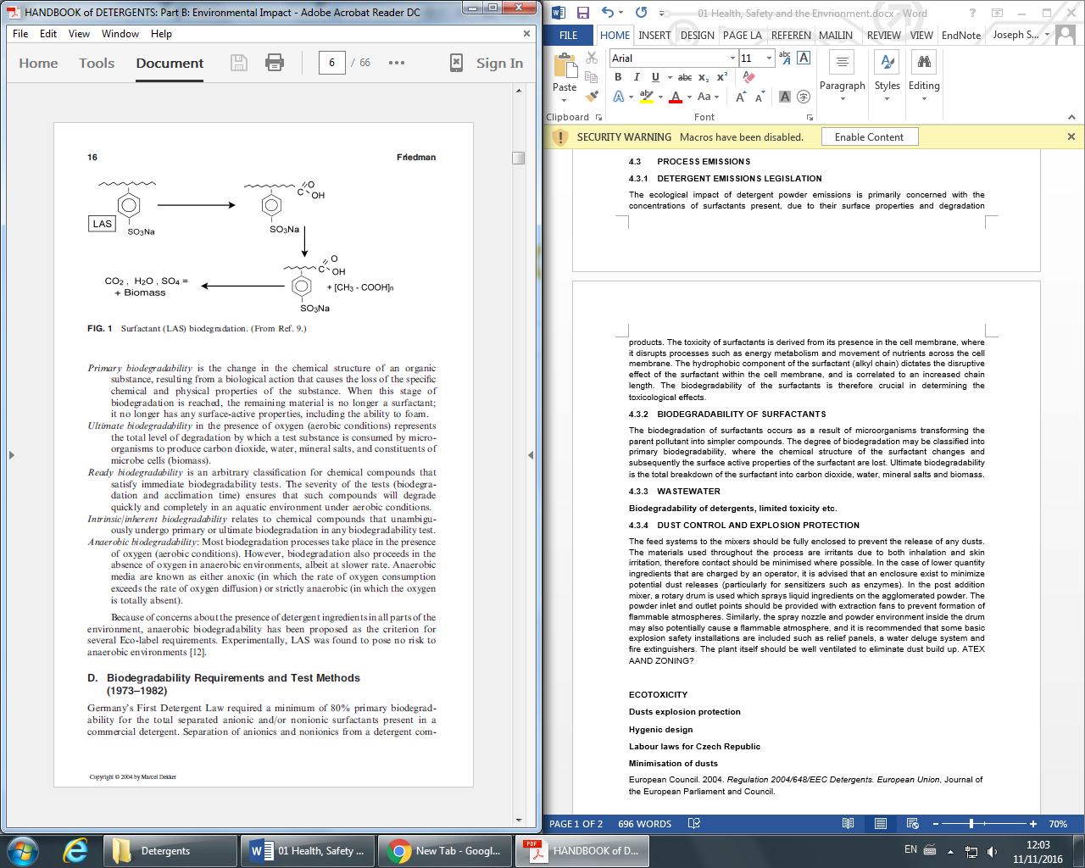

Figure 4.1. Surfactant LAS degradation reaction pathway (Zoller, 2004a)

4.4.2 Detergent and Dust Emissions Regulation
The criteria for the biodegradability of detergent emissions in the European Union is stipulated by EU Directive 648/2004/EC in Annex III. The regulations state an ultimate biodegradability of >60% within 28 days based on a number of standard tests (European Council, 2004). A compiled list of these criteria for all ingredients used in the process, in addition to the acute toxicity, is provided in Table 4.1. The sensitization of workers from enzymes dusts is to not exceed 3% of the workforce per annum, and the Occupational Exposure limit is 60ng/m³ for a one hour sample, based on the Subtilisin (a class of proteolytic enzymes) (AISE, 2013). For general dust emissions, the concentration in air should not 5x10⁻³gm⁻³ of air (De Groot et al, 1995).
 | Biodegradability |  | Acute Toxicity (EC/LC₅₀) (mg/L)
Chemical | Primary Degradation (OECD Screening Test % Removal | Ultimate Degradation  Coupled Units Test, % C removal | Fish | Daphnia
LAS | 95 MBAS | 73-82 | 2.9 | 4-6
Non-ionic  From C₁₂₋₁₈, EO ₇₋₃₀ | 99BiAS | 89-96 | 3.5 | 16
Zeolite A | >95% removal at sewage treatment by mechanical and biological means |  | >250 | >250
Polycarboxylates | >90% removal at sewage treatment by mechanical and biological means |  | >200 | >350
Sodium Carbonate | - | - | >200 | >260
TAED | >95% removal at sewage treatment by mechanical and biological means |  | >1000 | >800
Enzymes | Loss of 99% of proteolytic activity in model sewage treatment |  | 25-350 | 160
Sodium Percarbonate | - |  | 200-740 | 265-565
Optical Brighteners | Removed >90% in sewage treatment, not biodegradable |  | >320 | >1000
CMC | Zahn-Wellens test, only 40% removal |  | >1000 | >1000
Sodium Sulphate | - |  | >1 | -
Table 4.1. Compiled eco toxicological and biodegradability/sewage removal of detergent compounds (Smulders, 2002)

4.4.3 Carbon Dioxide Emissions Regulations
The main source of carbon dioxide emissions in this process is from the combustion of fuel to produce heat for streams in this process such as air, alkyl ethoxylate and the agglomeration unit. Carbon dioxide produced the neutralisation reaction is negligible compared to that produced from fuel (Zoller, U. 2004b). New technologies have been developed in an attempt to minimise these emissions. The ‘Downflow Gas Contact Reactor’ converts the CO₂ into sodium carbonate, a raw material in the detergent making process, by treating it with soda ash (Erguney, 2015). This process could be potentially used in the detergent powder plant if our capacity exceeds more than the current 60,000 tonnes per year it is currently operating at.

4.4.4 Plant Automation and Operator Training
The operators and technicians should have a familiarity with HMI’s and SCADA systems used in the plant. For example, the system should give real time information on stock levels for hoppers and storage vessels and alert operators to stock depletion. Similarly, the system should also provide information on equipment status and diagnostics (e.g. valve open or closed) to aid in troubleshooting. The machines should also have a cascade of access, for example a technician or OEM should be able to alter more functions in the control setup than a shift operator. This ensures that if product specifications are not met, accountability for changes can be traced to individual persons. In the formulation specification is changed (i.e. different brand or region), then a formulation specification can be installed in the system that informs operators of the correct material dosages (Schneider Electric, 2012).

5 PROJECT MANAGEMENT

5.1 Background
The stated deliverables for the project are a full, detailed process for the manufacture of detergent powder and consideration of all design factors, including raw material sourcing, environmental impact and full material and energy requirements. Additionally, the project was required to present a full description of the process and calculation assumptions to the project consultants and to also develop a Process Integration model for efficient use of energy within the plant. These objectives were achieved through a clear delegation of duties, with accountability to a particular work stream, consistent communication between members on technical and logistical items and repeated revisions, challenges and updates to the current body of work to identify weaknesses and improvements. The following describes the key milestones and work streams of the project, the distribution and scheduling of tasks and the mitigation of any identified risks.

5.2 Delegation and Scheduling
The first week of the semester was used to develop a Project Manager rota, which would rotate every two weeks. The style of each nominee was different, but basic duties such as supervisor communication, minute taking and scheduling were required. This rota was as follows:
Table 5.1: Project manager rota
Project Manager | Duration
Not Allocated/Carl Jackson | 26th September – 2nd October
Carl Jackson | 3rd October – 16th October
Joseph Smith | 17th October – 30th October
Ghulam Qureshi | 31st October – 13th November
Adi Ab Fatah | 14th November – 27th November
Ashleigh Buck | 28th November – 9th December
The project milestones, work streams and duties were tracked in a Gantt chart (see Figure 5). This was continually revised to provide an up to date view of duties and whether key milestones were expected to be met. As shown, the project manager duties and any meetings (technical or with the group supervisor) were logged at the top of the Gantt chart. The key work streams were logged on the left side of the chart, which were then sub divided into smaller allocations of particular tasks. The anticipation of the group members was to have a completed draft report with all sections by 18/11, which would then be subject to revision and scrutiny in the final weeks of the project. This also allowed a buffer for other project work such as the Pinch Analysis.

Figure 5: Semester 1 Gantt chart

5.3 Key Milestones, Project Timeline

The logistical duties of the project included minute taking of meetings, formal meetings with the project supervisor and meetings with the technical consultants. In the latter case, the group collaborated on questions and gaps in knowledge prior to these meetings to optimise the information received. Additionally, it was agreed that during these meetings minutes would be distributed so that comprehensive coverage of all the consultant’s points could be taken. The delegation of project manager and the first iteration of the Gantt chart were both completed to the expected dates, as these were simple duties. In the case of the process flow diagram, another key milestone, one group member voluntarily worked on AutoCAD to develop a first draft. It was also anticipated that these skills would be required for continual updating of the PFD, and in semester 2 the P & ID, so this work stream was managed by a single member with feedback and comments provided by other team members.
The process route selection was the key deliverable for the first three weeks of the project. All group members individually researched the process options available and considered the risks and benefits of each. This was followed by extensive discussion and final alignment on the desired process route of agglomeration. Due to the interlinked nature of the report, the raw materials section of the report was developed early by one group member to understand the ingredient forms, properties and interactions. This research, with the collated information on the process route via patents and literature, formed the basis of the Process Flow Diagram. The diagram was developed using AutoCAD and a feedback session was scheduled with a technical consultant for clarity on knowledge gaps and recommendations. This also formed a pseudo-deadline for delivery of this key milestone.
During the technical consultancies, further gaps in our knowledge were made clear, such as how fines were dealt with, the effect of water content on agglomeration, particle size distribution etc. Each group member was tasked with investigating one of these problems and adding it to the process route selection section. The process route selection was completed on the 14 October, with a feedback session scheduled with the 26/10/16 to update both the project supervisor and module leader. The outcomes and points raised during this meeting fed back into the Process Route revisions. A final update of the process route occurred during the w/c 21/11, given the Mass and Energy Balance feedback.
The material and energy balances were started by simplifying the overall process flow diagram to a series of unit operations, and providing stream tables. Following this, several meetings were scheduled with all group members to understand the basis for the calculations, and to include any design criteria (such as moisture content of the detergent powder) into the calculations (using Excel). The raw material compositions proved instrumental in defining the calculations and managing the water content of the detergent powder. For the material, as in the case of the energy balance, all formulae were developed in excel and a standard table of assumptions collated. These assumptions are provided in the M & EB section of the report. As the calculations increased in complexity, the group sub divided into two teams: one team refined the material balances (particularly the separations) and another collated thermodynamic data and developed the energy balance on a kJmol⁻¹ basis. The material balance was subject to a feedback from a detergent technical consultant, where key assumptions such as binder content and extent of reaction were discussed. A further feedback discussion was scheduled with Dr. Borrisova, for common sense checks (i.e. are masses equal?) and clarification on energy balance issues.
The week commencing 07/11 was used for allocation and development of the final sections of the report, such as the project management and safety, health and environment portions. It was decided that providing full responsibility to an individual member would yield better results and optimise the available time. These allocations are shown in Table 5.1 and within the Gantt chart. The smaller remaining work streams (e.g. introduction, nomenclature) were developed in the final weeks and updated according to revisions in the main sections. The completion of these sections was following by extensive scrutiny and revision from other team members who had no involvement in the section – this provided a fresh analysis and allowed any errors or missing items to be included. This is represented by the 35% allocation for each work stream in the front matter of the report. The presentation was given on 21/11, and in preparation the team was allocated individual unit operations and ‘areas of expertise’ – this was to ensure all member contributed equally during the Q and A, and presented a fair allocation of workload.

5.4 Associated Risks and Mitigation
There were a number potential risks during the project that were mitigated during the project. Notably, the distribution of work to accommodate deadlines from other modules and time conflicts during scheduling meeting. In the former case, this was handled through effective management of time with clear agendas and actions from every meeting, in addition to artificial deadlines to allow a buffer or latency if any serious problems occurred in the project. Other difficulties included accessing particular software (e.g. AutoCAD) or computer clusters due to high usage, so group members accessed these facilities during non-peak hours. Finally, an issue the group encountered was a consultant falling ill close to a deadline when advice was required – this was remediated by arranging a tele call with the group on loudspeaker. Overall the group was effective and every member contributed fairly to final report outcome. All members had an awareness of deadlines and were engaged in communication to challenge each other about particular assumptions or developments in the report. The project manager for every week performed the duties well, and substitutes were arranged during absences.

Table 5.2: Activities list
Activities |  | Methodology | Required Resources | Responsibility | Completion
1 | Initial Group Meeting | Initial meeting for all team members to meet | Email, Phone | All | 27/09/2016
2 | Agreed Project Manager schedule | Alignment on project manager responsibilities for Sem 1 | Email, Phone | All | 03/10/2016
3 | Project Gantt Chart | Development of duties, tasks and schedule into a draft Gantt chart | Microsoft Excel, Email | All | 07/10/2016
4 | Process Route Selection | Decision on preferred process route given specifications of project | Microsoft Excel, Email, Literature, Microsoft Word | All | 04/10/2016
5 | Process Flow Diagram | Development of process diagram from research | Email, AutoCAD | JS | 07/10/2016
6 | Alternative Process Routes | Investigation into other available process routes and the drawbacks of these | Microsoft Excel, Email, Literature, Microsoft Word | AB | 04/10/2016
7 | Unit Handling, Particle classification etc. | Research and development on other key aspects of process - e.g. particle sieving, fines capture | Microsoft Excel, Email, Literature, Microsoft Word | CJ, GQ, AB | 11/10/2016
8 | Raw Materials | Sourcing suppliers and material properties to understand how they implemented in the selected process | Microsoft Excel, Email, Literature, Microsoft Word | AAF, GQ | 14/10/2016
9 | M & EB - Stream Tables, Block Diagram | Framework for the completion of mass and energy balances, simplified unit operations | Microsoft Excel, Email | GQ | 17/10/2016
10 | M & EB - Mass Balance Assumptions | Compile all information on assumptions and specifications needed to complete mass balance with citations | Microsoft Excel, Email, Literature | AB, CJ | 24/10/2016
11 | M & EB - Calculations | Complete the calculations on all material flows for the process | Microsoft Excel, Email | All | 11/11/2016
12 | M & EB presentation | Full description of process and calculations to technical consultants | Microsoft PowerPoint, Email | All | 21/11/2016
13 | M & EB Amendments | Update and refine the mass balance from presentation feedback and supervisor feedback | Microsoft Excel, Email, Literature, Microsoft Word, HYSYS | All | 02/12/2016
14 | Energy Balance Calculations | Perform energy balance calculations for all flows in process | Microsoft Excel, Email, Literature, Microsoft Word, HYSYS | All | 02/12/2016
15 | Health, Safety and Environmental | Develop health and safety considerations of process and any emissions/legislative requirements | Microsoft Word, Email, Literature | JS | 25/11/2016
16 | Project Management | Complete a description of the project planning and network used to deliver the project, including Gantt Chart | Microsoft Word, Email, Literature | GQ, JS | 02/12/2016
17 | Plant Visit, Newcastle | Trip to P&G factory to gain understanding of detergent making process | Email | All | 16/11/2016
18 | Report Compiling | Collation of individual sections and editorial changes | Microsoft Word, Email, Literature | AB, CJ | 05/12/2016
19 | Introduction | Development of concise introduction that covers key highlights of the report, with data | Microsoft Word, Email, Literature | CJ | 02/12/2016
20 | Conclusion | Final closing statements and key learnings of the project | Microsoft Word, Email, Literature | CJ | 02/12/2016
21 | Executive Summary | Cohesive statement that explains the project and aims | Microsoft Word, Email, Literature | All | 07/12/2016
22 | Report Revisions | Final updates to the report given all feedback | Microsoft Excel, Email, Literature, | All | 07/12/2016
23 | Pinch Analysis | Development of efficient use of energy model using Process integrations for selected process | Microsoft Excel, Email, Literature, Microsoft Word, HYSYS | All | 02/12/2016
24 | Unit Operations Allocations | Allocate unit operations for individual work in Semester 2 | None | All | 05/12/2016
25 | Part I - Report Hand in | Submit completed report | Printers | All | 09/12/2016

6 MASS AND ENERGY BALANCES

6.1 Mass Balances
NB: Specific assumptions are cited in the relevant section. The unit operation assumptions can be found in Table 6.3 and general assumptions are referenced throughout.

6.1.1 Production Rate
Prior to the formal calculations of the process route selected, it was necessary to determine the production rate of the facility given operational downtime and a desired moisture content in the end product. The capacity utilization (or operating time) of the plant was simplified and assumed to be 80% - this takes into account legal losses (e.g. mandatory holiday entitlements) and scheduled equipment maintenance. Hence, the production rate on an hourly basisː
Component | ‘Wet’ Basis
 | Weight % | Flow rate kg/hr
LABSA (Sodium Salt) | 10 | 856.16
Sodium carbonate | 18 | 1541.10
Zeolite | 25 | 2140.41
Sodium sulphate | 13 | 1106.16
Alkyl sulphate | 5 | 428.08
Alkyl ethoxylate | 4 | 342.47
Bleach | 12 | 1027.40
Enzymes | 0.5 | 42.81
Perfume Oil | 0.5 | 42.81
Perfume encapsulates | 1.0 | 85.62
Brighteners | 0.5 | 42.81
Polycarboxylate | 2.0 | 171.23
CMC | 0.5 | 42.81
TAED | 3.0 | 256.85
Sud Suppressors | 0.5 | 42.81
Water | 4.5 | 392.12
Total | 100.0 | 8561.64
The product typically includes moisture within a specified range to prevent the formation of dusts, and is sufficient to not cause caking. Reference values for this range are 2-5% of the end product, a value of 4.5% was selected for the mass balance (Capeci et al, 1996). To maintain the desired active content of the detergent powder, the filler (sodium sulphate) can be removed in proportion to the moisture content. The specification of the end product with moisture is shown in Table 6.1.
Table 6.1: Production specification on with desired moisture content

6.1.2 Process Flow Diagram and Raw Materials Specification

The selected process route was simplified into a series of streams to perform the balances (see Figure 6.1). The raw materials supplied to the site typically have some impurity components or additional water. In the former case, these impurities are termed ‘Miscellaneous’ and it is assumed that these are carried through to the product stream due to their varying chemical properties and phases. For example, some heavy metals are present and cannot be assumed to be removed by any separation means within the plant. To manage this, the supply chain will be organized to monitor the raw materials and alert any potentially significant build-up. The raw material feeds are shown in Table 6.2 with citations to typical formulations.
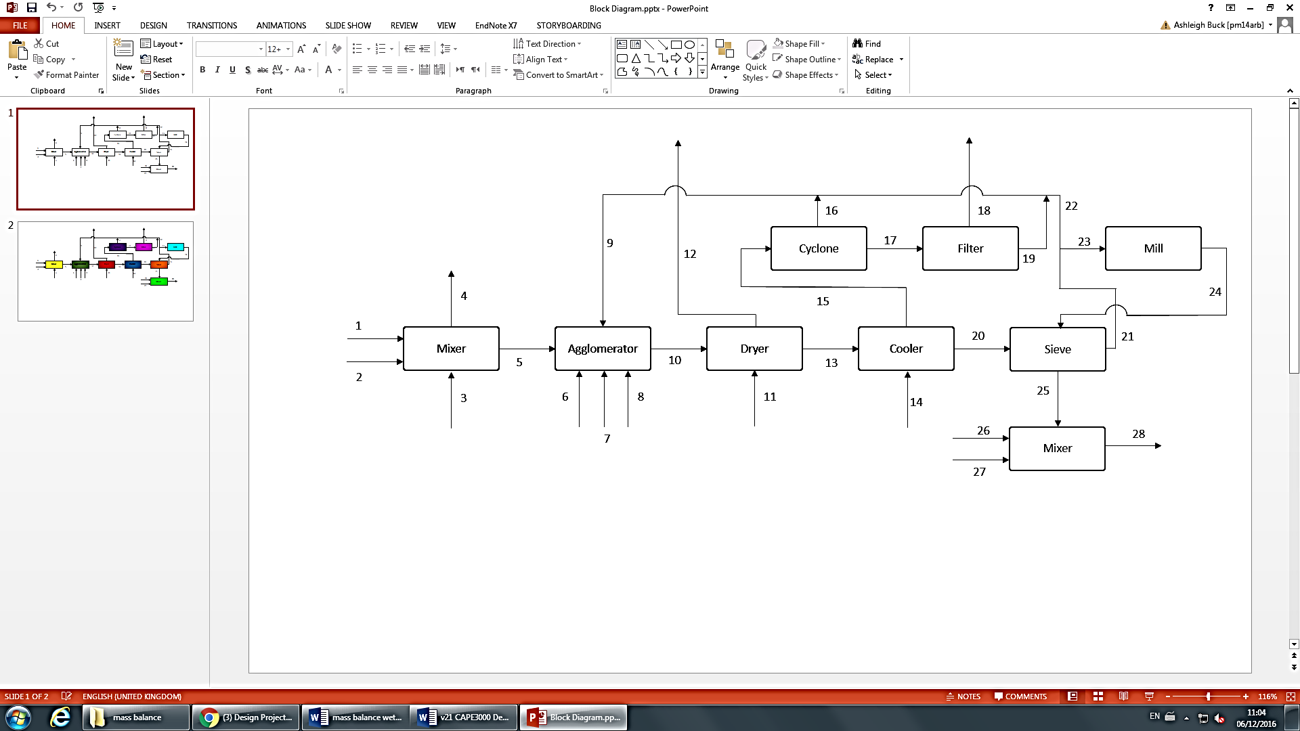
Figure 6.1: Simplified Process Flow Diagram
Table 6.2: Raw Material feeds with active components, water content and impurities
Component | Active Component | Water Content | Impurities | Phase | References
LABS | 0.960 | 0.015 | 0.025 | (l) | (Zhengzhou Clean Chemical, 2013)
Sodium carbonate | 0.980 | 0.015 | 0.005 | (s) | (UNEP, 2005)
Zeolite | 0.990 | 0.010 | 0.000 | (s) | (Zeochem, 2016)
Sodium sulphate | 0.995 | 0.005 | 0.000 | (s) | (UNEP, 2002)
Alkyl Sulphate | 0.900 | 0.050 | 0.050 | (s) | (Sigma Aldrict, 2016)
Alkyl Ethoxylate | 1.000 | 0.000 | 0.000 | (l) | (Nantong Earth Chemical, 2009)
Percarbonate Bleach | 0.880 | 0.000 | 0.120 | (l) | (Mistralni, 2016)
Enzymes | 0.980 | 0.020 | 0.000 | (s) | (Bio-Tec, 2013)
Perfume oil | 0.990 | 0.010 | 0.000 | (l) | (Dongguan Boton Flavors & Fragrances, 2014)
Perfume encapsulates | 1.000 | 0.000 | 0.000 | (s) | (Dongguan Boton Flavors & Fragrances, 2014)
Brighteners | 0.990 | 0.010 | 0.000 | (s) | (Hangzhou Yuanhui Technology, 2010)
Poly carboxylate | 0.380 | 0.620 | 0.000 | (l) | (Jiangmen City Bio-Tech, 2007)
CMC | 0.750 | 0.100 | 0.150 | (s) | (Linyi Viho Chem, 2000)
TAED | 0.980 | 0.020 | 0.000 | (s) | (Shanghai Worldyang Chemical, 2012 )
Sud Suppressor | 0.980 | 0.020 | 0.000 | (l) | (Shandong Wanda Organosilicon New Material, 2010)

6.1.3 Assumptions

Assumptions used in the mass balance are clearly stated and justified when they are used in the process: this section provides a brief overall summary of them.

6.1.3.1 General Assumptions made to conduct the mass balance

The mass balance is performed assuming that the process is at steady state and the agglomerates have the ideal properties. In practice, the process control parameters such as amount of binder, retention times in dryers/coolers, quantity of recycled fines/coarse and temperature of units may need to be adjusted. The general form of mass balance is applied in all cases according to Equation 6.1 (Felder and Rousseau, 2005).
(6.1)

It is assumed that there is no accumulation of product within the system (Equation 6.2)
(6.2)

All powders and liquids are transported perfectly and isothermally throughout the process. When operating some powders may stick to the sides of conveyors or units but this is negated for the mass balance calculation. It is assumed there is no fines loss throughout the process due to the combined separation processes of the cyclone and bag filter. There may be some loss of fines when the process is carried out due to varying efficiency of the units and some fines escaping in the cooling air stream.
During transfer of materials, water will naturally evaporate and the hygroscopic nature of the powder means there will be some uptake of water. It is assumed that an equilibrium exists and the moisture content during transfer in the plant is constant (Scott-Adams and Pallares-Galvan, 1998). The extent of the neutralisation reaction is expected to reach 100%, due to the addition of excess sodium carbonate, high surface area of HLAS and high shear mixing. From standard industry practice it was found that the common conversion rates for similar formulations of similar processes were 80% in the first high shear mixer and the remaining 20% in the second medium shear mixer (Mort III and Sullivan, 2004) (Appel et al, 1992). Miscellaneous materials are assumed to have the same physical properties as the agglomerate and therefore all unit operations will affect them in the same way. In practise this may not be the case, some heavy metals may have to be cleaned out of the cooler/cyclone due to their higher densities causing them to settle.

6.1.3.2 Unit specific assumptions summary

Table 6.3: Summary of assumptions
Unit operation | Specification | Value | Justification
High shear mixer | Free water content | 3 wt% of LABSA | Used to catalyse the reaction (Appel et al, 1992)
High shear mixer | Extent of reaction (neutralisation) | 80% | Bulk of neutralization occurs in a minute, assumed 80% from patent literature (Mort III and Sullivan, 2004) (Zoller, 2009b)
High shear mixer | Extent of Reaction  (Side reaction) | 100% | It is assumed all sulfuric acid is neutralized prior to medium shear mixer, and any remainder is in negligible quantities (1% of LABSA addition)
Medium shear mixer | Extent of reaction (neutralisation) | 20% | Remaining conversion from high shear mixer (Mort III and Sullivan, 2004)
Medium shear mixer | Extent of Reaction  (Side reaction) | 100% | Typical value found in industry (Scott-Adams and Pallares-galvan, 1998)
Sieve | Coarse grain removal | 20% | Typical value found in industry (Nassano and Capeci, 1997)
Dryer | Fines removal | 15% | Based on the particle size distribution after the medium shear mixer, typical value found in industry. (Nassano and Capeci, 1997)
Cyclone | Fines removal | 95% | Typical value found in industry (Zhao et al, 2004)
Bag filter | Fines removal | 100% | Typical value found in industry (Kohlus et al, 2002)
Cooler | Fines removal | 0% | All fines are assumed to leave the process in the air stream exiting the fluidised bed dryer (Mort III, 2004)
Coarse grain split | Separation | 20% | 20% coarse grains recycled into agglomerator
Post addition Mixer | Final moisture content | 4% weight | Typical value found in industry (Capeci et al, 1996).

6.1.4 Post Addition Mixer
To ensure the product specification is met, the unit operations were started from the product stream and calculated backwards (Equation 6.3).
(6.3)
Where: = product stream component on a ‘wet’ basis determined in Table X
= solid post addition ingredient
= liquid post addition ingredient
= sieve outlet component

The individual components are simply added in stream 25, there are no reactions or separations to consider (Equations 6.4 and 6.5). Additionally, the extraction fans included in the process are not considered as part of formal mass balance as it is unknown the quantity of fines generated and this can also affect a late stage particle distribution. Instead, all powders are assumed to enter the mixer.
$$m_{i,26}=m_{i,28}$$ | (6.4)
Where i represents either polycarboxylate, perfume oil or sud suppressors

$$m_{i,27}=m_{i,28}$$ | (6.5)
Where i represents either percarbonate bleach, enzymes, perfume encapsulates, brighteners, CMC or TAED

6.1.4.1 Moisture Content
The desired moisture content in stream 28 is 385.27 kghr⁻¹ (see Table 6.1). In order to ensure the outlet contains 4% water, the liquid post addition moisture content is taken from the end moisture content and the make-up moisture provided by stream 25 (Equation 6.6)
$$m_{H2O,25}=m_{H2O,28}-m_{H2O,27}-m_{H2O,26}$$ | (6.6)

This sets a specification limit for the water content and the drying requirements. The full material compositions for the streams are shown in Table 6.4.
Table 6.4: Stream composition data for 28, 27, 26 and 25.
Component | Stream 28 kg/hr | Stream 27 kg/hr | Stream 26 kg/hr | Stream 25 kg/hr
LAB sulphonate | 856.16 | 0.00 | 0.00 | 856.16
Sodium carbonate | 1541.10 | 0.00 | 0.00 | 1541.10
Zeolite | 2140.41 | 0.00 | 0.00 | 2140.41
Sodium sulphate | 1106.16 | 0.00 | 0.00 | 1106.16
Alkyl Sulphate | 428.08 | 0.00 | 0.00 | 428.08
Alkyl Ethoxylate | 428.08 | 0.00 | 0.00 | 428.08
Water | 391.74 | 12.56 | 280.69 | 98.72
Miscellaneous | 184.97. | 148.66 | 0.00 | 36.31
Percarbonate Bleach | 1027.40 | 1027.40 | 0.00 | 0.00
Enzymes | 42.81 | 42.81 | 0.00 | 0.00
Perfume oil | 42.81 | 0.00 | 42.81 | 0.00
Perfume encapsulates | 85.62 | 85.62 | 0.00 | 0.00
Brighteners | 42.81 | 42.81 | 0.00 | 0.00
Poly carboxylate | 171.23 | 0.00 | 171.23 | 0.00
CMC | 42.81 | 42.81 | 0.00 | 0.00
TAED | 256.85 | 0.00 | 0.00 | 0.00
Sud Suppressor | 42.81 | 0.00 | 42.81 | 0.00
Total | 8838.69 | 1659.20 | 537.54 | 6549.49

6.1.5 Sieving and Milling
The particle classification removes coarse granules that exceed 1000µm in size. The separation efficiency was assumed to be 20% coarse removal from similar processes found in industry (Nassano and Capeci, 1997). This value is common for agglomerates but could change depending on the particle size distribution achieved by this process. The milling operation assumes perfect throughput of coarse grains, with no accumulation. There are no compositional changes at this point (particle size reduction), hence Equation 6.7 is used. The data for the balance around this point is shown in Table 6.5.
(6.7)
Where i represents any component in the stream
Formally, the separation efficiency is defined in Equation 6.8.
(6.8)
Particles too coarse to be sent on to the post addition stage will leave the sieve (stream 21) and subsequently be separated into stream 22 and 23 by 20% and 80% respectively. Stream 22 is used as a process control measure as the addition of coarse grains into the agglomerator help to control the size distribution of the agglomerates being produced (Mort III, 2004). This is defined formally in Equations 6.9 and 6.10.
(6.9)
Where i represents any component in the stream
(6.10)

Table 6.5: Stream composition data around the sieve, streams 20, 24, 21 and 25.
Component | Stream 20 kg/hr | Stream 24 kg/hr | Stream 21 kg/hr | Stream 25 kg/hr
LAB sulphonate | 898.97 | 171.23 | 214.04 | 856.16
Sodium carbonate | 1618.15 | 308.22 | 385.27 | 1541.10
Zeolite | 2247.43 | 428.08 | 535.10 | 2140.41
Sodium sulphate | 1161.15 | 221.23 | 276.54 | 1106.16
Alkyl Sulphate | 449.49 | 85.62 | 107.02 | 428.08
Alkyl Ethoxylate | 359.59 | 68.49 | 85.62 | 428.08
Water | 103.73 | 19.76 | 24.70 | 98.72
Miscellaneous | 38.13 | 7.26 | 9.08 | 36.31
Total | 6876.95 | 1309.90 | 1637.41 | 6549.49

Table 6.5: Stream composition data 21, 22 and 23.
Component | Stream 21 kg/hr | Stream 22 kg/hr | Stream 23 kg/hr
LAB sulphonate | 214.04 | 42.80 | 171.23
Sodium carbonate | 385.27 | 77.05 | 308.21
Zeolite | 535.10 | 107.02 | 428.08
Sodium sulphate | 276.54 | 55.31 | 221.23
Alkyl Sulphate | 107.02 | 21.40 | 85.62
Alkyl Ethoxylate | 85.62 | 17.12 | 68.50
Water | 24.70 | 4.94 | 19.76
Miscellaneous | 9.08 | 1.82 | 7.26
Total | 1637.41 | 327.47 | 1309.87

6.1.6 Fluidised Bed Cooling

The cooling operation uses air from Stream 14 to cool the product from Stream 13. The dryer is to be designed to remove free water through vaporisation. Such vaporisation percentage is chosen through iteration to ensure the final end product water content of 4.5% is achieved. This is to exit within the air stream, along with the inherent intrinsic water percentage of the fines and the water already present in the wet air stream. Calculation of the intrinsic water content is shown below in which the NaLAS was used a basis, where the mass fraction of crystalline water within the agglomerates was assumed to be 1.5%.
$$m_{H20, intrinsic}=\frac{m_{naLAS}}{x_{NaLAS}}×x_{H20, agglomerate}$$ | (6.11)
Where x represents weight fraction
It is assumed that the air outlet in Stream 15 contains fines which are 15% of the total stream. This is shown formally in Equation 6.12.
(6.12)
Where i represents any component in the stream.

Formally, the mass balance is given across the cooler by:
(6.13)
Where i represents NaLAS, Na₂CO₃, zeolite, sodium sulphate, alkyl sulphate or alkyl ethoxylate

The mass flow rate of air required to heat the product is given by the energy balance (see 6.2.6).
Table 6.6: Stream composition data for 13, 14, 15 and 20.
Component | Stream 13 kg/hr | Stream 14 kg/hr | Stream 15 kg/hr | Stream 20 kg/hr
LAB sulphonate | 1057.61 | 0.00 | 158.64 | 898.97
Sodium carbonate | 1903.71 | 0.00 | 285.56 | 1618.15
Zeolite | 2644.04 | 0.00 | 396.61 | 2247.43
Sodium sulphate | 1366.44 | 0.00 | 204.97 | 1161.15
Alkyl Sulphate | 528.81 | 0.00 | 79.32 | 449.49
Alkyl Ethoxylate | 423.05 | 0.00 | 63.46 | 359.59
Water | 122.03 | 422.96 | 441.26 | 103.73
Miscellaneous | 44.86 | 0.00 | 6.73 | 38.13
Air | 0.00 | 21174.81 | 21147.81 | 0.00
Total | 8090.54 | 21570.77 | 22784.35 | 6876.95

6.1.7 Fluidised Bed Drying
The drying operation uses cooling air from Stream 11 to heat product from Stream 10. The mass of air required for cooling the product is determined from dryer energy balance (see 6.2.6). The air inlet is assumed to have a humidity of 3%, this was found as an annual average in the Czech Republic where the plant is located (Holoubek et al, 2007). It is also assumed that no fines are removed in the drying stage through the use of a minimal fluidization velocity, this could be ensured by using a bag filter on Stream 12 to trap fines leaving the dryer. Practically, some fines would be present in Stream 12. This assumption allows Stream 10 to be determined by Equation 6.14. The material amounts are provided in Table 6.7. The dryer is designed to remove the free water in the system so as to acquire 4.5% water in the final product, this is a combination of the intrinsic (bound) water in the agglomerate, remaining free water and water added in post addition.

(6.14)
Where i represents any component in the stream.
Table 6.7: Stream composition data for 10, 11, 12, 13.
Component | Stream 10 kg/hr | Stream 11 kg/hr | Stream 12 kg/hr | Stream 13 kg/hr
LAB sulphonate | 1057.61 | 0.00 | 0.00 | 1057.61
Sodium carbonate | 1903.71 | 0.00 | 0.00 | 1903.71
Zeolite | 2644.04 | 0.00 | 0.00 | 2644.04
Sodium sulphate | 1366.44 | 0.00 | 0.00 | 1366.44
Alkyl Sulphate | 528.81 | 0.00 | 0.00 | 528.81
Alkyl Ethoxylate | 423.05 | 0.00 | 0.00 | 423.05
Water | 644.06 | 11.9858 | 534.01 | 122.03
Miscellaneous | 44.86 | 0.00 | 0.00 | 44.86
Air | 0.00 | 399.53 | 399.53 | 0.00
Carbon Dioxide | 10.81 | 0.00 | 10.81 | 0.00
Total | 8623.44 | 411.51 | 944.35 | 8090.54

6.1.8 Fine Separation and Recycling

The fines exiting the cooler in Stream 15 enter the cyclone, which is assumed to have an efficiency of 95% based on typical quoted values for standard industry use of tangential single inlet cyclone separator (Zhao et al, 2004). The outlet Stream 16 contains 95% of the fines, which are recycled back into the process, along with their intrinsic water content. The remainder are transferred by Stream 17 into a bag filter which is assumed to remove all remaining fines from the system (Kohlus et al, 2002). It is assumed that all of the previously vaporised free water exits the system within the air stream by Stream 12.The material balance across the cyclone is given by:
(6.15)
Where i represents any component in the stream

(6.16)
Where i represents NaLAS, Na carbonate, zeolite, sodium sulphate, alkyl sulphate or alkyl ethoxylate
.

The material compositions of these streams is compiled in Table 6.8
Table 6.8: Stream composition data for 15, 16 and 17.
Component | Stream 15 kg/hr | Stream 16 kg/hr | Stream 17 kg/hr
LAB sulphonate | 158.64 | 150.71 | 7.93
Sodium carbonate | 285.56 | 271.28 | 14.28
Zeolite | 396.61 | 376.78 | 19.83
Sodium sulphate | 204.97 | 194.72 | 10.25
Alkyl Sulphate | 79.32 | 75.36 | 3.97
Alkyl Ethoxylate | 63.46 | 60.28 | 3.17
Water | 441.26 | 17.39 | 423.87
Miscellaneous | 6.73 | 6.39 | 0.34
Air | 21147.81 | 0.00 | 21147.81
Total | 22784.35 | 1152.90 | 21631.44
The outlet Stream 17 enters the bag filter, where it is assumed that all remaining fines (100%) are captured in Stream 19 and recycled back into the agglomerator. The balances for this stage are shown in Equations 6.17, 6.18 and 6.19.
(6.17)
Where i represents any component in the stream

(6.18)
(6.19)
Where j represents NaLAS, Na₂CO₃, zeolite, sodium sulphate, alkyl sulphate or alkyl ethoxylate

The stream composition data is provided in Table 6.9.
Table 6.9: Stream composition data for 14-16
Component | Stream 17 kg/hr | Stream 18 kg/hr | Stream 19 kg/hr
LAB sulphonate | 7.93 | 0.00 | 7.93
Sodium carbonate | 14.28 | 0.00 | 14.28
Zeolite | 19.83 | 0.00 | 19.83
Sodium sulphate | 10.25 | 0.00 | 10.25
Alkyl Sulphate | 3.97 | 0.00 | 3.97
Alkyl Ethoxylate | 3.17 | 0.00 | 3.17
Water | 423.87 | 422.95 | 0.952
Miscellaneous | 0.34 | 0.00 | 0.34
Air | 21147.81 | 21147.81 | 0.00
Total | 21631.44 | 21570.77 | 60.68

The recycle stream is an assumed sum of Streams 16, 19 and 22 which includes fines and coarse granules. In practicality, this is not representative of the plant – for instance, bag filter residue is provided on a batch or semi-continuous basis back into the process. Similarly, the coarse granules and fines are to added back into the process depending on the agglomeration output in Stream 10. Therefore this recycle is assumed for steady state, perfect agglomeration so that discreet values can be used (Equation 6.20). These values are shown in Table 6.10
(6.20)
.
Table 6.10: Stream composition data for recycles
Component | Stream 16 kg/hr | Stream 19 kg/hr | Stream 22 kg/hr | Stream 9 kg/hr
LAB sulphonate | 150.71 | 7.93 | 42.80 | 201.45
Sodium carbonate | 271.28 | 14.28 | 77.05 | 362.61
Zeolite | 376.78 | 19.83 | 107.02 | 503.63
Sodium sulphate | 194.72 | 10.25 | 55.31 | 260.27
Alkyl Sulphate | 75.36 | 3.97 | 21.40 | 100.73
Alkyl Ethoxylate | 60.28 | 3.17 | 17.12 | 80.58
Water | 17.39 | 0.952 | 4.94 | 23.24
Miscellaneous | 6.39 | 0.34 | 1.82 | 8.54
Total | 1152.90 | 60.78 | 327.47 | 1541.06

6.1.9 Medium Shear Mixer (Agglomerator)

The medium shear mixer has feed entering from the high shear mixer in Stream 5, which contains sodium carbonate, NaLAS (80%) and un-neutralized LABSA (20%) (See 6.9). A fundamental characteristic of this system is the variability of the agglomeration process – in this material balance, it is assumed that the agglomerate in the product outlet has all the desired properties and the binder contents are sufficient. Water is added in the medium shear mixer as a process control measure, and is variable. In this balance, the added quantity is 100kghr⁻¹. The powder stream is added in stream 7, consisting of Zeolite, Sodium Sulphate and Alkyl Sulphate powder. The liquid additions are alkyl ethoxylate and water. The recycle stream is also added at this stage to reduce material wastage and as a controlling parameter for the agglomeration. Under these assumptions, and steady state, the following material balance applies:
(6.21)

The material compositions for these streams is provided in Table 6.11.
Table 6.11: Stream composition data for medium shear mixer
Component | Stream 5 kg/hr | Stream 6 kg/hr | Stream 7 kg/hr | Stream 8 kg/hr | Stream 9 kg/hr | Stream 10  kg/hr
LAB sulphonate | 684.93 | 0.00 | 0.00 | 0.00 | 201.45 | 1057.61
HLAS | 160.40 | 0.00 | 0.00 | 0.00 | 0.00 | 0.00
Sodium carbonate | 1567.14 | 0.00 | 0.00 | 0.00 | 362.61 | 1903.71
Zeolite | 0.00 | 0.00 | 2140.41 | 0.00 | 503.63 | 2644.04
Sodium sulphate | 12.12 | 0.00 | 1094.06 | 0.00 | 260.27 | 1366.44
Alkyl Sulphate | 0.00 | 0.00 | 428.02 | 0.00 | 100.73 | 528.81
Alkyl Ethoxylate | 0.00 | 342.47 | 0.00 | 0.00 | 80.58 | 423.05
Water | 65.49 | 0.00 | 50.90 | 500.00 | 23.24 | 644.06
Miscellaneous | 12.53 | 0.00 | 23.78 | 0.00 | 8.54 | 44.86
Carbon dioxide | 0.00 | 0.00 | 0.00 | 0.00 | 0.00 | 10.81
Total | 2502.60 | 342.47 | 3737.23 | 500.00 | 1541.06 | 8623.37

The conversion of H₂SO₄ to sodium sulphate formed in Equation 6.24 is accounted for in Stream 7 (see Table 6.12) and is balanced by Equation 6.22.
(6.22)

Table 6.12: Stream composition data for medium shear mixer
Component | Stream 5  kmol/hr | Stream 6  kmol/hr | Stream 7  kmol/hr | Stream 8  kmol/hr | Stream 9  kmol/hr | Stream 10  kmol/hr
LAB sulphonate | 1.97 | 0.00 | 0.00 | 0.00 | 0.58 | 3.03
HLAS | 0.49 | 0.00 | 0.00 | 0.00 | 0.00 | 0.00
Sodium carbonate | 14.79 | 0.00 | 0.00 | 0.00 | 3.42 | 17.96
Zeolite | 0.00 | 0.00 | 10.59 | 0.00 | 2.49 | 13.08
Sodium sulphate | 0.08 | 0.00 | 7.70 | 0.00 | 1.83 | 9.62
Alkyl Sulphate | 0.00 | 0.00 | 1.48 | 0.00 | 0.35 | 1.83
Alkyl Ethoxylate | 0.00 | 0.65 | 0.00 | 0.00 | 0.15 | 0.80
Water | 3.64 | 0.00 | 0.00 | 27.78 | 1.29 | 35.78
Carbon dioxide | 0.00 | 0.00 | 0.00 | 0.00 | 0.00 | 0.25

6.1.10 High Shear Mixer/Neutralization

The amount of raw materials entering into high shear mixer is the same mass as the corresponding components in the product stream as it has been previously assumed that the combination of cyclone and bag filter will recycle all the fines. The neutralization occurs according to the following stoichiometry:
(6.23)
There is also an additional competing neutralization reaction of H₂SO₄ present in the raw material feed:
(6.24)
The stoichiometry of Equation 6.23 shows that all NaLAS present in the product is derived from the neutralised LAS. The stoichiometric ratio of Na₂CO_{3:} LABSA is given as 1:2, therefore in ideal circumstances only half the total molar quantity of Na₂CO₃ is required to neutralize the acid. However, diffusional effects and coating of the free surface of the acid influence the conversion. Typical industrial practice uses a stoichiometric ratio that exceeds 1:3.5 to ensure neutralization of the LABSA (Mort III and Sullivan, 2004). It is also necessary to have an excess of sodium carbonate due to the competing reaction in Equation 6.24. The Na₂CO₃ is also present in the final formulation as a detergency builder, therefore the excess for the reaction is 139.24 kh/hr (see Table 6.14). The composition of the Na₂CO₃ in the end product was maintained by iterating the feed value to ensure sufficient quantity.
The reaction conversion is assumed as 80% in the first high shear mixer, and the remaining acid (20%) is neutralized in the medium shear mixer. This estimate is derived from industrial literature (Mort III and Sullivan, 2004). The quantity of CO₂ produced from both reactions is assumed to leave the mixer by a vent under a negative pressure system, some carbon dioxide may be entrained in the agglomerate as it forms though high shear mixing can liberate this. Regardless, the remaining CO₂ is taken up in the air stream of the fluidized bed dryer. It is also assumed that all sulphuric acid reacts in the first mixer, though if conversion is similar to LABSA then the product in the medium shear mixer can be assumed negligible. The material balances are then determined formally in Equations 6.25-6.28.
(6.25)
(6.26)
(6.27)
(6.28)

Additionally, water was added to the high shear mixer to catalyse the reaction and is typically 2-3wt% of the LABSA (Equation 6.29).
(6.29)

These compositions are shown in Table 6.13 and 6.14.
Table 6.13: Stream composition data on a molar basis for high shear mixer
Component | Stream 1  kmol/hr | Stream 2  kmol/hr | Stream 3  kmol/hr | Stream 4  kmol/hr | Stream 5  kmol/hr
LAB sulphonate | 0.00 | 0.00 | 0.00 | 0.00 | 1.97
HLAS | 0.00 | 2.46 | 0.00 | 0.00 | 0.49
Sodium carbonate | 15.85 | 0.00 | 0.00 | 0.00 | 14.8
Sodium sulphate | 0.00 | 0.00 | 0.00 | 0.00 | 0.09
Water | 1.42 | 0.69 | 0.45 | 0.00 | 3.64
Sulphuric acid | 0.19 | 0.09 | 0.00 | 0.00 | 0.00
Carbon dioxide | 0.00 | 0.00 | 0.00 | 1.26 | 0.00

Table 6.14: Stream composition data on a mass basis for high shear mixer
Component | Stream 1  kg/hr | Stream 2  kg/hr | Stream 3  kg/hr | Stream 4  kg/hr | Stream 5  kg/hr
LAB sulphonate | 0.00 | 0.00 | 0.00 | 0.00 | 684.93
HLAS | 0.00 | 801.99 | 0.00 | 0.00 | 160.40
Sodium carbonate | 1680.33 | 0.00 | 0.00 | 0.00 | 1567.14
Sodium sulphate | 0.00 | 0.00 | 0.00 | 0.00 | 12.11
Water | 25.72 | 12.53 | 8.02 | 0.00 | 65.49
Sulphuric acid | 0.00 | 8.35 | 0.00 | 0.00 | 0.00
Carbon dioxide | 0.00 | 0.00 | 0.00 | 55.56 | 0.00
Miscellaneous | 0.00 | 12.35 | 0.00 | 0.00 | 12.35
Total | 1714.63 | 835.41 | 8.02 | 55.56 | 2502.60

6.2 Energy Balance
The energy balance for the selected process route covers the required duties for heating and cooling, in addition to pumping requirements and other unit operations (e.g. milling and agitation). The temperatures and pressures are determined from literature (particularly patents) where possible, and other information is assumed with best estimates. The general energy balance equation in all cases is shown in Equation 6.30, while Equation 6.31 incorporates molar flows from the mass balance (Perry et al, 2008):
(6.30)
(6.31)

6.2.1 Preliminaries
Prior to the balances, a reference temperature and pressure was assumed (293K and 101kPa) to develop the enthalpy changes. In all cases, pressure was assumed constant so that specific heat capacity at constant pressure (C_{p}) could be used for sensible heat changes. Material transport between unit operations was considered isothermal for areas not covered by trace heating. This assumption implies infinite insulation, causing no temperature change of the streams. In practice, appreciable heat loss will be observed primarily through conduction across pipe walls and natural convection during conveying. In addition, the fluidised bed drier and cooler were both considered as adiabatic unit operations for air flow calculations.
Work in the form of mechanical energy is added in the mixer during agitation and the milling stages of particle reduction. In these cases, the free surface of the particles is increased and hence the free surface energy, with a likely increase in temperature. However, these work and heating changes are difficult to predict and as such, all mechanical energy is assumed to contribute solely to the resizing of the detergent and is not considered within the energy balance itself.

6.2.1.1 Thermodynamic Properties of Materials
In some cases, thermodynamic property data (e.g. heats of formation or specific heat capacities) were not readily available through literature for the particular chemical species. For the purposes of these balances, some chemically similar compounds are used or estimates are determined from research papers. In real world plant design, this information would be corrected through experimentation prior to plant construction. All relevant thermodynamic properties are summarised in the appendix, Table A1.

6.2.1.2 Enthalpy of Formation – Alkyl Sulphate (Sodium Dodecyl Sulphate)
The primary alcohol sulphate selected for detergency has an alkyl chain length of C₁₂-C₁₄, in this case sodium dodecyl sulphate is used. The enthalpy of formation was estimated by gathering the thermodynamic data of two molecules which, if imposed upon one another, produce a resultant molecule of similar structure to that of Sodium Dodecyl Sulphate. Dodecene provides the hydrocarbon backbone of the required molecule whereas sodium sulphate provides the sulphate group. The two values were summed and scaled for the differing molecular weight to that of Sodium Dodecyl Sulphate. The calculation is shown below in Equation 6.32 and summarised in Table 6.15.
Table 6.15: Data used in the prediction of the enthalpy of formation of sodium dodecyl sulphate
Molecule | Enthalpy of Formation [kJ mol⁻¹] | Molecular Weight [g gmol⁻¹] | Reference
Dodecene | -528.50 | 168.32 | Vatani et al, 2007
Sodium Sulphate | -1387.10 | 142.04 | Vatani et al, 2007
Sodium Dodecyl Sulphate |  | 288.37 | Perry, 2008

(6.32)

6.2.1.3 Enthalpy of Formation – Alkyl Ethoxylate (Ethoxylated Dodecanol)
The same method used in the alkyl sulphate enthalpy estimation was applied to ethoxylated dodecanol to approximate the unknown heat of formation using the thermodynamic data in Table 6.16. Dodecene contributes the hydrocarbon backbone whereas ethylene oxide provides an estimation to the enthalpy of formation contribution from the 7 ethoxy chains (Equation 6.33, Table 6.16).
Table 6.16: Data utilised in the prediction of the enthalpy of formation of ethoxylated dodecanol
Molecule | Enthalpy of Formation [kJ mol⁻¹] | Molecular Weight [kg kmol⁻¹] | Reference
Ehtylene oxide | -52.6 | 44 | Perry, 2008
Dodecene | -226.2 | 168.319 | Vatan et al, 2007
Ethoxylated Dodecanol |  | 529 | Perry, 2008

(6.33)

6.2.1.4 Enthalpy of Formation - LABSA

The sulphonation of linear alkyl benzene can be studied to derive a heat of formation of LABSA shown in Equations 6.33 and 6.34 (De Groot et al, 1991).
(6.34)
(6.35)
Adding these reactions together gives Equation 6.36.
(6.36)
Thus the heat of formationis given by Equation 6.37.
(6.37)
Where: (Dodecyl Benzene) (Vatani et al, 2007) (Sulphur Trioxide) (Vatani et al, 2007)
(Alkylbenzene Sulphonation) (De Groot et al, 1991)

6.2.1.5 Enthalpy of Formation - LABSA
Using the derived heat of formation of LABSA, the heat of reaction for LABSA with caustic soda was explored to derive the heat of formation of NaLAS. The reaction is shown below in Equation 6.38.
(6.38)
It is stated in De Groot et al, 1991 that the heat of neutralization of LABSA with caustic soda is typically in the 100-110kJ gmol⁻¹ range, with this observed in practical scenarios. For reactions with Na₂CO₃, it is typically only ¼ the reaction enthalpy of caustic soda. Therefore, with a reaction enthalpy of 25kJ mol⁻¹:
(6.39)

6.2.1.6 Specific Heat Capacity – Zeolite 4A
Qiu et al (2000) experimentally derived the heat capacity of the zeolite using differential scanning calorimetry for up to 311K on a per weight basis. The zeolite is expected to be exposed to temperatures of 383K so linear forecasting was applied (as shown below) to predict the heat capacity at the given temperature range. This assumes no significant denaturing or anomalies above 311K. (See Equation 6.40).
(6.40)

The thermodynamic value is to be integrated across the temperature ranges of the datum enthalpy value (298K) up to 383K. An average of the two corresponding heat capacity values was taken as 2.230 kJ gmol⁻¹ K⁻¹.

6.2.2 Alkyl Ethoxylate Heating
The alkyl ethoxylate used in the process route solidifies at room temperature, and hence requires heating to stay as a liquid. The heating duty was predicated on several assumptions: firstly, the storage volume in a tank was assumed to be a 2 day supply of the material, which corresponds to 31.07 kmol/hr from the material balance. Primary mode of heat transfer losses are assumed to be conduction through the storage tank. Finally, the delivery temperature outlined is assumed to be 293K which requires heating to by a further 20K to prevent solidification. Calculations are shown in Equation 6.41.
(6.41)

A heater of 100kW is to be applied, allowing the storage temperature to be reached in 41 minutes, assuming negligible heat loss and heat transfer coefficients.
Maintaining said temperature during storage requires trace heating from the heater. The energy losses may be assigned to heat conduction through the storage tank and natural convection from the tank surface. Approximation of maximum energy loss is shown in Figure 6.1 where it is assumed the container wall temperature is equal to that of the bulk alkyl ethoxylate.
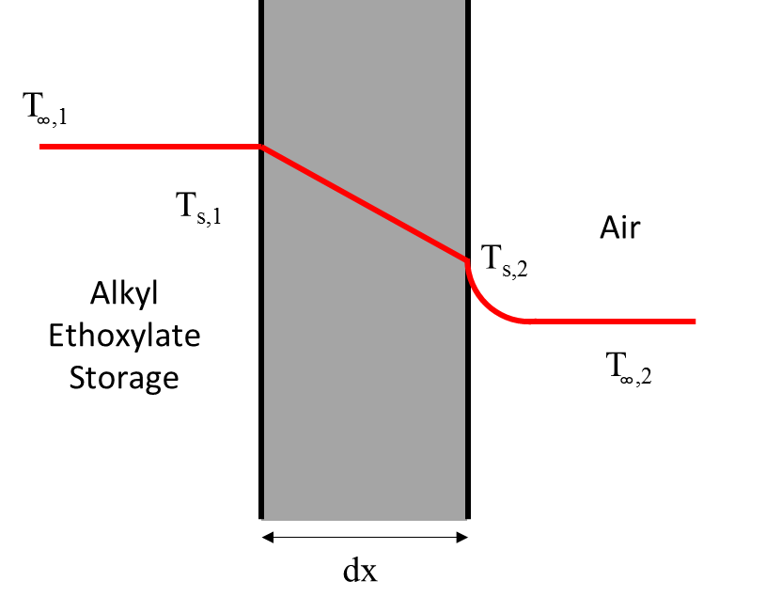
Figure 6.1: Heat transfer through the plane wall of the alkyl ethoxylate storage tank, where subscript s is surface.
The heat loss is therefore calculated using the equations below, assuming heat loss from radiation is negligible. The heat transfer resistances are calculated using Equations 6.42 and 6.43 (Dewitt et al, 1990).
(6.42)
(6.43)

The volume of the container must be greater than that of 2 days of storage of alkyl ethoxylate. The density of alkyl ethoxylate is taken as 1100.5 kg m⁻³ from Table 2.1 (Cameo Chemicals, 1999), hence the volume required can be calculated using Equation 6.44.
(6.44)
By assuming a cylindrical storage tank with a length equal to twice the diameter, the wetted contact area when 90% full is 29.38m² for the alkyl ethoxylate and the outside wetted perimeter to air is 35.8m². The wall thickness is assumed to be 50mm and made of carbon steel, giving a thermal conductivity of 53.6 W m⁻² K⁻¹. Air velocity outside the tank is assumed low (~2 m s⁻¹) giving a convective heat transfer coefficient of 20 W m⁻² K⁻¹ (Felder and Rousseau, 2005). The maximum energy loss, ergo the maximum trace heating required, is calculated below using Equation 6.45.
(6.45)
To conclude, heating up a two-day supply of alkyl ethoxylate requires 248.6MJ and maintaining such temperatures requires overcoming maximum heat losses of 10.5kW, of which will decrease as the supply is reduced. Transfer of the solution to the neutraliser is assumed to be perfectly insulted – hence isothermal.

6.2.3 Heating of LABSA
A storage supply of 2 days was assumed, thus the energy required for reaching a storage temperature of 313K is the integral of the specific heat capacities of each component within the solution. This is shown formally below in Equation 6.46.
(6.46)

Said energy requirement is to be satisfied with a 100kW heater, requiring 2.7 hours to reach storage temperature – neglecting energy losses and assuming a negligible heat transfer coefficient.
Calculating the trace heat required for the maintenance of said storage temperature is achieved using the same procedure in the heating of alkyl ethoxylate, where the density of sulphuric acid is 1840kgm⁻³ (Dewitt et al, 1990). The volume occupied in a stainless steel cylindrical storage tank is 40m³, which results in an energy loss of 20.2kW – the maximum trace heating required. Transfer of the solution to the neutraliser is also assumed to be perfectly insulted – hence isothermal.

6.2.4 High Shear Mixer (Neutralization)
The energy balance on the mixer is outlined in Figure 6.2. In this case, there are two reactions: neutralization of LABSA which proceeds to an 80% conversion (Equation 6.23), and neutralization of small amounts of sulphuric acid which is assumed completely converted (Equation 6.24) or in negligible quantities after this operation. From these, enthalpy changes are associated with the reactions and the sensible heating of the feed streams to the outlet temperature. The balance is represented in Figure 6.2.
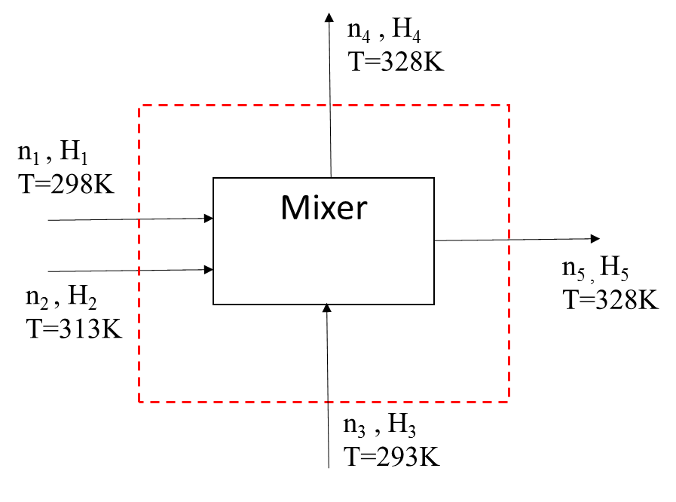

Figure 6.2: Isolated Neutraliser unit operation with the imposed boundary for energy balance analysis
Equation 6.30 and 6.31 were applied across the mixer and iterated to zero difference by varying the outlet temperatures – hence allowing adiabatic operation. The enthalpy of formation of each species allowed the energy associated with the neutralisation reaction to be reflected in the enthalpy balance. Equation 6.47 shows a sample calculation for a stream outlet.
(6.47)
This methodology was applied to all 5 streams, producing Table 6.17, with the outlet temperatures ensuring no enthalpy change across the unit, thus all heats of reaction at the assumed conversions contribute to the heating of the outlet stream.
Table 6.17 Energy balance analysis of the Mixer
Stream | Species | T [K] | n [mol h⁻¹] | H [kJ mol⁻¹] | H [kJ h⁻¹]
1 | Na₂CO₃ | 298 | 15853.7 | -1127.4 | -18358868.5
 | H₂O | 298 | 1428.9 | -285.8
 | CO₂ | 298 | 194.8 | -393.5
2 | HLAS | 313 | 2456.9 | -892.5 | -2460270.7
 | H₂O | 313 | 696.2 | -284.7
 | H₂SO₄ | 313 | 85.2 | -812.8
3 | H₂O | 293 | 445.6 | -286.2 | -127524.1
4 | CO₂ | 328 | 1262.8 | -392.4 | -495549.3
5 | NaLAS | 328 | 1965.5 | -1120.3 | -20450609.3
 | HLAS | 328 | 491.4 | -884.7
 | H₂O | 328 | 3638.6 | -283.6
 | Na₂CO₃ | 328 | 14785.7 | -1127.0
 | Na₂SO₄ | 328 | 85.2 | -1386.5
 |  |  |  | Q [kW] | 0

6.2.5 Agglomerator
The enthalpy of formation approach was applied to the Agglomerator, across the boundary shown in Figure 6.3. Such unit consists of further exothermic LABSA neutralisation, heating of the inlet streams to 323K and the cooling of stream 5.
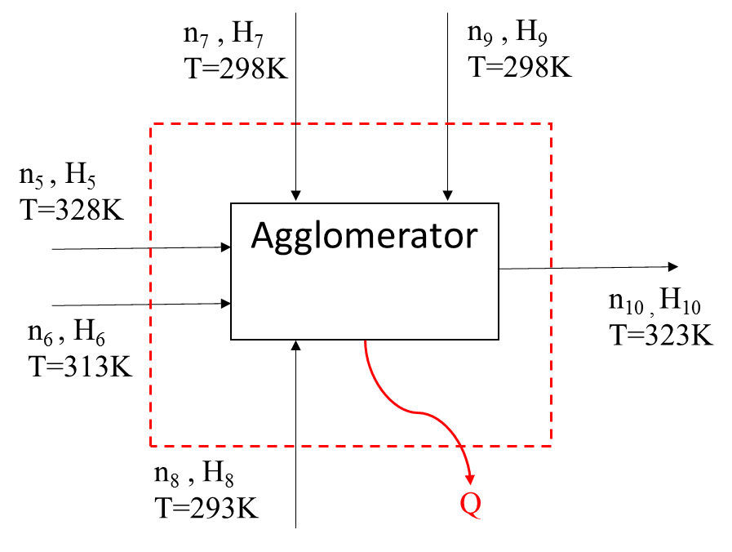
Figure 6.3: Isolated agglomerator unit with the imposed boundary for energy balance analysis.
The energy balance is shown in Table 6.18, where the enthalpy change is 487.1kW - the required duty of the cooler.
Table 6.18 Energy balance analysis of the Agglomerator
Stream | Species | T [K] | n [mol h⁻¹] | H [kJ mol⁻¹] | H [kJ h⁻¹]
5 | NaLAS | 328 | 1965.5 | -1120.3 | -20450609.3
 | HLAS | 328 | 491.4 | -884.7
 | H₂O | 328 | 3638.6 | -283.6
 | Na₂CO₃ | 328 | 14785.7 | -1127.0
 | Na₂SO₄ | 328 | 85.2 | -1386.5
6 | Alkyl Ethoxylate | 313 | 647.4 | -588.4 | -380920.3
7 | Zeolite | 298 | 10589.0 | 2069.0 | 10413666.0
 | Na₂SO₄ | 298 | 7702.5 | -1387.1
 | Alkyl Sulphate | 298 | 1.5 | -1779.9
 | H₂O | 298 | 2827.8 | -285.8
8 | H₂O | 293 | 27777.8 | -286.2 | -7950472.2
9 | NaLAS | 298 | 578.1 | -1137.0 | -2982463.8
 | Na₂CO₃ | 298 | 3421.2 | -1127.4
 | Zeolite | 298 | 2491.5 | 2069.0
 | Na₂SO₄ | 298 | 1832.4 | -1387.1
 | Alkyl Sulphate | 298 | 349.3 | -1779.9
 | Alkyl Ethoxylate | 298 | 152.3 | -594.4
 | H₂O | 298 | 1291.3 | -285.8
10 | NaLAS | 323 | 3034.9 | -1123.1 | -23104256.6
 | Na₂CO₃ | 323 | 17961.2 | -1127.1
 | Zeolite | 323 | 13080.6 | 2124.8
 | Na₂SO₄ | 323 | 9620.1 | -1386.6
 | Alkyl Sulphate | 323 | 1833.7 | -1734.9
 | Alkyl Ethoxylate | 323 | 799.7 | -584.4
 | H₂O | 323 | 35781.2 | -284.0
 | CO₂ | 323 | 245.7 | -392.6
 |  |  |  | Q [kW] | 487.1

6.2.6 Fluidised Bed Dryer
The vaporisation of the free moisture into the air stream requires the formation enthalpies to be considered as compositional changes are observed. In addition, the unit is assumed to be adiabatic which allowed air flow rate iteration until the enthalpy change across the dryer has zero difference. The unit is represented in Figure 6.4. The temperature of the air outlet was chosen to be 328K, ensuring sensible temperature differential for the exchange of heat.
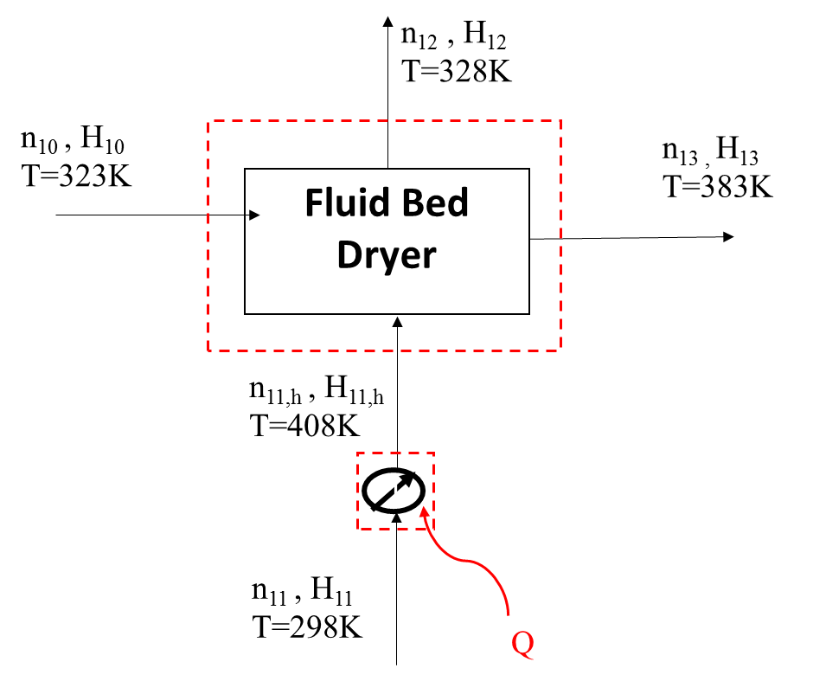
Figure 6.4: Isolated Fluid Bed Dryer unit operation with the imposed boundary for energy balance analysis
Table 6.19 shows the applied balance with a dry air flow rate of 13.79 kmol h⁻¹, corresponding to a flow rate of 411.5 kg h⁻¹ of wet air (3% humidity) – 0.11kg s⁻¹. Heating of such air stream is calculated in Equation 6.49 by integration of the specific heat capacity of dry air and water. The heater duty is 13kW.
(6.49)
Table 6.19: Energy balance analysis of the Fluid Bed Dryer
Stream | Species | T [K] | n [mol h⁻¹] | H [kJ mol⁻¹] |  | H [kJ h⁻¹]
10 | NaLAS | 323 | 3034.94 | -1123.06 | -23104256.6
 | Na₂CO₃ | 323 | 17961.19 | -1127.10
 | Zeolite | 323 | 13080.55 | 2124.75
 | Na₂SO₄ | 323 | 9620.10 | -1386.61
 | Alkyl Sulphate | 323 | 1833.72 | -1734.88
 | Alkyl Ethoxylate | 323 | 799.71 | -584.40
 | H₂O | 323 | 35781.18 | -283.96
 | CO₂ | 323 | 245.69 | -392.60
11 | Air | 408 | 13791.00 | 245.30 | 3224287.8
 | H₂O | 408 | 665.88 | -238.25
13 | NaLAS | 383 | 3034.94 | -1089.61 | -12647976.2
 | Na₂CO₃ | 383 | 17961.19 | -1126.33
 | Zeolite | 383 | 13080.55 | 2258.55
 | Na₂SO₄ | 383 | 9620.10 | -1385.44
 | Alkyl Sulphate | 383 | 1833.72 | -1626.88
 | Alkyl Ethoxylate | 383 | 799.71 | -560.40
 | H₂O (l) | 383 | 6779.58 | -279.43
12 | Air | 328 | 13791.00 | 0.87 | -7231968.8
 | H₂O (g) | 328 | 29667.47 | -240.92
 | CO₂ | 328 | 245.69 | -392.41
 |  |  |  | ΔH [kW] | 0.0

6.2.7 Fluidised Bed Cooler
The fluidised bed cooler includes separation and removal of fines from the feed (Stream 17) and entrained in the exiting air stream. Therefore the heat of formation approach is used due to the composition changes. The calculated values are shown in Table 6.20 below, where air flow rate was iterated until the enthalpy change across the unit was 0 for the desired temperature changes. The iteration resulted in a wet air flow rate of 5.99 kg s⁻¹.
Table 6.20: Energy balance analysis of the Fluidised Bed Cooler
Stream | Species | T [K] | n [mol h⁻¹] | H [kJ mol⁻¹] | H [kJ h⁻¹]
13 | NaLAS | 383 | 3034.94 | -1089.61 | -12647976.2
 | Na₂CO₃ | 383 | 17961.19 | -1126.33
 | Zeolite | 383 | 13080.55 | 2258.55
 | Na₂SO₄ | 383 | 9620.10 | -1385.44
 | Alkyl Sulphate | 383 | 1833.72 | -1626.88
 | Alkyl Ethoxylate | 383 | 799.71 | -560.40
 | H₂O (l) | 383 | 6779.58 | -279.43
14 | Air | 278 | 729990.00 | -0.58 | -6125206.9
 | H₂O (g) | 278 | 23497.57 | -242.58
20 | NaLAS | 298 | 2579.70 | -1137.00 | -13309244.9
 | Na₂CO₃ | 298 | 15267.01 | -1127.42
 | Zeolite | 298 | 11118.47 | 2069.00
 | Na₂SO₄ | 298 | 8177.08 | -1387.10
 | Alkyl Sulphate | 298 | 1558.66 | -1779.88
 | Alkyl Ethoxylate | 298 | 679.75 | -594.40
 | H₂O | 298 | 5762.64 | -285.84
15 | Air | 308 | 729990.00 | 0.29 | -5464037.3
 | H₂O (g) | 308 | 23497.57 | -241.58
 | NaLAS | 308 | 455.2405418 | -1131.42
 | Na₂CO₃ | 308 | 2694.178727 | -1127.29
 | Zeolite | 308 | 1962.082569 | 2091.3
 | Na₂SO₄ | 308 | 1443.014316 | -1386.91
 | Alkyl Sulphate | 308 | 275.0576046 | -1761.88
 | Alkyl Ethoxylate | 308 | 119.9563131 | -590.4
 | H₂O (l) | 308 | 1016.937333 | -285.086
 |  |  |  | ΔH [kW] | 0.0

The cooling requirement was calculated through same means as those used for the heating requirement of the drier air stream. The basis for the calculation is shown in Equation 6.50, producing a cooling duty of 122.4kW.
(6.50)
6.3 Pressure Drop and Pump Power
The pressure drops were calculated for the pumps used in the process route. In some cases, an initial calculation was performed and the pressure drop applied to other liquids (e.g. additives). The pressure drops calculated are for three sections: neutralization reactor, agglomerator, and post addition mixer.
6.3.1 Neutralization Reactor
There are two streams that transport liquid feed: LABSA and a water stream used to catalyse the reaction. The spray nozzle pressure has been defined as 7000kPa for all inlet liquid streams, and this section will focus on material transport from storage and through the pipeline prior to the pumps required to spray nozzle. It is assumed that LABSA flows to the reactor through 2 sections of pipe as shown in Figure 6.5. This includes a valve, elbow piece and the two sections of pipe. Initial estimates were calculated for the pipe diameter, average velocity and pipe length. In plumbing, pipe size is referred to as nominal pipe size that is roughly related to the actual diameter (Engineering Toolbox [A], 2016). From nominal size, the value of resistance coefficient can be determined from the data provided by Metro Pumps.

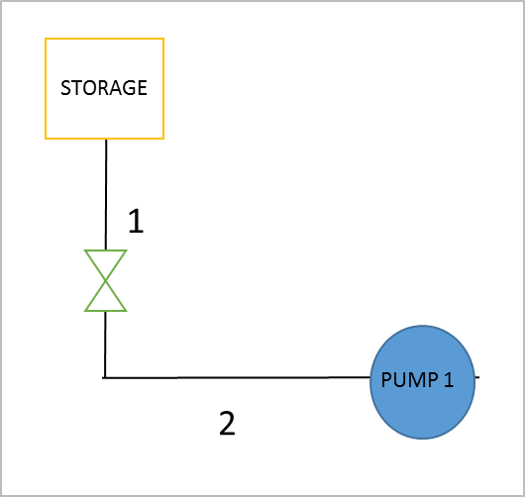
Figure 6.5: Schematic diagram of LABSA piping system to the reactor

Table 6.21: Data for pressure drop evaluation (De Groot et al, 1995)
Pipe Diameter | 0.5 m
Nominal Pipe Size | 20
Average Velocity | 1.22 ms⁻¹
Viscosity | 0.6 Pa s at 313K
Density | 1045 kgm⁻³
Pipe Length | 20 m at 1, 5m at 2
Resistance Coefficient, K | 0.1 using Gate Valve (Metro Pumps, 2016)  0.7 using Threaded Long Radius 90º Elbow (Engineering Toolbox [B], 2016)

The LABSA is a viscous liquid and it is assumed to flow with laminar characteristic in pipe. Reynolds number is used to confirm such assumption.
$$Re=\frac{ρVD}{μ}$$ | (6.51)
$$Re=\frac{(1045)(1.22)(0.5)}{0.6}$$
$$Re=1062.42<2000, laminar$$

For laminar, Hagen-Poiseuuille equation is used to calculate pressure drop along the pipe. (Mahmud, 2016)
$$∆P= \frac{32μVL}{D^{2}}$$ | (6.52)

Where $μ$ = dynamic viscosity, V = average velocity of flow, L = pipe length, D = diameter of pipe.
$${∆P}_{1}= \frac{32\left(0.6\right)(1.22)(20)}{{(0.5)}^{2}}=1873.92 Pa$$
$${∆P}_{2}= \frac{32\left(0.6\right)(1.22)(5)}{{(0.5)}^{2}}=468.48 Pa$$

In laminar flow, minor losses are proportional to fluid velocity that velocity varies smoothly between the bulk of the fluid and the pipe surface, where it is zero. The roughness of the pipe surface influences neither the fluid flow nor the friction loss. However, factors other than straight pipe flow induces friction loss such as bends, couplings or valves need to be considered. There is one valve used along pipe 1. Darcy–Weisbach equation can also be written in terms of head loss. (Mahmud, 2016)
$$h_{L}=K\left(\frac{V^{2}}{2g}\right)$$ | (6.53)

Where L = equivalent length of pipe, f = friction factor.
$$h_{L}=(0.1)\left(\frac{{1.22}^{2}}{2(9.81)}\right)=7.586E-3 m$$
$$∆P= ρgh=1050\left(9.81\right)\left(7.586E-3\right)=77.77Pa$$

There are one 90º elbow used to change the direction of pipe 1 to pipe 2. The Darcy–Weisbach equation is used again to determine the head loss.
$$h_{L}=(0.7)\left(\frac{{1.22}^{2}}{2(9.81)}\right)=0.053 m$$
$$∆P= ρgh=1050\left(9.81\right)\left(0.053 \right)=544.38 Pa$$

Table 6.22: The calculated data for LABSA flow piping to neutralization reactor
Type of Pressure Drop | 1 | 2
Pressure Drop (Pa) | 1873.92 | 468.48
Valves Minor Loss (Pa) | 77.77 | 0
TOTAL PRESSURE  DROP (Pa) | 1951.69 | 468.48

Table 6.23: The calculated data for bends head loss
Bends Resistance Coefficient, K | 0.7
Bends Minor Loss (Pa) | 544.38

6.3.2 Agglomerator
There are two streams which transport liquids to the mixer in this stage of process: the non-ionic fatty alcohol ethoxylate surfactant stream and a water stream to control the size of agglomerates. As before, the spray nozzle pressure has been defined. It is assumed that the surfactant flows to reactor through 2 sections of pipe before going to agglomerator as shown in Figure 6.6.
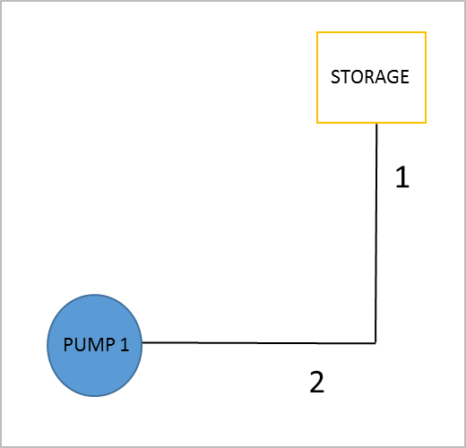
Figure 6.6: Schematic diagram of non-ionic surfactant piping system to the agglomerator
Table 6.24: The calculated data for non-ionic surfactant flow piping to agglomerator (De Groot et al, 1995)
Type of Pressure Drop | 1 | 2
Pipe Diameter (m) | 0.1 | 0.1
Pipe Length (m) | 5 | 10
Average Velocity (ms⁻¹) | 1 | 1
Density (kgm⁻³) | 960 | 960
Viscosity (Pa s) | 0.05 | 0.05
Reynolds Number | 1920 (Laminar) | 1920 (Laminar)
Pressure Drop (Pa) | 800 | 1600
TOTAL PRESSURE  DROP (Pa) | 800 | 1600

Table 8: The calculated data for bends head loss
Bends Resistance Coefficient, K | 0.7 using Threaded Long Radius 90º Elbow (Engineering Toolbox [B], 2016)
Bends Minor Loss (Pa) | 336

6.3.3 Post addition mixer
There are three liquid-type of additives in the post addition mixer; perfume oil, suds suppressor and polycarboxylate. However, assumption is made that their properties has similar characteristic thus only one calculation is needed.
Table 6.25: The calculated data for post addition stream (De Groot et al, 1995)
Pipe Diameter (m) | 0.2
Pipe Length (m) | 5
Average Velocity (ms⁻¹) | 2.65
Density (kgm⁻³) | 1000
Viscosity (Pa s) | 0.05
Valves Resistance Coefficient, K | 0.1
Reynolds Number | 1766.67 (Laminar)
Pressure Drop (Pa) | 3180
Valves Minor Loss (Pa) | 351.13
TOTAL PRESSURE DROP (Pa) | 3531.13

6.3.4 Pump Power Calculation
The ideal hydraulic power to drive a pump depends on the mass flow rate the fluid density the differential height. By using the total head, the theoretical and the actual power needed for the system to perform can be determined. The theoretical power is calculated by: (Netrium,2016)
$$P_{h}=\frac{qρgh}{3.6E6}$$ | (8)

Where q = fluid flowrate, ρ = density of the fluid, g = gravitational acceleration and h = differential head.
Nevertheless, the actual power required can be calculated by dividing the actual power with the efficiency of positive displacement pump, P_{a}=P_{h}/E_{p}. The flowrate of LABSA and non-ionic surfactant and efficiency of pump are taken from mass balance section and 0.75 respectively.

Table 6.26: Summary of total pressure drop and with required pump power
Pipe Section |  | Pressure Drop (Pa) | Total Pressure Drop (Pa) | Theoretical power of pump (W) | The actual power required (W)
Neutralization reactor | 1 | 1951.69 | 2964.55 | 0.63 | 0.84
 | Bend | 544.38
 | 2 | 468.48
Agglomerator | 1 | 800.00 | 2736.00 | 0.27 | 0.36
 | Bend | 336
 | 2 | 1600
Post addition mixer |  | 3531.13 | 3531.13 | 0.49 | 0.65

Conclusion

The remit of the project was the design of a flexible process for the production of laundry detergent with a bulk density of 850kgm⁻³ that is free flowing, white, quick to dissolve and dust free. A review of current manufacturing processes for powder detergents found that there were two viable routes to achieve the required density – extrusion and agglomeration. The agglomeration process was implemented due to the availability of established industrial expertise and journals, in addition to the flexibility offered by the process with rapid start up and low emissions. The process variability was acknowledged and a series of design measures incorporated to ensure that the product specification can be achieved, such as an additional water binder and dryer to manage water content.
The material feeds were selected from typical industrial selections and incorporated into the process. In cases where the raw materials did not have the desired material properties (e.g. particle size, viscosity), equipment was added to the design to optimise the process. Examples of this include the Na₂CO₃ micronizer and inclusion of trace heating for higher viscosity liquids that are sprayed via nozzle. In terms of purchasing, suppliers were sourced locally where possible particularly for the bulk materials to reduce distribution costs and limit the environmental impact of the design. In particular, the LABSA was sourced from Henkel as the primary anionic and zeolite as the primary builder was sourced from Zeochem in Zurich at a price of 68.45USDkg⁻¹. Other additives and minors were sourced further afield (often China) as these materials are required in smaller volumes and cost effectiveness was prioritized.
It was determined from the route selection that agglomeration is a particularly safe manufacturing process with low environmental impact and emissions. Detailed investigation of the materials found mostly irritant properties with suitable mitigation measures recommended, though storage and handling of LABSA presents a high hazard to which a series of equipment and best practices were recommended. The handling of powders required effective dust control measures to minimise flammable atmospheres and potential ignition sources, and the primary environmental hazard was the emission of surface active chemicals into rivers and soils.
Finally, mass and energy balances were developed to understand the material feed and utility requirements of the process. The manufacture of 60,000tonnesyr⁻¹ of high bulk density powder requires a feed rate of 801.99kgh⁻¹ of LABSA stored in a vessel requiring a duty of 300kW. The high shear mixer used for neutralization of the LABSA operates adiabatically at 328K while the conditioning stage in the medium shear mixer requires a cooling utility of 487kW. The drying and cooling stages were completed by fluidized beds with a duty of 13kW and 122.4kW respectively. The moisture content of the end product was 4.5%, which contributed to the desirable qualities of the powder.

References

Abulencia, J. P. and Theodore, L. 2009. Fluid Flow for the Practicing Chemical Engineer. New Jersey, United States: John Wiley and Sons. pp200-300
AISE, 2013. For the Safe Handling of Enzymes in Detergent Manufacturing. International Association for Soaps, Detergents and Maintenance Products. [Online] [Accessed 13/11/16] Available from: https://www.aise.eu
Appel, P. W. et al. 1994. United States Patent: US6282996 – Detergent Compositions and Process for preparing them. New York, United States: Lever Brothers. pp1-13
Barletta, G and Bianchi, A. 1998. US 4919847: A Process for manufacturing particulate detergent composition directly from in situ produced anionic detergent salt. United States: Colgate Palmolive Co. pp3-5
BASF. 2012. GPS Safety Summary: Benzenesulfonic acid, C10-13-alkyl derivatives, sodium salts. [Online] [Accessed 12/11/16] Available from: http://www.safety-summaries.basf.com/
Bayly, A., Rough, S. L. Wilson, D. I. and York, D. 2003. Tapping Characterization of high shear mixer agglomerations made with ultra-high viscosity binders. Powder Technology 132, pp 249-266
Beetz, C.P., Corbett, R. and Salem, D. 2015. US8939388 B1: Methods and apparatus for low heat spray drying. United States: Branchburg Inc. pp5-10
Bianchetti, G. O, Devlin, C. L and Seddon, K. R. 2015. Bleaching systems in domestic laundry detergents: a review. RSC Advances. 65365, 5. United Kingdom: Royal Society of Chemistry. pp1-3
Bio-Tec. 2013. Protease Enzymes. [Online]. [Accessed 27/10/16]. Available from: https://www.alibaba.com/product-detail/Professional-Factory-Supply-Protease-Amilase-Bio_60551583316.html?spm=a2700.7724838.0.0.Cf74jX
Block, E. 2016. Sulfonic Acid. [Online]. [Accessed 08/10/16]. Available from: https://www.britannica.com/science/sulfonic-acid
Businesscoot. 2016. The European Market for Laundry Detergents. [Online]. [Accessed 5 November 2016]. Available from: http://www.businesscoot.com/the-european-market-for-laundry-detergents-160/
Cahn, A. 1998. Proceedings of the 4th World Conference on Detergents: Strategies for the 21st Century. Champaign, Illinois, USA: AOCS Press. pp213-215
Cameo Chemicals. 1998. Ethoxylated Dodecanol. [Online]. [Accessed 08/11/16]. Available from: https://cameochemicals.noaa.gov/chris/EOD.pdf
Capeci, S W. et al. 1996. US 5486303: Process for making high density detergent agglomerates using an anhydrous powder additive. United States: The Procter and Gamble Company. pp1-5
Cowen-Ellsberry, C et al. 2014. Environmental Safety of the Use of Major Surfactant Classes in North America. Critical Reviews in Environmental Science and Technology, 44 (17). pp1893-1993.
De Groot, W. H. 1991. Sulphonation Technology in the Detergent Industry. United States: Springer-Science + Business Media. pp83-179
De Groot, W. H., Adami, I. and Moretti, G.F. 1995. The Manufacture of Modern Detergent Powder. The Netherlands: Herman de Groot Publisher. pp1-58
Department of International Trade. 2016. Austria trade and Export guide. [Online]. [Accessed 13 November 2016]. Available from: https://www.gov.uk/government/publications/exporting-to-austria/doing-business-in-austria-austria-trade-and-export-guide
Dongguan Boton Flavors & Fragrances. 2014a. Encapsulation Fragrance. [Online]. [Accessed 29 October 2016]. Available from: https://www.alibaba.com/product-detail/Encapsulation-Fragrance_60534007387.html
Dongguan Boton Flavors & Fragrances. 2014b. Fragrance for Detergent. [Online]. [Accessed 28 October 2016]. Available from: https://dgboton.en.alibaba.com/product/60521339552-803797645/Fragrance_For_Detergent.html
Dorset, A. and Paquatte, O. 1993. EU Patent 0555622: Process for making detergent granules by neutralization of sulphonic acids. The Netherlands: The Procter & Gamble Company. pp1-5
Erguney, F M. 2015. A Novel Process for Zero Emission Detergent Production. Turkey: Airrane Co. Ltd. pp3-20
European Council. 2004. Regulation 2004/648/EEC Detergents. European Union: Journal of the European Parliament and Council. 104(2), pp 1-35
Eurostat. 2015. Labour costs per hour in EUR, 2004-2015 whole economy excluding agriculture and public administration. [Online]. [Accessed 12 October 2016]. Available from: http://ec.europa.eu/eurostat/statistics-explained/index.php/File:Labour_costs_per_hour_in_EUR,_2004-2015_whole_economy_excluding_agriculture_and_public_administration.png
Export.gov. 2016. Doing Business in Austria. [Online]. [Accessed 13 November 2016]. Available from: http://2016.export.gov/austria/doingbusinessinaustria/index.asp
Export.gov. 2016. Doing Business in Germany. [Online]. [Accessed 13 November 2016]. Available from: http://2016.export.gov/germany/MarketResearchonGermany/CountryCommercialGuide/DoingBusinessInGermany/index.asp
Farn, R. J. 2006. Chemistry and Technology of Surfactants. Oxford, United Kingdom: Blackwell Publishing. pp138-140
Felder, R.M. and Rousseau, R.W. 2005. Elementary Principles Of Chemical Processes. 3rd ed. New Yorkː John Wiley & Sons.pp81-155
Fisher Scientific. 2009. Safety Data Sheet: Anhydrous Sodium Sulphate. [Online] [Accessed 12/11/16]. Available from: https://www.fishersci.com
Goovaerts, Haacht, Vega, J. L. 1996. United States Patent 5494599: Agglomeration of High Active Pastes to form surfactant granules useful in Detergent compositions. Cincinnati, USA: The Procter & Gamble Company. pp1-14
Grandview Research. 2016. Fatty Alcohols Market Analysis by Product. [Online]. [Accessed 26/11/16]. Available from: http://www.grandviewresearch.com/industry-analysis/fatty-alcohols-market
HA Campbell. 2011. Carbonates. [Online]. [Accessed 13 October 2016]. Available from: http://www.chemistry.co.nz/deterg_inorganic.htm
Hangzhou Yuanhui Technology. 2010. OBA for Detergent. [Online]. [Accessed 29 October 2016]. Available from: https://hzyuanhui.en.alibaba.com/product/386757663-211954473/Optical_brightening_agent_for_detergent_CXT_CAS_No_16090_02_1_.html
Health and Safety Executive. 2003a. Bulk Storage of Acids. United Kingdom: Crown Publishing. pp1-10
Health and Safety Executive. 2003b. Designing and operating safe chemical reaction processes. United Kingdom: Crown Publishing. pp1-12
Henkel. 2016. Sustainability. Germany: Henkel AG & Company. pp1-5
HERA. 2004. Zeolite A. [Online]. [Accessed 11/10/16]. Available from: http://www.mma.gov.br/port/conama/processos/D10B4F0E/08HERA-ineos.pdf
Hirschen, M, Waldhoff, H and Spilker, R. 2005. Handbook of Detergents Part C: Analysis. CRC Press pp. 439–470.
Holoubek, I. et al. 2007. Trends in background levels of persistent organic pollutants at Kosetice observatory, Czech Republic. Part I. Ambient air and wet deposition 1996–2005. J. Environ. Monit. 9(6), pp.557-563.
International Fragrance Association (IFRA), 2006. IFRA Code of Practice. pp1-20
Jiangmen City Bio-Tech. 2007. Sodium Polyacrylate. [Online] [Accessed 30/10/2016]. Available from: https://wholesaler.alibaba.com/product-detail/Hot-sale-water-treatment-agent-liquid_60533977354.html?spm=a2700.7782932.0.0.fkrGhN
Jones, C. W. 1999. Applications of hydrogen peroxide and its derivatives. United Kingdom: Royal Society of Chemistry. pp5-7
Kohlus, R. et al. 2002. US 6369020: Granular detergent components and particulate detergent compositions containing them. The Netherlands: Unilever PLC. pp1-7
Koley, D., Bard, A.J. 2010. Triton X-100 concentration effects on membrane permeability of a single HeLa cell by scanning electrochemical microscopy (SECM). Proceedings of the National Academy of Sciences of the United States of America. 107 (39), pp.16783
Linyi Viho Chem. 2000. Sodium Carboxymethyl Cellulose. [Online] [Accessed 01/11/16]. Available from: https://www.alibaba.com/product-detail/Sodium-Carboxymethyl-Cellulose-CMC-_60290712992.html?s=p
Mahmud, T. 2016. Fluid Mechanics. CAPE2010 Engineering Science 2. United Kingdom: University of Leeds. pp10
Malewski, Y. 2016. Correspondence to Adi Ab Fatah, 10 November.
Mallari, G, A. et al. 1999. US005968891A: Process for preparing detergent composition having high bulk density. New York, United States: Colgate-Palm-Olive Company. pp1-8
Metro Pumps. 2015. Friction Losses in Pipe Fittings - Resistance Coefficient K. [Leaflet]. New Jersey: Metro Pumps and Systems, Inc.
Mistralni. 2016. Sodium Percarbonate. [Online]. [Accessed 18 October 2016]. Available from: https://mistralni.co.uk/products/sodium-percarbonate-ultra-pure
Mort III, P. R. and Sullivan, M. E. 2004. United States Patent 6794354B1: Continuous Process for making Detergent composition. Cincinnati, United States: The Procter & Gamble Company. pp2-10
Mujumdar, A. S. et al. 2006. Handbook of Industrial Drying. Singapore: Taylor & Francis group LLC. pp1-5
Nantong Earth Chemical, 2009a. Company Overview. [Online]. [11/10/16]. Available from: https://earthchem.en.alibaba.com/company_profile.html
Nantong Earth Chemical. 2009b. Fatty Alcohol Ethoxylate. [Online] [18/10/16]. Available from: https://www.alibaba.com/product-detail/Emulsifier-AEO-Fatty-alcohol-ethoxylate-68551_1872859216.html
Nassano, D R and Capeci, S W. 1997. US 5691297: Process for making a high density detergent composition by controlling agglomeration within a dispersion index. pp2-10
Nielsen, 2016. The Dirt on Cleaning: Home Cleaning/Laundry attitudes and trends around the world. United States: The Nielsen Company. pp1-8
Nieuwmeyer, F. 2009. Process understanding on high shear granulated lactose agglomerates druing and after drying. The Netherlands: Schering-Plough Corporation. pp14-20
Nitta, H., Yamashita, H and Saito, J. 2006. US Patent 6992055: Process for preparing Detergent compositions having high bulk density. Tokyo, Japan: Kao Corporation. pp10-12
OSHA Europe. 2016. OSHA Directives and Information. [Online] [Accessed 13/11/16] Available from: https://osha.europa.eu
Perry, R., Chilton, C. and Perry, J. 1973. Perry’s Chemical Engineers Handbook. New York: McGraw-Hill. pp1400-1600
PubChem. 2016. Sodium Dodecyl Sulphate. [Online]. [Accessed 10 October 2016]. Available from: https://pubchem.ncbi.nlm.nih.gov/compound/Sodium_dodecyl_sulfate
PubChem. 2016. Sodium Percarbonate. [Online]. [Accessed 11 October 2016]. Available from: https://pubchem.ncbi.nlm.nih.gov/compound/Sodium_percarbonate#section=Top
Qiu, L., Murashov, V. and White, M. A. 2000. Zeolite 4A: heat capacity and thermodynamic properties. Elsevier. Solid State Sciences, 2(8), pp841-846.
Research & Markets, 2016. Global Zeolite Market 2016-2020. [Online] [Accessed 26/11/16] Available from: http://www.researchandmarkets.com/reports/3795252/global-zeolite-market-2016-2020#relb0
Riccardi, J.R. and Landry, M.S. 2011. US8047355 B2: Automatic belt tracking system. United States: Acrison, Inc. pp2-8
Salman, A. D. et al. 2006. Handbook of Powder Technology Volume 11: Granulation. United Kingdom: Elsevier Science. pp675-700
Schneider Electric, 2012. SCADA Systems. Ontario, Canada: Schneider Electric.
Schongut, M., Grof, Z. and Stepanek, F. 2011. Kinetics of Dry Neutralization of Dodecyl-Benzenesulfonic Acid with Respect to Detergent Granulation. Ind. Eng. Chem. Res., 50(20), pp 11576–11584
SDA. 1994. Soaps and Detergents. [Online] [08/10/16] Available from: http://www.cleaninginstitute.org/assets/1/assetmanager/soapsanddetergentsbook.pdf
Shamlou, P.A. 1988. Handling of bulk solids. 1st ed. London: Butterworths.
Shandong Wanda Organosilicon New Material. 2010. Polydimethylsiloxane. [Online]. [Accessed 18 October 2016]. Available from: https://www.alibaba.com/product-detail/Polydimethylsiloxane_1671588449.html?spm=a2700.7724838.0.0.HDP5e1
Shanghai Worldyang Chemical. 2012. Tetraacetylethylenediamine. [Online]. [Accessed 19 October 2016]. Available from: https://www.alibaba.com/product-detail/Tetraacetylethylenediamine-10543-57-4_60143202108.html?spm=a2700.7724838.0.0.nZQLFa
Sichuan Habio Bioengineering Co., Ltd. 2002. Detergent Enzymes Protease. [Online]. [Accessed 18 October 2016]. Available from: https://www.alibaba.com/product-detail/detergent-enzyme-lipase-protease-amylase-for_60318633001.html?s=p
Sigma Aldrich. 2016. Sodium Dodecyl Sulphate. [Online]. [Accessed 30 October 2016]. Available from: http://www.sigmaaldrich.com/catalog/product/sial/62862?lang=en&region=GB
Smulders, E et al. 2002. Laundry Detergents. United States: John Wiley & Sons. pp122-145
Sonia. 2012. MSDS of Secondary Alcohol Ethoxylate. [Online] [Accessed 10 October 2016]. Available from: https://www.spectrumchemical.com/MSDS/T3123.PDF
Tan, M.X.L. and Hapgood, K.P. 2011. Foam Granulation: Liquid penetration or mechanical dispersion? Chemical Engineering Science. 66(21), pp.5204-5211
UNEP. 2002. Sodium Sulphate. [Online]. [Accessed 25 October 2016]. Available from: http://www.inchem.org/documents/sids/sids/7757826.pdf
UNEP. 2005. Sodium Carbonate. [Online]. [Accessed 25 October 2016]. Available from: http://www.inchem.org/documents/sids/sids/Naco.pdf
Unichimica. 2016. Group Companies – Unichimica. [Online]. [Accessed 11 October 2016]. Available from: http://www.unichimica.it/en/group-companies/unichimica
US Commercial Service. 2014. Germany Household Care Products. [Online]. [Accessed 13 November 2016]. Available from: http://files.export.gov/x_4888445.pdf
Vatani, A., Mehrpooya, M. and Gharagheizi, A. 2007. Prediction of Standard Enthalpy of Formation by a QSPR Model. International Journal of Molecular Sciences. 8(1), pp. 407-432
World of Chemicals. 2016. Linear Alkyl Benzene Sulfonic Acid. [Online]. [Accessed 8 October 2016]. Available from: http://www.worldofchemicals.com/chemicals/chemical-properties/linear-alkyl-benzene-sulfonic-acid.html
York, D. W. 2003. An industrial user’s perspective on agglomeration development. Powder Technology, 130. Newcastle-upon-Tyne, Procter and Gamble Technical Centre. pp14-17
Zauba. 2016. Analysis of Exports of Linear Alkyl Benzene Sulphonic Acid. [Online] [Accessed 26/11/16] Available from: https://www.zauba.com/exportanalysis-linear+alkyl+benzene+sulphonic+acid-report.html
Zauba. 2016. Analysis of Imports of Sodium Sulphate. [Online] [Accessed 26/11/16] Available from: https://www.zauba.com/importanalysis-sodium+sulphate-report.html
Zeochem. 2016. Products. [Online]. [Accessed 11 October 2016]. Available from: http://www.zeochem.ch/dev/html/products.html
Zeochem. 2016. Special Zeolite. [Online]. [Accessed 2 November 2016]. Available from: http://www.zeochem.ch/dev/html/specialty_zeolites.html
Zeodet. 2000. Zeolites for Detergents. Brussels, CEFIC. [Online] [Accessed 12/11/16]. Available from: http://www.zeolites.eu/
Zhao, B., Shen, H. and Kang, Y. 2004. Development of a symmetrical spiral inlet to improve cyclone separator performance. Powder Technology. 145(1), pp.47-50.
Zhengzhou Clean Chemical. 2013. LABSA. [Online]. [Accessed 20 October 2016]. Available from: https://www.alibaba.com/product-detail/Good-Price-LABSA-96-Linear-alkylbenzene_60235476573.html
Zoller, U. 2004a. Handbook of Detergents Part B: Environmental Impact. New York, United States: Marcel-Dekker. pp7-50
Zoller, U. 2004b. Handbook of Detergents Part F: Production. New York, United States: Marcel-Dekker. pp323-46

Appendix

A1 Ancillary information

A1.I Summary of Thermodynamic Properties

Table A1 Thermodynamic data used throughout energy balance
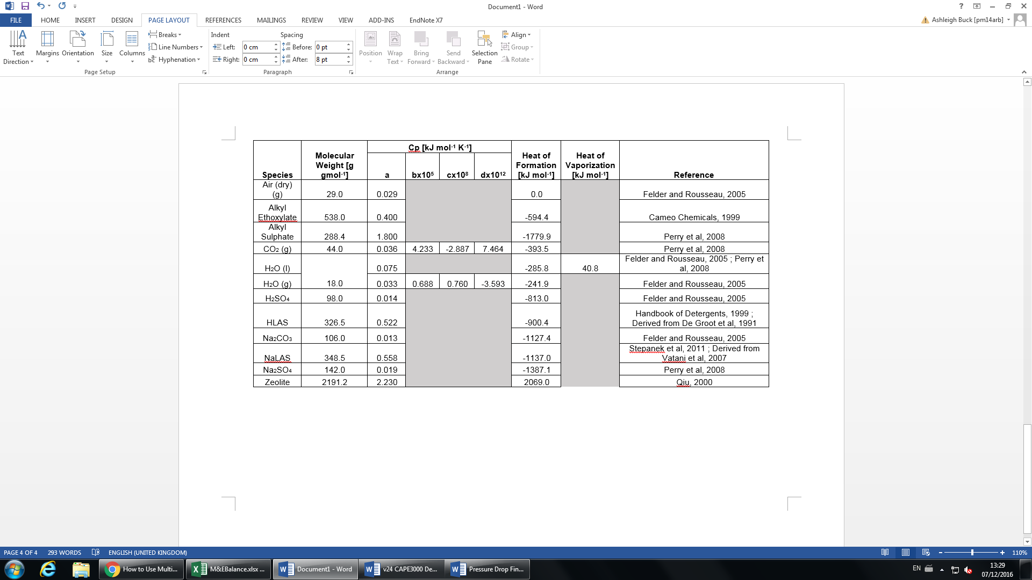

A1.II Dryer and Cooler Inlet Air Pressure Estimations

For the dryer, the air inlet conditions are predefined as 298K, 7bar. The flow rate can therefore be calculated using Equation A1.
A1

The same flow rate is required after the pump and heater, where the air temperature is 408K. The required pressure inlet estimation is as follows (Equation A2)
A2
The cooler requires a significantly greater air flow rate, requiring a greater inlet pressure the volumetric flow. The pressure is therefore estimated to be 25bar though air flow rate may be controlled by increasing the number of air inlets, as part of the unit design.

A2 Process Flow Diagram

A2.I Equipment Designations

A2.II Stream Data

A3 Minutes of Group Meetings

A3.I Minutes of the Group Meeting held at 12:00 on 30/09/16
Present: - Adi Hani Ab Fatah
Ashleigh Buck.
Carl Jackson
Ghulam Qureshi
Joseph Smith
4. The meeting was chaired and minutes were taken by Carl Jackson.
7. Minutes of items arising from the meeting agenda:
Introduction to Dr Anthony and the project.
Decided to agree on weekly internal meetings within the group every Tuesday at 11:00am.
Discussed suitable software for PFD creation.
Project Manager Rota decided.
Actions to be taken:
- Submission of Project Manager Rota by Carl by 04/10/16.
- Gantt Chart to be completed by Joe, reviewed as a group and submitted by Carl by 03/10/16
- Complete independent process research prior to 04/10/16.
- Process selection agreement as a group by 04/10/16.
- Create a PFD for said process prior to the next formal meeting on 07/10/26.
- Divide technical briefing document into 5 sections as a group on 04/10/16 and allocate to each member.
- Prepare presentation for briefing presentation on 07/10/16.
8. Other notes:
Check Edward Boyle library for the journal papers.
9. Chairperson for the next meeting: Carl Jackson.
10. Next meeting to be held at 12:00 on 07/10/16 in Room 1.09, 11-14 Blenheim Terrace.

A3.II Minutes of the Group Meeting held at 11:00 on 04/10/16
1. Present:-
Adi Hani Ab Fatah
Ashleigh Buck
Carl Jackson
Ghulam Qureshi
Joseph Smith
2. Apologies for absence:-
None
3. Absentees:-
None
4. The meeting was chaired and minutes were taken by Carl Jackson.
5. Minutes of the previous meeting of the group held on 30/09/16.
6. Matters arising from the previous meeting:
- Technical briefing thoroughly read by all
- Possible processes researched in preparation for today’s discussion
- Gantt chart first attempt completed in preparation for today’s discussion
7. Minutes of items arising from the meeting agenda
- Divided the technical report into individual sections, which are to be familiarised with for a brief presentation on Friday (07/10/16):
Ghulam - Project Overview
Ashleigh - Design requirements (1.1-1.5)
Carl -Roles and Responsibilities (2.0)
Adi - Process Outline
Joe - Product Specifications
- Preliminary Gantt chart completed by Joe and Carl and then to be overviewed and adjusted by remaining group members for Friday (07/10/16).
- Agreed on agglomeration and discussed issues regarding the alternative processes (density).
- Discussed PFD research for Agglomeration production of detergents and this was assigned to Carl, Joe and Ghulam in preparation for a preliminary block diagram on Friday (07/10/16).

- Assigned alternative process research to Ashleigh (Spray drying, dry mixing) for Friday (07/10/16).
- Discussed Raw Materials and Products and assigned this task to Adi to research for Friday (07/10/16).
8. Any other business:
- Unsure as to the structure and placement of Plant Location, PFDs and other such areas within the report – this is to be questioned at the next supervisor meeting on Friday (07/10/16).
9. Chairperson for the next meeting: Carl Jackson
10. Next meeting to be held at 11:00 on 07/10/16 in 11-14 Blenheim Terrace.

A3.III Minutes of the Group Meeting held at 12:00 on 10/10/16
- Present:-
Adi Hani Ab Fatah (AAF)
Ashleigh Buck (AB)
Ghulam Qureshi (GQ)
Joseph Smith (JS)
Dr. S. J. Anthony (SJA)
2. Apologies for absence:- Carl Jackson (Illness)
3. Absentees:- None
4. The meeting was chaired and minutes were taken by Joseph Smith (substitute for CJ).
5. Minutes of the previous meeting of the group held on 07/10/16
6. Matters arising from the previous meeting:
With Andrew Bayly (Technical Supervisor):

- Consider state of raw materials (solid or liquid? % active ingredient?)
- Research areas
    - Last 3 books within the referencing list
    - Patents from P&G, Unilever, Kao, Henkel
    - Powder Technology journal, Industrial Chemical Engineering Design journal
- Possible processes
    - Spray dry
    - Granulation
    - Dry mixing
    - Compression
    - Extrusion
- Research legislations for plant location
- Reduce waste where possible with recycle streams (might not always be viable)
- Consider storage size (while being flexible for expansion)
- Plant downtime for maintenance and reliability issues (failures)
- Consider new technologies for process route selection

Internal meeting:
- Discussed possible plant locations and considerations – Plant location to be completed by Carl for 10/10/16
- Raw materials and Products to be wrote up by Adi for 10/10/16
- Process route alternatives to be wrote up by Ashleigh for 10/10/16
- Preliminary PFD reviewed and neutralisation stage to be further researched by Ghulam and Joe for 10/10/16
- All are to further read their allocated Technical Briefing areas for presentation on 10/10/16

7. Minutes of items arising from the meeting agenda
- Presentation of technical brief to SJA
- Selection of agglomeration for detergent manufacture – validated by SJA
- Presentation of preliminary PFD to SJA – modify to include any possible waste streams, particle wastes or water wastes
- Cost Analysis for raw feedstocks
- Ensure that choice of site is clear by 17/10/16
- Meeting to be scheduled by JS/CJ with Tariq Mahmud, S.J. Anthony to review PFD and process selection (Monday 17/10/16)
- Discussion of stream tables and mass balances

Actions:
- JS to modify PFD by 11/10/16, in preparation for technical meeting (@13:00, 11/10/16)
- JS to convert PFD into AutoCAD following Technical Meeting and deliver by 14/10/16
- JS to draft Process route selection by 14/10/16
- CJ to complete site location choice and write up by 17/10/16
- AAF to complete Raw Materials draft by 17/10/16
- GQ to develop stream tables as basis for Mass Balance (proviso that JS completed PFD by 14/10/16)
- AB to complete alternative process routes draft by 17/10/16
- JS/GQ to draft technical questions for consultant visit, by 11/10/16

8. Any other business
9. Chairperson for the next meeting: Carl Jackson
10. Next meeting to be held at 11:00, 11/10/16 (Technical Consultant Visit with Andrew Bayly). SCAPE Building

A3.IV Minutes of the Group Meeting held at 13:00 on 11/10/16
- Present:-
Adi Hani Ab Fatah (AAF)
Ashleigh Buck (AB)
Ghulam Qureshi (GQ)
Joseph Smith (JS)
Carl Jackson (CJ)
Professor Andrew Bayly
2. Apologies for absence:- None
3. Absentees:- None
4. The meeting was chaired and minutes were taken by Carl Jackson.
5. Minutes of the previous meeting of the group held on 10/10/16
6. Matters arising from the previous meeting:

Actions:

JS modified PFD and converted to AutoCAD
JS began draft Process route selection
CJ in progress to justifying site selection
AAF in progress to completing raw materials
AB in progress to completing alternative processes
JS/GQ prepared technical questions for the process of choice

7. Minutes of items arising from the meeting agenda
- Consider 1 step or 2 step granulation process
- Consider neutralisation prior to agglomeration in a seperate reactor
- Add non ionic after the neutralisation
- Add polycarboxylate after agglomeration
- Control liquid to solid ratio for efficient agglomeration
  - Just below saturation point so all liquid between particles
    - Described further in Handbook of Powder Technology
- Learn and state the solubilities/physical states of all materials (e.g. Don’t want sodium sulphate to dissolve)
- Justify plant location with raw materials – not so much with taxes
- Briefly mention and describe processes which don’t meet criteria (not too much detail)
- Justify unit operation choices in Process Route and Evaluation
  - Why these recycle routes?
  - Why filters?
  - Why screw conveyor rather than belt?
- Consider Personal Safety and Process Safety for Safety Health and Environment Section

Actions:
- JS to modify PFD with recommended alterations stated above for 17/10/16
- AB to complete alternative processes with CJ for 17/10/16
- AAF to complete raw materials and products with integrated plant location by CJ for 17/10/16
- AAF to state material states/solubilities in raw materials section
- GQ to begin justifying process unit operations with CJ for 17/10/16
- GQ to begin constructing stream tables in preparation for mass balance for 17/10/16 while aiding with PFD research/modification
- All to research:
  - control of liquid to solid ratio (saturation point)
  - neutralisation chemistry

8. Any other business
- General project and PFD heading in the right direction
- Discussed possible areas of research
  - Handbook of Powder Technology - Granulation (vol 11)– AD Salman et al
  - Author F. Stepanek for the chemistry
  - Author Mort P. Burnett for control papers and patents

9. Chairperson for the next meeting: Joseph Smith
10. Next meeting to be held at 13:30, 17/10/16, Laidlaw Library

A3.V Minutes of the Group Meeting held at 13:30 on 17/10/16
- Present:-
Adi Hani Ab Fatah (AAF)
Ashleigh Buck (AB)
Ghulam Qureshi (GQ)
Joseph Smith (JS)
Carl Jackson (CJ)
2. Apologies for absence:- None
3. Absentees:- None
4. The meeting was chaired and minutes were taken by Joseph Smith.
5. Minutes of the previous meeting of the group held on 11/10/16
6. Matters arising from the previous meeting:

- Consider 1 step or 2 step granulation process
- Consider neutralisation prior to agglomeration in a seperate reactor
- Add non ionic after the neutralisation
- Add polycarboxylate after agglomeration
- Control liquid to solid ratio for efficient agglomeration
  - Just below saturation point so all liquid between particles
    - Described further in Handbook of Powder Technology
- Learn and state the solubilities/physical states of all materials (e.g. Don’t want sodium sulphate to dissolve)
- Justify plant location with raw materials – not so much with taxes
- Briefly mention and describe processes which don’t meet criteria (not too much detail)
- Justify unit operation choices in Process Route and Evaluation
  - Why these recycle routes?
  - Why filters?
  - Why screw conveyor rather than belt?
- Consider Personal Safety and Process Safety for Safety Health and Environment Section

Actions:
- JS to modify PFD with recommended alterations stated above for 17/10/16
- AB to complete alternative processes with CJ for 17/10/16
- AAF to complete raw materials and products with integrated plant location by CJ for 17/10/16
- AAF to state material states/solubilities in raw materials section
- GQ to begin justifying process unit operations with CJ for 17/10/16
- GQ to begin constructing stream tables in preparation for mass balance for 17/10/16 while aiding with PFD research/modification
- All to research:
  - control of liquid to solid ratio (saturation point)
  - neutralisation chemistry

7. Minutes of items arising from the meeting agenda
- Consideration on valves and types of valve used to dose feeds correctly
- Use of weight belt to deliver product in correct quantities
- Consideration on the types of mill and sieving process to be used – how is particle classification achieved for practical design?
- Discussed the benefits and drawbacks of extrusion as an alternative process
  - Provides high bulk density, with flexibility in process
  - However, requires use of lubricant and process is not discussed in literature as widely as granulation (agglomeration)
  - Large particles are generated following extrusion, which leads to poorer solubility
  - Data on process parameters is predominately empirical and industry based – theoretical models are harder to find and subsequent quantify
  - Extrusion arose as post densification process from spray tower powders
- Alterations to PFD:
  - Include heating and cooling at fluidised bed dryer, with waste streams
  - Include waste CO2 from fluidised bed dryer, and purge stream from filter
  - Alkyl sulphate moved to agglomeration step to simple feeds and process chemistry for neutralization reaction
- Discussion of mass and energy balances
  - Sourcing Cp data and heats of reaction

Actions:

- JS to update PFD with alterations and email to CJ
- JS to complete Process Route draft under proviso the work is accepted during PFD presentation – to completed by 21/10/16
- AAF/GQ to source Cp data and heats of reaction for 21/10/16
- Room for presentation to be discussed with SJA and AB by JS, others to be copied in
- CJ to research milling and particle classification to understand practical design
- AB to incorporate PFD research and Process selection into alternative processes (conditional on JS completing by 21/10/16)
- GQ to research new technologies for high density detergent powder manufacture
- All to research neutralization and agglomeration in more depth, in preparation for Wednesday PFD presentation (19/10/16). Includes process control, liquid to solid ratio, temperature, pressure, mixing vessel, retention time, type of impeller etc.

8. Any other business
9. Chairperson for the next meeting: Joseph Smith
10. Next meeting to be held at 12:00, 19/10/16, Technical Consultants office

A3.VI Minutes of the Group Meeting held at 12:00 on 19/10/16
- Present:-
Adi Hani Ab Fatah (AAF)
Ashleigh Buck (AB)
Ghulam Qureshi (GQ)
Joseph Smith (JS)
Carl Jackson (CJ)
Andrew Bayly (AB)
S J Anthony (SJA)

2. Apologies for absence:- None
3. Absentees:- None
4. The meeting was chaired and minutes were taken by Joseph Smith.
5. Minutes of the previous meeting of the group held on 17/10/16
6. Matters arising from the previous meeting:
- Consideration on valves and types of valve used to dose feeds correctly
- Use of weight belt to deliver product in correct quantities
- Consideration on the types of mill and sieving process to be used – how is particle classification achieved for practical design?
- Discussed the benefits and drawbacks of extrusion as an alternative process
  - Provides high bulk density, with flexibility in process
  - However, requires use of lubricant and process is not discussed in literature as widely as granulation (agglomeration)
  - Large particles are generated following extrusion, which leads to poorer solubility
  - Data on process parameters is predominately empirical and industry based – theoretical models are harder to find and subsequent quantify
  - Extrusion arose as post densification process from spray tower powders
- Alterations to PFD:
  - Include heating and cooling at fluidised bed dryer, with waste streams
  - Include waste CO2 from fluidised bed dryer, and purge stream from filter
  - Alkyl sulphate moved to agglomeration step to simple feeds and process chemistry for neutralization reaction
- Discussion of mass and energy balances
  - Sourcing Cp data and heats of reaction

Actions:
- JS to update PFD with alterations and email to CJ
- JS to complete Process Route draft under proviso the work is accepted during PFD presentation – to completed by 21/10/16
- AAF/GQ to source Cp data and heats of reaction for 21/10/16
- Room for presentation to be discussed with SJA and AB by JS, others to be copied in
- CJ to research milling and particle classification to understand practical design
- AB to incorporate PFD research and Process selection into alternative processes (conditional on JS completing by 21/10/16)
- GQ to research new technologies for high density detergent powder manufacture
- All to research neutralization and agglomeration in more depth, in preparation for Wednesday PFD presentation (19/10/16). Includes process control, liquid to solid ratio, temperature, pressure, mixing vessel, retention time, type of impeller etc.

7. Minutes of items arising from the meeting agenda
- Presentation of PFD by JS
- AB:
  - What is the composition of the streams, how much active in the LABS
  - Process is fine for high active surfactant
  - Possible issue with separate stage dry neutralisation – what phase is formed and how is it transported
  - Moisture sorption isotherm – how much moisture as a function of humidity
  - How to control the moisture content of the end products
  - The formation of hydrates of sodium carbonate from moisture present in dry neutralization stage – i.e. the LAB acid precursor
  - Deliquescence
  - Control and removal of inerts such as oil in LAB
Actions:
- JS to send Patent US 6,794,354 into file share
- JS to draft process route selection
- CJ to investigate inerts removal, fines recycling options
- AB to research moisture control, solubility, the moisture sorption isotherm, humidity
- CJ to review weather and humidity in plant location
- AAF to continue sourcing Cp values, and to research dry neutralisation and agglomeration process control with JS. Examples such as tip speed, temperature, processing time, binder viscosity
- GQ to develop initial stream tables for process selected

8. Any other business
9. Chairperson for the next meeting: Joseph Smith
10. Next meeting to be held at 12:00, 24/10/16, Study Zone Room B

A3.VII Minutes of the Group Meeting held at 12:00 on 24/10/16
- Present:-
Adi Hani Ab Fatah (AAF)
Ashleigh Buck (AB)
Ghulam Qureshi (GQ)
Joseph Smith (JS)
Carl Jackson (CJ)
S J Anthony (SJA)
Tariq Mahmud (TM)
- Apologies for absence:- None
- Absentees:- None
4. The meeting was chaired and minutes were taken by Joseph Smith.
5. Minutes of the previous meeting of the group held on 19/10/16
6. Matters arising from the previous meeting:
- Presentation of PFD by JS
- AB:
  - What is the composition of the streams, how much active in the LABS
  - Process is fine for high active surfactant
  - Possible issue with separate stage dry neutralisation – what phase is formed and how is it transported
  - Moisture sorption isotherm – how much moisture as a function of humidity
  - How to control the moisture content of the end products
  - The formation of hydrates of sodium carbonate from moisture present in dry neutralization stage – i.e. the LAB acid precursor
  - Deliquescence
  - Control and removal of inerts such as oil in LAB
Actions:
- JS to send Patent US 6,794,354 into file share
- JS to draft process route selection
- CJ to investigate inerts removal, fines recycling options
- AB to research moisture control, solubility, the moisture sorption isotherm, humidity
- CJ to review weather and humidity in plant location
- AAF to continue sourcing Cp values, and to research dry neutralisation and agglomeration process control with JS. Examples such as tip speed, temperature, processing time, binder viscosity
- GQ to develop initial stream tables for process selected

7. Minutes of items arising from the meeting agenda
- Presentation of PFD by JS
TM
- Comments on process route:
  - Use of hydro cyclone or filter, to research for fines recovery
  - Fluidised bed regime – to determine minimum fluidisation velocity based on desired particle size
  - Gelders (?) chart for particle weight
  - Fluidised bed design – research Levenspiel, chapter 18-19
  - Moisture content removal – Handbook of Drying Technology
  - Type of heating required for process – steam heating or other?
  - Mixer – to show agitation and jacketing on PFD
  - Feedback slot is in week 9 for process and balances
  - 2.5-5.6% moisture content before fluid bed
Actions:
- All to begin Mass Balances separately for Wednesday meeting
- JS to compile report into one document
- CJ to complete a draft of particle classification (Done)

- Any other business
- GQ is unable to attend 26/10 meeting due to appointment.

- Chairperson for the next meeting: Joseph Smith
10. Next meeting to be held at 10:00, 26/10/16

A3.VIII Minutes of the Group Meeting held at 10:00 on 02/11/16
- Present:-
Adi Hani Ab Fatah (AAF)
Ashleigh Buck (AB)
Ghulam Qureshi (GQ)
Joseph Smith (JS)
Carl Jackson (CJ)
2. Apologies for absence:- None
3. Absentees:- None
4. The meeting was chaired and minutes were taken by Ghulam Qureshi.
5. Minutes of the previous meeting of the group held on 24/10/16
6. Matters arising from the previous meeting:
- Presentation of PFD by JS
TM
- Comments on process route:
  - Use of hydro cyclone or filter, to research for fines recovery
  - Fluidised bed regime – to determine minimum fluidisation velocity based on desired particle size
  - Gelders (?) chart for particle weight
  - Fluidised bed design – research Levenspiel, chapter 18-19
  - Moisture content removal – Handbook of Drying Technology
  - Type of heating required for process – steam heating or other?
  - Mixer – to show agitation and jacketing on PFD
  - Feedback slot is in week 9 for process and balances
  - 2.5-5.6% moisture content before fluid bed
Actions:
- All to begin Mass Balances separately
- JS to compile report into one document
- CJ to complete a draft of particle classification (Done)

7. Minutes of items arising from the meeting agenda
Mass Balance
- Mass Balance begun on Excel

Specifications:
- Based on 80% LAS acid
- Reaction is 100% conversion – need to verify or justify
- Sodium carbonate is: amount needed to convert LAS acid + the extra needed in the formulation
- Raw Material contents and %’s need specifying completed by Adi to complete Mass Balance
- Air flow rate will found from moisture content that required to be removed during fluidised bed drying stage
- Calculation done on a wet basis – with desired moisture content in final product specified between 3.5 -5.6%
- What do we do with CO2 produced?
- How are inerts treated in final product?

Assumptions:
- Neutralization reaction is 2:1, LAS Acid : Sodium Carbonate. Sodium carbonate is in excess to ensure that reaction goes to completion and is in correct amount for end product
- Drier separator is 20% efficient – to be verified
- Separator cyclone is 5% efficient – to be verified
- Sieve for particle classification is 20% efficient – to be verified
- Wet basis calculation – is this 60000tonnes + moisture content or is the 60000 tonnes inclusive of moisture?
- Sodium carbonate is 98% pure, 1.5% moisture and remainder is inerts/heavy metals
- Alkyl ethoxylate is 100% purity

Actions
- Raw material impurities are to be sourced
- Reaction conversion is to be confirmed and whether product addition order is changed
- Separation efficiencies of different operations is to be researched
- Reaction enthalpy for neutralization reaction to be found for energy balance
- AB to research process route, mass balance, Cp values and to work on presentation of report.
- AAF to continue working on raw materials and research Cp values
- CJ to research heats of formation, Cp values and start working on introduction and conclusion.
- JS to update PFD, research Cp values and effluent materials and start health, safety and environmental section.
- GQ start working on project management section and assist with health, safety and environmental section.

8. Any other business
9. Chairperson for the next meeting: Ghulam Qureshi
10. Next meeting to be held at 12.00pm, 07/11/16, Blenheim Terrace

A3.IX Minutes of the Group Meeting held at 2PM on 17/11/2016
(Including internal meeting on 11/11/2016 and P&G meeting on 16/11/2016)

1. Present:
Adi Hani Ab Fatah (AAF)
Ashleigh Buck (AB)
Ghulam Qureshi (GQ)
Joseph Smith (JS)
Carl Jackson (CJ)

2. Apologies for absence: None
3. Absentees: None
4. The meeting was chaired and minutes were taken by Adi Hani Ab Fatah.
5. Minutes of the previous meeting of the group held on 7/11/2016
6. Matters arising from the previous meeting:

• JS gave summary of progress on report
• Technical consultancy 13:30 – 14:00 with Dr. York
• Discussed use of liquid alkyl ethoxylate and alkyl sulphate
• Mass ratio of liquid anionic and non-ionic to powder stream 1:1 – 1:4
• Temperature and residence time of reactor discussed
• Water considered as additional binder
• Alkyl sulphate – need extra sodium carbonate for neutralisation
• Water considered as additional binder
• Conveyor sizing discussed
• Considered whether to remove heated piping
• Research powder technology – Paul Mort for water content
• Minimise use of conveyors by utilising gravity
• Investigate particle size distribution
• Consider whether 100% neutralisation is necessary
• Substitute chemically similar component when heat of enthalpy cannot be found
• Consider effects of enzymes in grinding mill, also note they deteriorate in the atmosphere, therefore increase volume to surface area ratio
• Choose pump power based on viscosity
• Discussed whether 2nd sieve necessary
• Considered finer granules of soda ash

Actions

• CJ to find enthalpy of reaction.
• JS to look up Cp values
• GQ to work on new technologies
• AB to write up mass balance
• AAF to investigate particle size distribution

Internal meeting on 11/11/2016
- Finishing the mass balance
- Working on the energy balance
- Starting on Project Management and the Safety, Health and Environment sections
- Reviewing mass and energy balance write-up
- Submitted two copies of preliminary mass and energy balance report
- Completing the first draft of report by the end of week 7 or week 8
- Preparing for presentation on 21/11/2016
- Booked a meeting with Dr. Antonio Borrisova to assist on energy balance on 17/11/2016

- Minutes of items arising from the meeting agenda
- Short meeting with an engineer from P&G
- To make changes to the current PFD
- Split the drier and cooler to two different unit operations
- Consider the high shear and medium shear in agglomeration.
- Set a bag filter for filtration of fines
- Add a rotary valve in hydrocyclone and micronizer for sodium carbonate
- Fixing the energy balance around the drier and cooler
- Ponder to include heat of evaporation of water when it reaches boiling point
- Assume the specification fines through filter
- Check specific heat capacity for oxygen and nitrogen within the air
- Need a mass and energy balance report feedback and from presentation to make changes on full report

Action
- JS to make change on PFD and supporting the mass and energy balance
- CJ to finish the energy balance
- AB to help with Safety, Health and Environment sections
- GQ to help with Raw and Materials section
- AAF to prepare process route for presentation
- Everyone to understand the detail process of the project following upcoming presentation

8. Any other business: None
9. Chairperson for the next meeting: Adi Hani Ab Fatah
10. Next meeting to be held at 12PM on 20/11/2016 at 12:00 in the 24 hr Houldsworth Cluster.

A3.X Minutes of the Group Meeting held at 3PM on 21/11/2016
(Including internal meeting on 20/11/2016 and presentation on 21/11/2016)

1. Present:
Adi Hani Ab Fatah (AAF)
Ashleigh Buck (AB)
Ghulam Qureshi (GQ)
Joseph Smith (JS)
Carl Jackson (CJ)
Dr. S. J. Anthony
Dr Xiaodong Jia

2. Apologies for absence: None
3. Absentees: None
4. The meeting was chaired and minutes were taken by Adi Hani Ab Fatah.
5. Minutes of the previous meeting of the group held on 17/11/2016
6. Matters arising from the previous meeting:

- Short meeting with an engineer from P&G
- To make changes to the current PFD
- Split the drier and cooler to two different unit operations
- Consider the high shear and medium shear in agglomeration.
- Set a bag filter for filtration of fines
- Add a rotary valve in hydrocyclone and micronizer for sodium carbonate
- Fixing the energy balance around the drier and cooler
- Ponder to include heat of evaporation of water when it reaches boiling point
- Assume the specification fines through filter
- Check specific heat capacity for oxygen and nitrogen within the air
- Need a mass and energy balance report feedback and from presentation to make changes on full report

Action
- JS to make change on PFD and supporting the mass and energy balance
- CJ to finish the energy balance
- AB to help with Safety, Health and Environment sections
- GQ to help with Raw and Materials section
- AAF to prepare process route for presentation
- Everyone to understand the detail process of the project following upcoming presentation

7. Minutes of items arising from the meeting agenda

Internal meeting (20/11/2016)
- Prepared the slides for presentation
- Introduction which covers plant location, markets and production rate per year
- Added bag filter and split fluidised bed dryer and cooler and removed mill in PFD
- Last checking of mass and energy balances to put into slides
- Reviewed assumptions used in mass and energy balances
- Practiced the presentation with everyone’s guidance
- CJ and AB to present and the others answer for questions

Presentation (21/11/2016)
- Water content would be in a range
- Dry neutralization water
- Producing more moisture content
- Having a secondary sieve
- Look up on solubility curve
- Consider carbon dioxide capture
- Freezing the drier with deliquescent drier

After presentation meeting (21/11/2016) with supervisor
- Check reliability of the agglomerates eg. using test to confirm the granules or camera to check on gravity feeds
- Calculation in report is too small
- Purpose of the calculation must be in the headline of a paragraph
- Referencing the equation used for calculation
- Referencing must be standard eg. Some information from books and journals
- Try to replace website reference to book references
- Include introduction or executive summary for mass and energy balances
- Content-wise of the report is good but its presentation could be better
- To ensure everyone revise other’s work
- Standard to use SI units but for temperature must in Kelvin
- Private conversation can be quoted in report
- Pressure drop can be assumed first with sensible pipe length and diameter
- Pinch analysis starts next week
- Maybe working parallel with pump calculation
- Book a meeting technical consultant, Dr. York, within this week for mass and energy balance feedback on 2PM on 22/11/2016

Action
- JS to make a change on process route and project management section
- AB to continue on mass balances write-up and safety, health and environment section
- AAF to look up on pump calculation and pressure drop
- GQ to review the raw material section
- CJ to continue on energy balance write-up

8. Any other business: None
9. Chairperson for the next meeting: Adi Hani Ab Fatah
10. Next meeting to be held at 2PM on 22/11/2016 at Dr. Yorks’s office

A3.XI Minutes of the Group Meeting held at 12:00PM on 28/11/2016
1. Present:
S J Anthony (SJA)
Adi Hani Ab Fatah (AAF)
Ashleigh Buck (AB)
Ghulam Qureshi (GQ)
Joseph Smith (JS)
Carl Jackson (CJ)

2. Apologies for absence: None
3. Absentees: None
4. The meeting was chaired and minutes were taken by Ashleigh Buck.
5. Minutes of the previous meeting of the group held on 21/11/2016
6. Matters arising from the previous meeting
- Check reliability of the agglomerates eg. using test to confirm the granules or camera to check on gravity feeds
- Calculation in report is too small
- Purpose of the calculation must be in the headline of a paragraph
- Referencing the equation used for calculation
- Referencing must be standard eg. Some information from books and journals
- Try to replace website reference to book references
- Include introduction or executive summary for mass and energy balances
- Content-wise of the report is good but its presentation could be better
- To ensure everyone revise other’s work
- Standard to use SI units but for temperature must in Kelvin
- Private conversation can be quoted in report
- Pressure drop can be assumed first with sensible pipe length and diameter
- Pinch analysis starts next week
- Maybe working parallel with pump calculation
- Book a meeting technical consultant, Dr. York, within this week for mass and energy balance feedback on 2PM on 22/11/2016
Actions
- JS to make a change on process route and project management section
- AB to continue on mass balances write-up and safety, health and environment section
- AAF to look up on pump calculation and pressure drop
- GQ to review the raw material section
- CJ to continue on energy balance write-up

7. Minutes of items arising from the meeting agenda
- JA read through the first draft of the report
- References need work to be more consistent, no initials are to be included.
- Consistency in the report needs work, figure labels, text justification
- Biophys reference needs to be checked and amended
- Some volume numbers missing from journal articles.
Actions
- CJ finish energy balance
- AB finish mass balance
- GQ check raw materials section, work on references
- AAF pump calculations and pressure drops
- JS finalise process route evaluation

A3.XII Minutes of the Group Meeting held at 11:00AM on 29/11/2016
1. Present:
David York (DY)
Adi Hani Ab Fatah (AAF)
Ashleigh Buck (AB)
Ghulam Qureshi (GQ)
Joseph Smith (JS)
Carl Jackson (CJ)
2. Apologies for absence: None
3. Absentees: None
4. The meeting was chaired and minutes were taken by Ashleigh Buck.
5. Minutes of the previous meeting of the group held on 28/11/2016
6. Matters arising from the previous meeting
- JA read through the first draft of the report
- References need work to be more consistent, no initials are to be included.
- Consistency in the report needs work, figure labels, text justification
- Biophys reference needs to be checked and amended
- Some volume numbers missing from journal articles.
Actions
- CJ finish energy balance
- AB finish mass balance
- GQ check raw materials section, work on references
- AAF pump calculations and pressure drops
- JS finalise process route evaluation
7. Minutes of items arising from the meeting agenda
Mass and energy balance feedback:
- NaLAS molecular weight should be larger
- Hourly rate of production needs to be changed
- Add more comments to calculations
- Add some colour to label streams
- Standard form to 2dp
- Need to add a grinder
- Raw materials table needs a miscellaneous column
- Polycarboxylate should be added as a liquid
- Neutralisation reaction should happen 80-20%
- Added process control measure, could consider adding choppers into the mixers
- Alkyl ethoxylate needs to be heated in the tank not along the pipe
- Parallel wire sieves recommended
- Drum mixer recommended for post addition
- Energy required to operate grinder needs to be added
- Belt conveyor needs to be changed to screw conveyor for addition of powders to medium shear mixer.
Actions
- CJ update and finish energy balance
- AB update and finish mass balance
- GQ check raw materials section, work on references
- AAF finish pump calculations and pressure drops
- JS finalise process route evaluation and update PFD

A3.XIII Minutes of the Group Meeting held at 12:00 on 05/12/2016
1. Present:
Adi Hani Ab Fatah (AAF)
Ashleigh Buck (AB)
Ghulam Qureshi (GQ)
Joseph Smith (JS)
Carl Jackson (CJ)
Dr. S. Joseph Anthony (SJA)

2. Apologies for absence: None
3. Absentees: None
4. The meeting was chaired and minutes were taken by Ashleigh Buck.
5. Minutes of the previous meeting of the group held on 29/11/2016
6. Matters arising from the previous meeting
Mass and energy balance feedback:
- NaLAS molecular weight should be larger
- Hourly rate of production needs to be changed
- Add more comments to calculations
- Add some colour to label streams
- Standard form to 2dp
- Need to add a grinder
- Raw materials table needs a miscellaneous column
- Polycarboxylate should be added as a liquid
- Neutralisation reaction should happen 80-20%
- Added process control measure, could consider adding choppers into the mixers
- Alkyl ethoxylate needs to be heated in the tank not along the pipe
- Parallel wire sieves recommended
- Drum mixer recommended for post addition
- Energy required to operate grinder needs to be added
- Belt conveyor needs to be changed to screw conveyor for addition of powders to medium shear mixer.
Actions
- CJ update and finish energy balance
- AB update and finish mass balance
- GQ check raw materials section, work on references
- AAF finish pump calculations and pressure drops
- JS finalise process route evaluation and update PFD

7. Minutes of items arising from the meeting agenda
- Presentation of report by AB
- Comments by SJA:
  - Add equation numbers to report
  - Referencing of equations
  - Formatting issues with tables, moving thermodynamic properties to Appendix A
- Selection and discussion of Unit Operations for Semester 2
Actions:
- JS to revise unit operations plan for Semester 2
- All to decide on preferred unit operations

A3.XIV Minutes of the Group Meeting held at 14:00 on 05/12/2016
1. Present:
Adi Hani Ab Fatah (AAF)
Ashleigh Buck (AB)
Ghulam Qureshi (GQ)
Joseph Smith (JS)
Carl Jackson (CJ)
Prof. David York (DY)

2. Apologies for absence: None
3. Absentees: None
4. The meeting was chaired and minutes were taken by Ashleigh Buck.
5. Minutes of the previous meeting of the group held on 05/12/2016
6. Matters arising from the previous meeting
- Presentation of report by AB
- Comments by SJA:
  - Add equation numbers to report
  - Referencing of equations
  - Formatting issues with tables, moving thermodynamic properties to Appendix A
- Selection and discussion of Unit Operations for Semester 2
Actions:
- JS to revise unit operations plan for Semester 2
- All to decide on preferred unit operations

7. Minutes of items arising from the meeting agenda
- Discussion of Unit operations split for Semester 2
  - Rod Mill & Micronizer
  - Fluidized Bed Dryer and Cooler
  - Mixer – HLAS neutralizer - CJ
  - Pumps, conveyors and all material transfer
  - Bag Filter and Cyclone - JS
- Altering the wet basis for the material balance
  - Using sodium sulphate as a balance and variable for moisture content
- Discussion of bound and free water and uptake of water by surfactants
- Addition of purge stream/another sieve into the process route
- Thicker lines for colours on the heating and cooling streams
- Fluidized bed dryer discussion
  - Enthalpy of formation at outlet
  - Heat of outlet air should be lower than assumed value
- Addition of bag filter for fluidised bed to ensure any fines are captured
- Small negative relative pressure in the mixer to ensure dusts do not escape

